PARAKH TRUST

ANNAUL REPORT
2024-2025

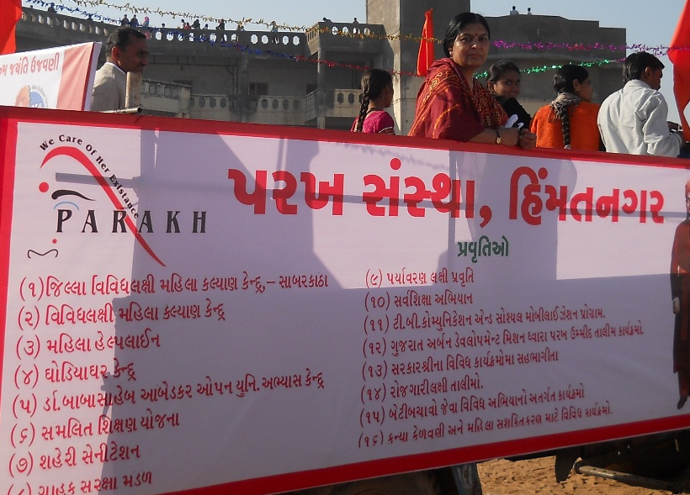

PARAKH TRUST
Ambawadi, Bar Bangla Ta.Himathanagar,Dist.Sabarkantha
(Gujarat)

  - VISION
Women Children have been Disadvantaged and
Marginalized to Connect them with the Mainstream

MISION
Seva Sahay Siddhi is the mission mantra of the organization
to bring about social and collective development.

About Us
Parakh Trust was established in 29th January 1994 with the aim of social development
(unlistment ). It has been able to get expected result by doing development activities in different economic,
social and education consistently. So make this dream come true , all the people involved with this
organization including trustee , Secretary and the president as well as workers have immense work .In
order to do good of common person . The Trust has in collaboration with the government participated in
various government scheme At the same time the trust it self he organized training program and workshop
to train the people so that they can be self reliant and do their activity them selves the organization has
spread it wing with interior areas state and tried to satisfy the desire of the people invites in remote areas
It has tried it lead best to give all kind of support and guidance to the common men so that He / she can not
Remain behind in the first developing society all over the world . Government has also helped to trust in
makes people aware about different program . The Trust has been primarily in active against the program for
women Atrocity save girl child campaign preventing killing of girl baby from taking birth abortion of women
violence against women etc. the trust has participated actively in the government sponsored programmes
like kanya Kelvin,women empowerment,Krishi Ruth etc.The helping the Government to spared the awareness
among people The trust has also helped women of different section by providing loans from the bank .

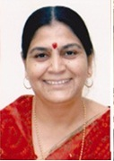
Kaushlyakuvarba Parmar
Founder-Member

Parakh Sanstha was established with the noble aim of all-round development of women and children in the society with the aim of social harmony service and assistance and today the seed of Parakh has become a banyan tree and stands strong as the voice of oppressed women and children in the society. I am proud to participate in this complex work of service from various dimensions. In the coming time, the organization will always be ready and striving to start a new chapter in the social sector and remove the inequality in the society and women can lead a better life.

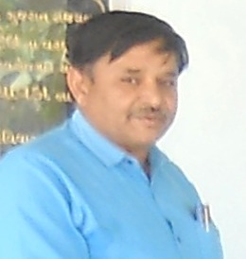
Sureshbhai Patel
President

It is a matter of great honor for me to join Parakh Institute which is dedicated to service achievement and assistance. More than ten thousand widows got an opportunity to work with the dedicated workers of the organization in providing pension, self-employment training and benefiting the exploited women and children schemes of the government. I will always strive to take this work of the organization to a new height
Detailed Activities of Trust

(1) District multipurpose woman welfare centre , Himmatnagar
The trust is running this centre in the 09th Taluka of Sabarkantha district This centre is sponsored by the commissioner women and child development Gandhinar under this programme women has provided guidance on legal aid social health , employment and career development Main Activities of this centre – legal aid in collaboration with
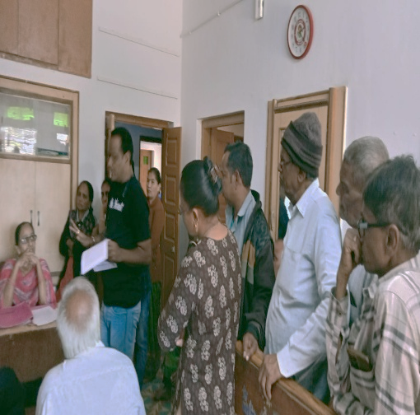
Work done
S.No | Work done | Beneficiares
1 | Govt. scheme | 052
2 | Legal Aid | 110
3 | Oriented Employment (Rojagar) | 025
4 | others | 258
5 | Samajik | 1408
 | Total | 1853

Work done under different Govt. scheme

S.No | Govt.Sceme | Beneficiares
1 | Widow-help | 13
2 | Old-age help | 04
3 | Neradhay vrudh sahay | 04
4 | Medical Aid | 00
5 | National Family Sahay | 03
6 | Women’s Self-Reliance | 04
7 | Sant surdas | 00
8 | Kunvarbainu mamerau yojana | 06
9 | Human Dignity | 00
10 | Palk Mata-Pita | 03
11 | Valhi Dicer Yojana | 10
12 | Pandit Dindyal aavas yojana | 05
 | Total | 52
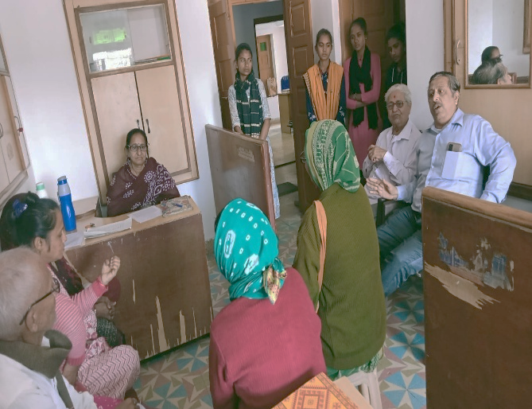
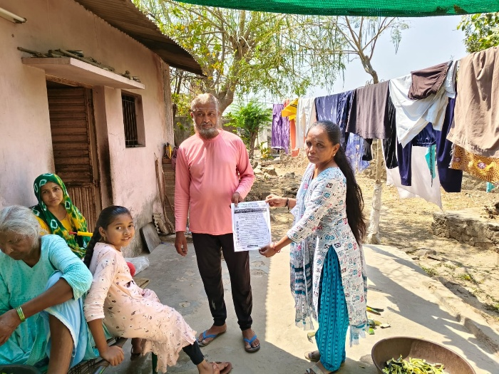
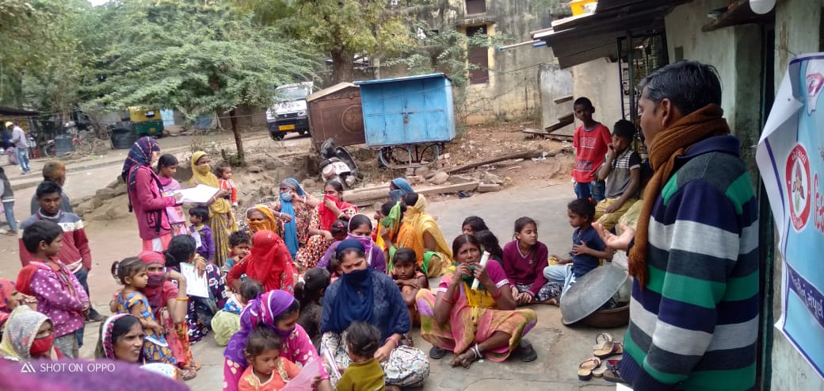
(2) Vividhlakshi Mahila Kalyan Kendra, Talod,
Under this programme women of different sections are provided with guidance, training and made aware about different subject like self-help group saving and team spirit, health aware newsstand presently development.
Since August 2006,the trust has three this centre provided information in to 101 village out of total 109 village the details is as under.
S.No | Work done | Beneficiares
1 | Govt. scheme | 063
2 | Legal Aid | 014
3 | Employment oriented | 118
4 | others | 087
5 | Samajik | 1495
 | Total | 1777
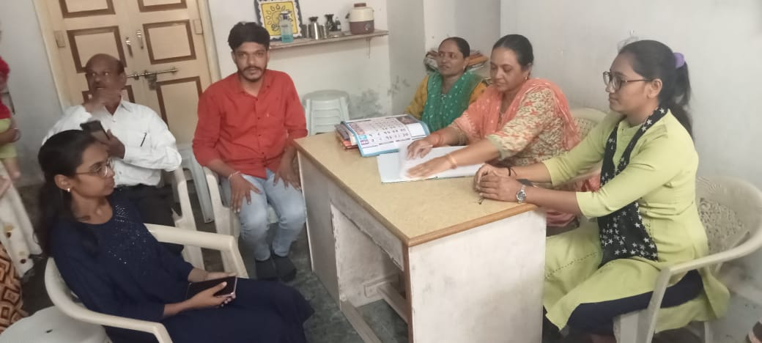

(3) Vividhlakshi Mahila Kalyan Kendra ,Bhilod Workdone
S.No | Work done | Beneficiares
1 | Govt. scheme | 061
2 | Legal Aid | 042
3 | Employment oriented | 311
4 | Others | 1728
5 | Samajik | 094
 | Total | 2236
Under this programme women of different sections are provided with guidance, training and made aware about different subject like self – hel group saving and team spirit, health awareness and presently development. Since March 2009,the trust has three this centrerovided information in to 95 village out of total 96 village the details is as under.
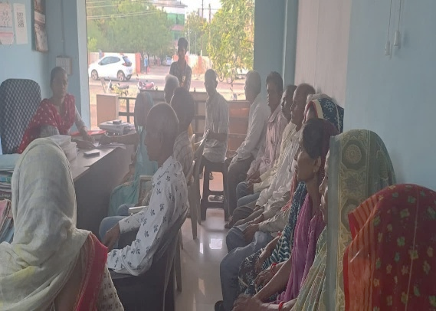

(4) Vividhlakshi Mahila Kalyan Kendra , Dahegam, Work done
Under this programme women of different sections are provided with guidance ,training and made aware about different subject like self-help group saving and team spirit ,health awareness and presently development. Since March 2009,the trust has three this centre provided information in to 104
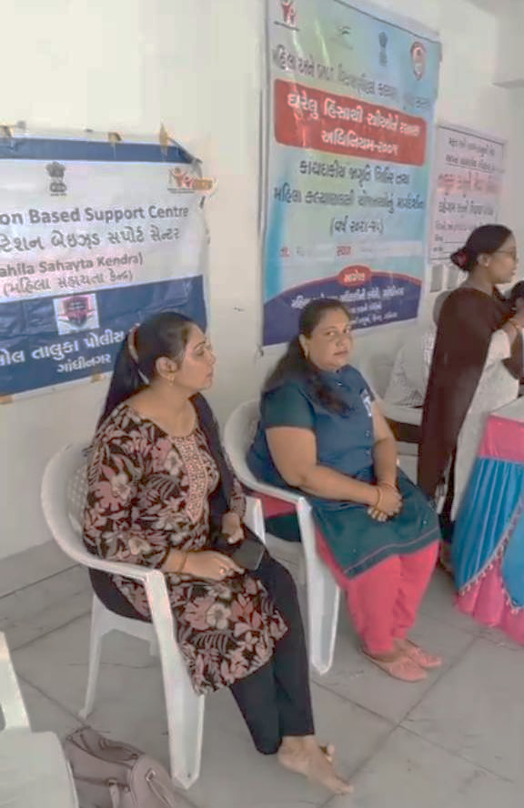
village out of total 93 village the details is as under.
S.No | Work done | Beneficiares
1 | Govt. scheme | 043
2 | Legal Aid | 025
3 | Employment oriented | 090
4 | Others | 1120
5 | Samajik | 423
 | Total | 1701

(5) Beti-Bachao Abhiyan and Kanya-Kelvan
To create awareness among the people by arranging the meetings, camps and conferences at the village,taluka and district level and bringing this cause to the limelight. When this natural balance has been disrupted and disturbed, Parakh has made the sincere and sustained endeavor in focusing among the people on the possible disastrous fallout of the imbalanced sex –ratio and contributed substantially.

(6) Nation Mental Health Programme.
Performance of targeted interventions
Due to today's fast-paced life and competition, and in terms of jobs and business, we are taking the most damage to mental health, so taking care of mental health becomes very necessary. Government has started District Mental Health Program under National Mental Health Programme.
As per the approved PIP for the year: 2024-25 under the “National Mental Health Program” (NMHP) by the office of District NCD Cell, Sabarkantha,the institute has been asked to carry out targeted intervention activities in rural areas of Talod, Prantij, Himmatnagar and Idar taluks of Sabarkantha district,Arvalli,Palnpur and Mahesana district all taluka and Government/Semi Government offices for various mental illnesses related to mental health in community sector in urban areas, Officials/employees of local Swaraj institutions, industrial units, public places and schools, colleges, milk societies, service cooperative societies and Asha workers and Anganwadi, Tedagar worker sisters, youths, youths have been assigned the task of imparting information about mental health.
Virapur Village to Caminiti mitting PHC, Dist.Siddhaur
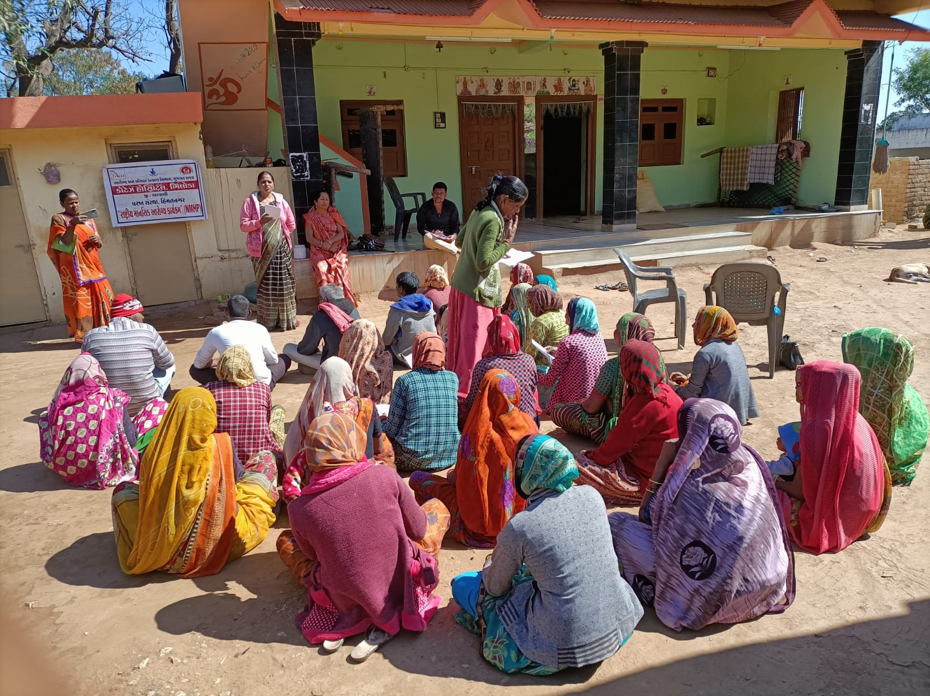
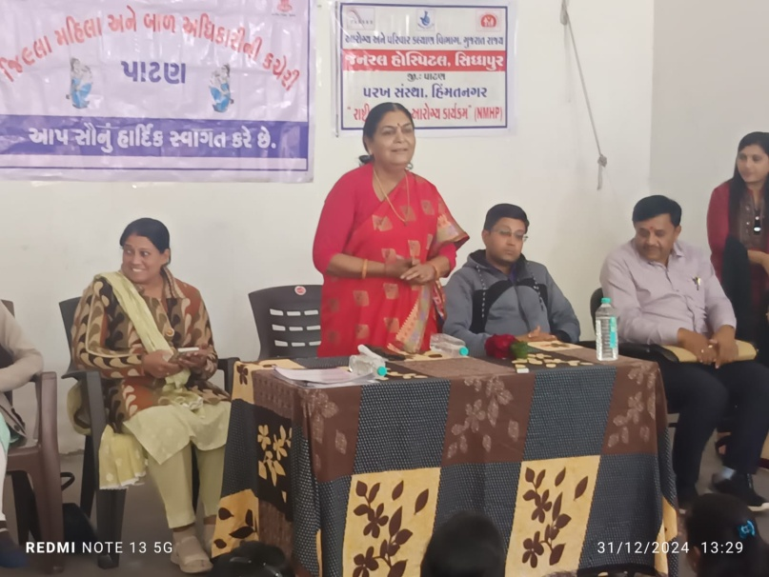
.

Caminiti mitting
ITI Bakor, Dist.Mahisagar Pr-School.Ladol,Dist. Mahesana
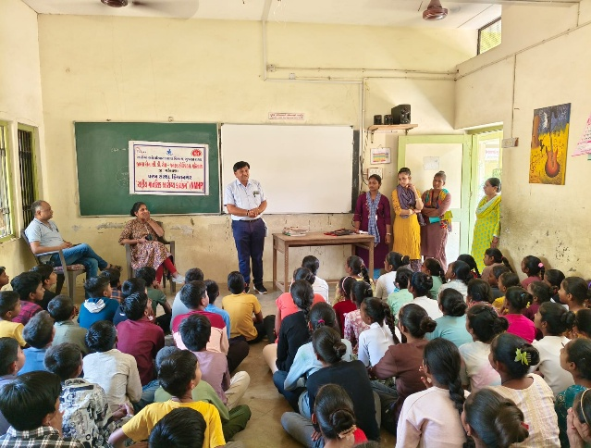
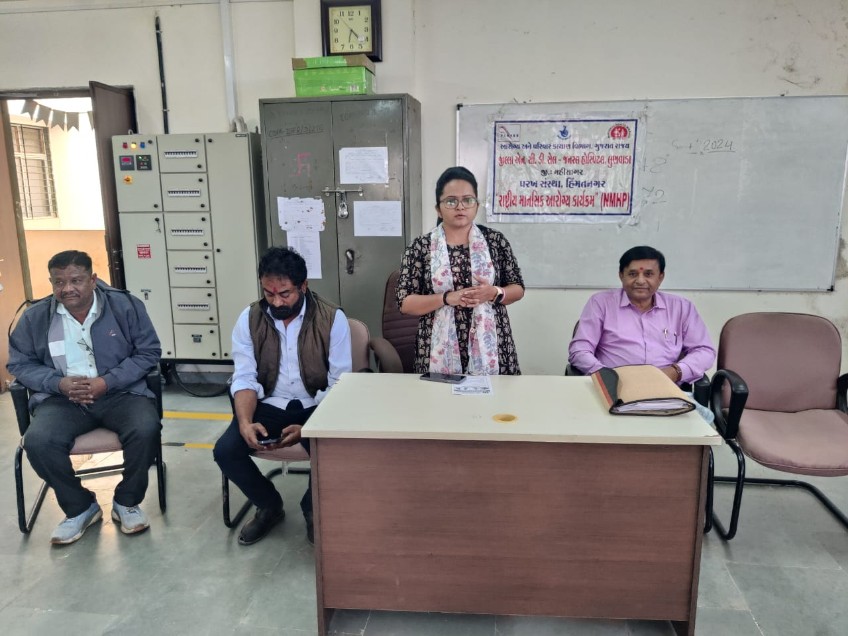

(NMHP) Caminiti mitting Village:-
Govindapura,Malapur,Dist. Aravalli
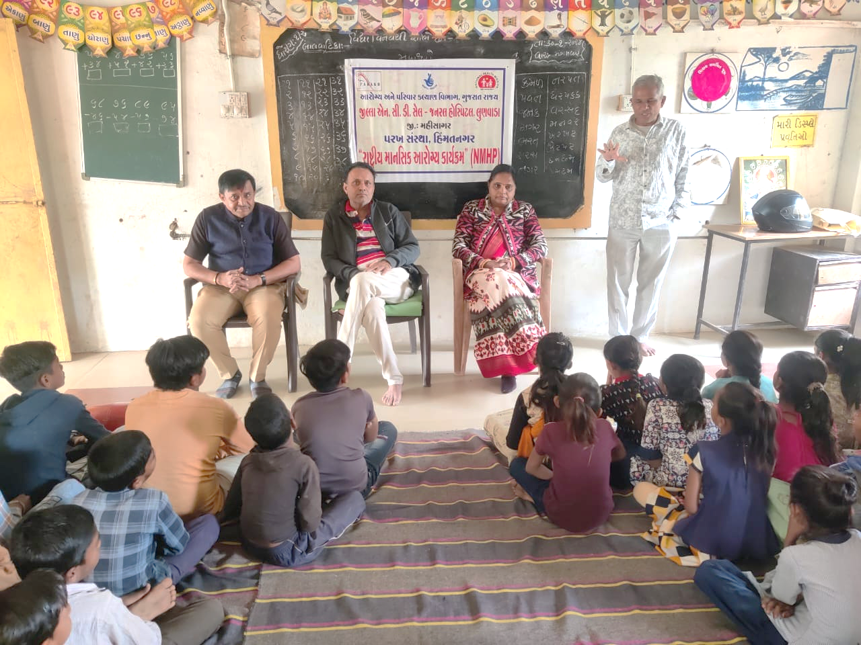

(9) Integrated Education Scheme,
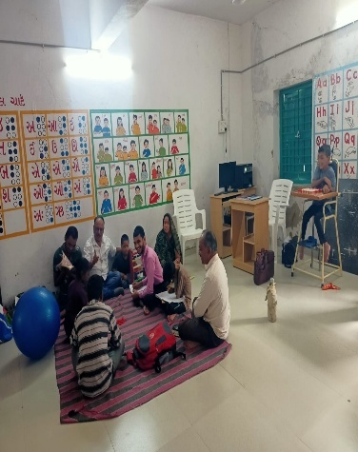
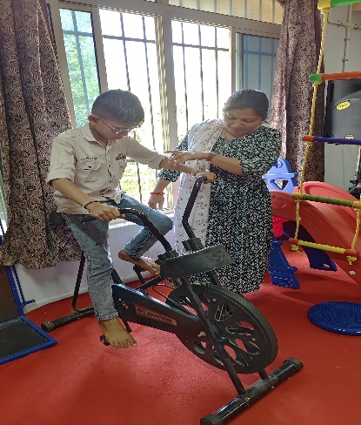
(7) Rashtriy Madhyamic shiksha Abhiyan
(SSA)(IEDSS) Gandhinagar
Integrated education means the children
bearing various types of disabilities can
educate themselves staying with their families
and studying in the general school of the
village of their on area

S.N. | Years | Facility Grant
1 | 2022-23 | 093
2 | 2023-24 | 093
3 | 2024-25 | 110
The benefits out of the allotted assistance to the handicapped children
To make survey to primary school to secondary and Higher Secondary School (1 to 12)
To Provide Medical Certificate to Disabled Children of their categories.
To Give Admission in his nearest School (Primary/Secondary/higher Secondary)
To give benefit by Govt Schemes to every disabled.
- The physically handicapped child can acquire education with the help of tricycle, callipers, crutches properly and effectively .Apart from it children can deal with other children of their own area amicably
- The help of M.R. Educational kit enhances the interest of learning among the children. The pragmatic training received by the children and the knowledge obtained thereby facilitate the children to achieve mental and physical development through effective expression. The help of hearing aid and educational kit develop in the hearing- impaired child the hearing capacity. The hearing impaired child bails out of the inferiority complex of deafness by getting acquainted with the sounds of the surroundings and developing concepts with the average children with the help of hearing-aid
(8) Baxipanch Kumar Chhatralay:
The Parakh institution has got grant in aid Baxi Panch Kumar Chhatralay from 1998 Through the social welfare, Department . Under which, in the year 2024 – 2025 50 students were given the facilities of lodging and boarding free of charge.The student living in the hostel are studying in the schools suitable to them. The hildren are being given educational articles as per their requirements. Over and above, planning for tours and picnics are also being arranged.

(9) Education Health and Population awareness programme

with the co-operation the prohibition and excise Department, the institution is in active working movement of the various programmes of freedom of addiction on the day of Gandhi Jayanti. The Parakh institution is doing many activities for social Health and for formation of awaiking society during the year in which includes freedom bringing out of addictrion campaigin save female child campaign programme for awareness regarding Aids, Girls Education Career,Employment Guidance Protection pollution.
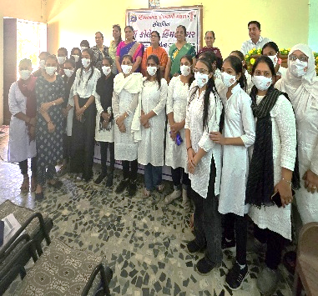
Remaining constantly active for eradicatio campaign,shibir of legal knowledge,consumer protection campaign through shibirs,meetings,ralley,pamphlets distribution etc.Duriong the year 2024-2025 , the activities as under were done.
No. | Details of programme | No. of Programme | Beneficiaries
1 | Leaving up of addiction | 01 | 093
2 | Environment Programme | 01 | 121
3 | Yoga day | 01 | 045
4 | Guide lines for career & employment | 02 | 330
5 | Pollution protection | 04 | 180
6 | Pre-knowledge of legal | 12 | 570
(10) The Parakh Institution has got approval as of consumer
Customer protection Mandal from the year 2005.Under this the institution is giving programmers of awareness programmers are beings arranged for bringing transparency. In the matters that the customer may not be cheated for the quality of goods mark for values of ,goods for weight and measurements etc. Taking complaints from the customers proper actions are being taken for its disposal. In the year 2024-25 the activities as shown below where taken on hand .
No | Date | Place | Number of Participate | Details programmes
1 | 18/12/2024 | Ashokpura | 053 | Shibir
2 | 19/12/2024 | Tajpuri | 055 | Shibir
3 | 20/12/2024 | Mohabatpura | --- | Patrika Distribute
4 | 21/12/2024 | Naavalapur | 058 | Shibir
5 | 22/12/2024 | Pra.school-Polajpur | 045 | Kviz/Spardha
6 | 23/12/2024 | Vakhatpura | --- | Patrika Distribute
7 | 24/12/2024 | Aadarsh Highschool-Motipura | 135 | Seminar
During the year total 76 programmers were arranged alike shippers, seminars, workshop, visual, meetings, Exhibition. – 15 Over and above this 43 complaints received from the customer -6375 .Pamphlates-9100 were distributed regarding awareness And celebration of 24, December. The number of programmers as unde
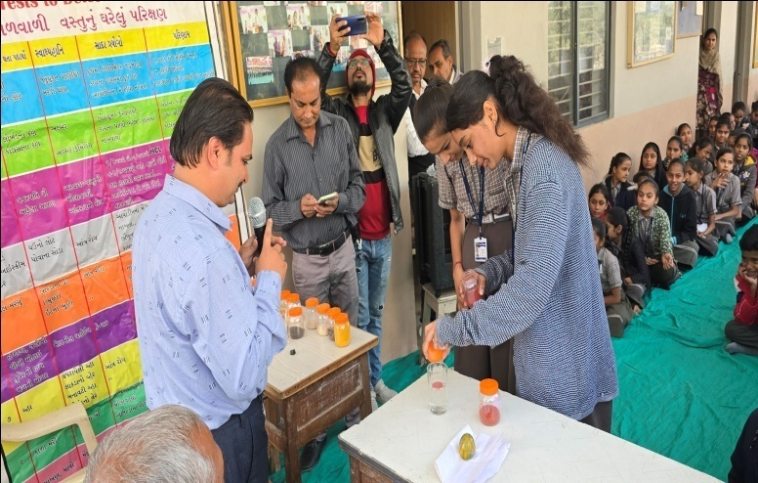
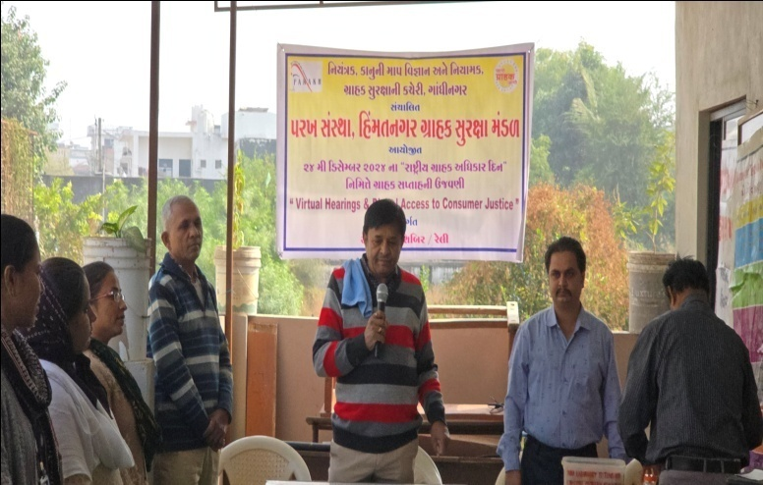

Celebration 15th March 2025 as customer rights Days for number of programmes as under:
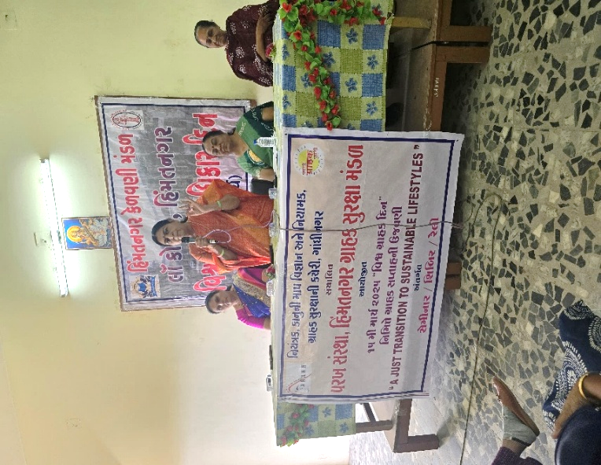
No | Date | Place | Number of Participate | Details programmes
1 | 09/3/2025 | Malinachapariya | 095 | Shibir
2 | 10/3/2025 | Brhamaninagar | 030 | Kviz/Spardha
3 | 11/3/2025 | Panapur | 035 | Shibir
4 | 12/3/2025 | Mahetapura Pra-School | 060 | Shibir
5 | 13/3/2025 | Satanagar | --- | Patrika Distribute
6 | 14/3/2025 | Kiphayatnagar | --- | Patrika Distribute
7 | 15/3/2025 | Lo-collej -Motipura | 080 | Seminar
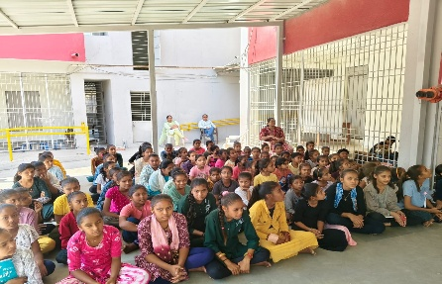

Details of Consumer Club
The Beginning of the Consumer Club for the purpose of young generation involve in this awareness programme of customer awareness for the whole state secondary School The 14 and college - 03 Consumer club allots to Parakh Trust in Sabarkantha district.

Corporate Social Responsibility (CSR)
Project Pratibha: Bridging Dreams and Empowering Women through Skill Development in Ahmedabad

Ahmedabad, Gujarat - August 10th | Parakh Trust (NGO), a prominent non-governmental organization in Ahmedabad, India, proudly announces the launch of Project Pratibha with the support of eInfochips, a collaborative endeavor driven by a shared commitment to Corporate Social Responsibility (CSR).
Project Pratibha is a pioneering initiative that encompasses Sewing and Beauty Parlor Training Center, operated by Parakh Trust (NGO). The center aims to become a transformative platform for unemployed and economically disadvantaged women by offering the training free of cost to the beneficiaries. eInfochips is supporting this initiative by funding the center's operational expenses. The inaugural phase of the project focuses on delivering comprehensive training in beauty parlor techniques and sewing skills, empowering women to achieve self-reliance and financial resilience. The initial group of Fase-2-64 and fase-3- 100 total-164 women will be expertly guided by accomplished trainers.
Reflecting on the significance of Project Pratibha, a representative from Parakh Trust (NGO) shared, "We embrace a steadfast belief in the empowerment of women as a cornerstone of sustainable progress. Parakh Trust (NGO) is committed to upholding women's rights and equipping them with the competencies needed to actively participate in decision-making processes. Our gratitude extends to eInfochips for their unwavering support, and we envision Project Pratibha as a catalyst for enriching countless lives, fostering societal strength through women's empowerment."
The core objective of this initiative is to enable women to recognize their individual aptitudes, nurturing them through tailored training to facilitate the establishment of small-scale entrepreneurial ventures or gainful employment, ultimately contributing to their families' well-being and holistic prosperity.
As Project Pratibha sets forth on this transformative journey, it aspires to not only stitch dreams but also weave a tapestry of empowered women, strengthening the fabric of society itself.
Total Four Fase Beneficiary Details are as under.
S.No | Phase | Date | Beneficiary
1 | 2 | 13-02-2024 to 12-05-2024 | 64
2 | 3 | 15-10-2024 to 14-01-2025 | 100

Objective
To reduce the poverty and vulnerability of urban and rural poor households by enabling them to gain access to gainful self-employment and skilled wage employment opportunities, resulting in the generation of innovative opportunities for strong grassroots employment of the poor and through this training, make them self-reliant and significantly improve their livelihoods on a sustainable basis. The mission ...

Sewing a good life skill.
Sewing is a life skill that can save your time and money. In addition to those practical savings, sewing can be a tool for teaching important life skills such as perseverance, patience, concentration, and creativity.

What kind of job is sewing.
The sewing industry provides a vast variety of career opportunities in textile production, sales, retail, sewing and manufacturing. Sewing industry jobs can involve the technical development or logistics of textile creation, along with the production and sale of clothing or other fabric items

Beauty Parlour Courses Details
Beauty Parlour courses help students to know how to work as a make-up artist and deal with cosmetics for the skin, eyes, cheeks and lips. Here, students learn various factors like – how to apply make-up for a regular day or a special occasion or for fashion models and applying foundations for different skin tones, using blushes, mascara, eyeliner, lipstick and much more.
Career Prospects
There are various job opportunities, as applicants can work in professional salons, Spa, beauty centres and more as a fresher. After gaining experience, can also start beauty salons on their own. Jobs that beauticians can apply for are.

Comprehensive training in beauty Parlor techniques and sewing skills, empowering women to achieve self-reliance and financial resilience. The initial group of Phaase-2 , 64 women will be expertly guided by accomplished trainers Date : 13-02-2024 to 12-05-2024

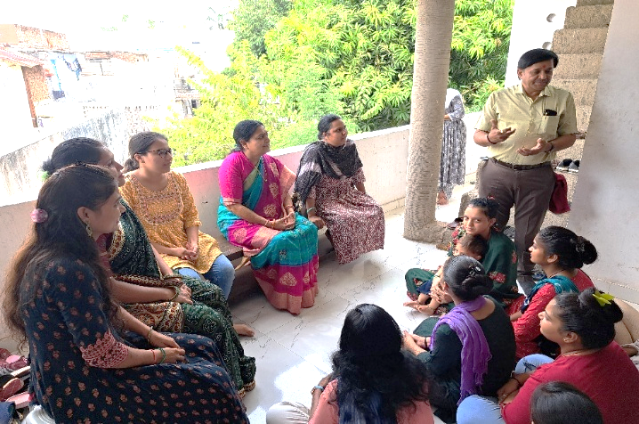

Parakh Trust Secretary Kaushalya Kuvarba Parmar visits sewing and beauty parlor classes

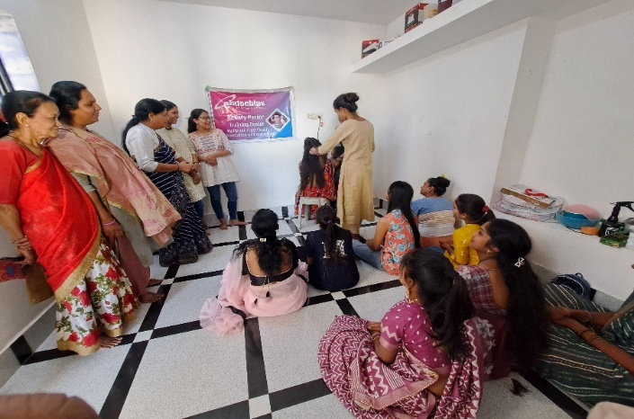
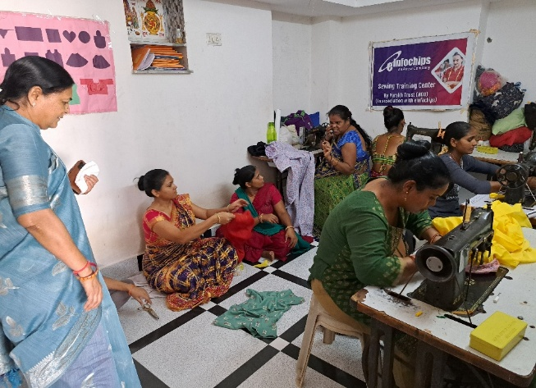

Comprehensive training in beauty Parlor techniques and sewing skills, empowering women to achieve self-reliance and financial resilience. The initial group of Phaase-3 , 100 women will be expertly guided by accomplished trainers Date : 15-10-2024 to 14-01-2025
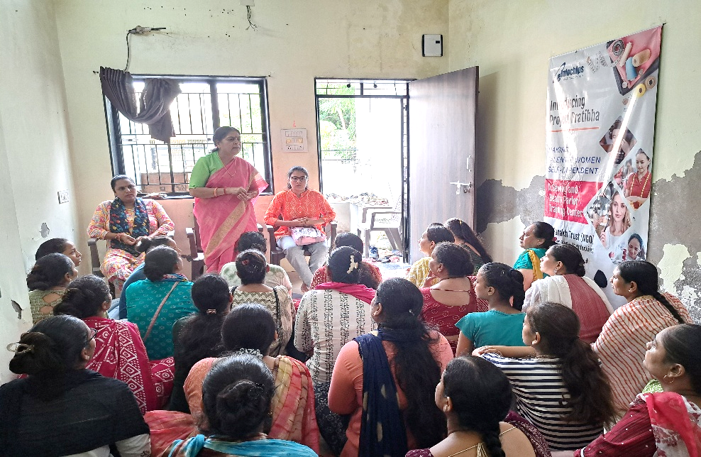

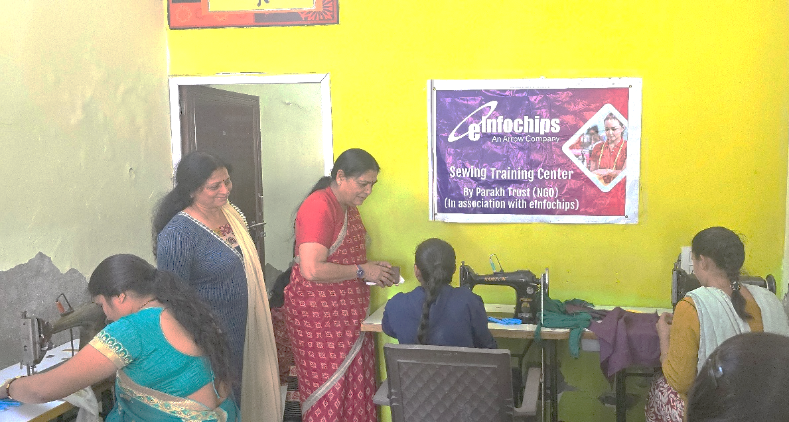

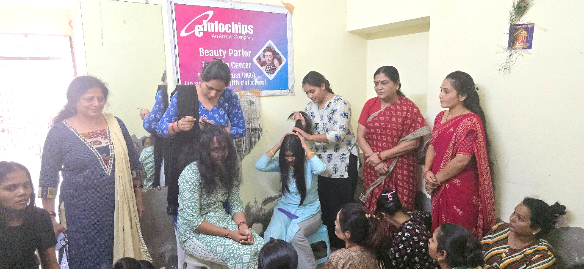


E-Infochips Private Ltd. Ahmedabad and Parakh Trust More for women to use sanitary pad and get knowledge about it Organized free sanitary pad distribution program to create awareness among poor and rural girls and women on menstrual hygiene management issues.
The trend of conservative beliefs is still not removed from rural areas. Somewhere new problems arise and some where new diseases arise. How many women use sanitary pads? Women in the area do not know what a sanitary pad is. We have made about 2500 women and girls aware of this by going to the following places to make them aware. It is also necessary for a woman to be physically and mentally healthy. We have made this campaign worthwhile through you.
Ahmedabad (Urban) Total Beneficiary : 1250
Date : 21/05/2024 to 27/09/2024 total 18 Place

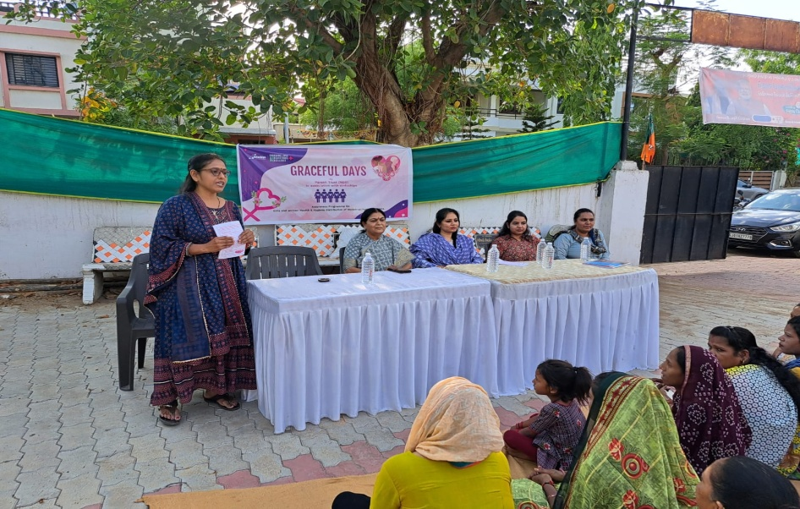

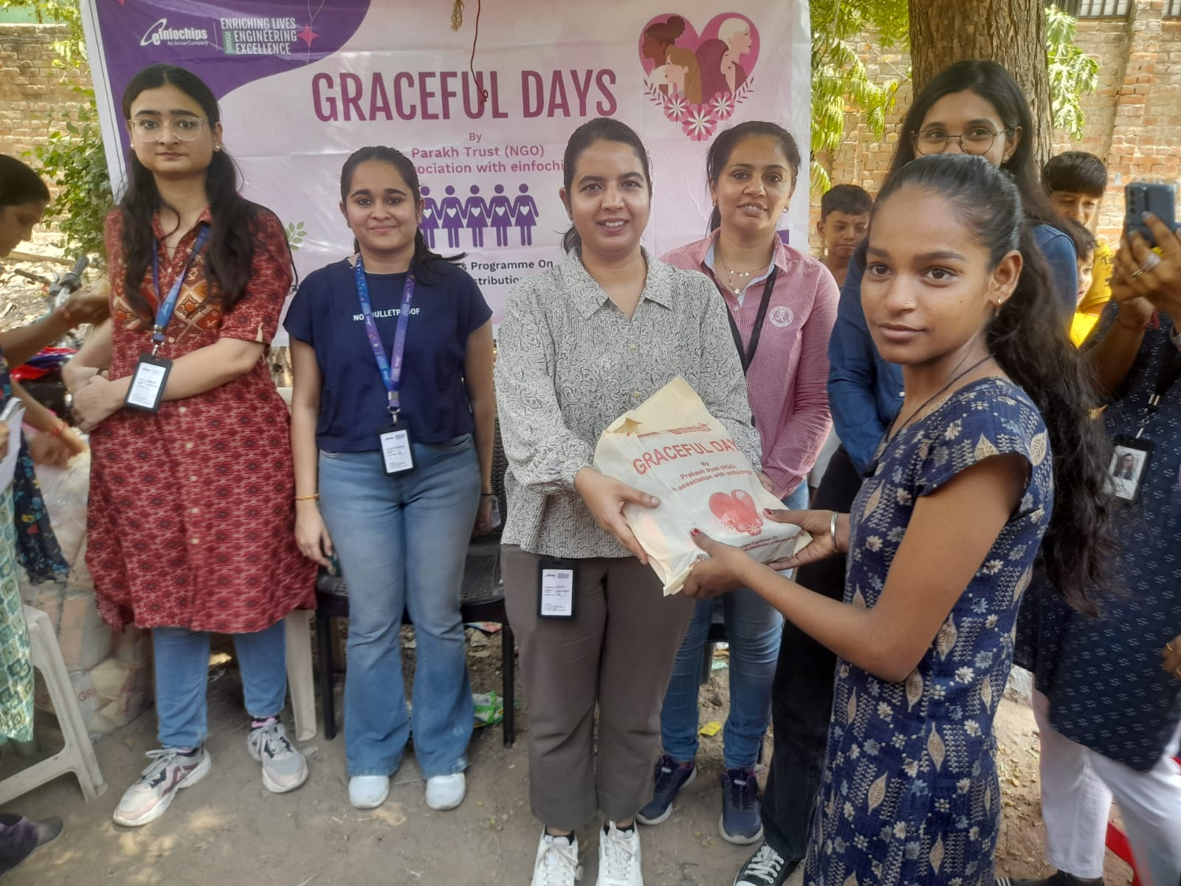

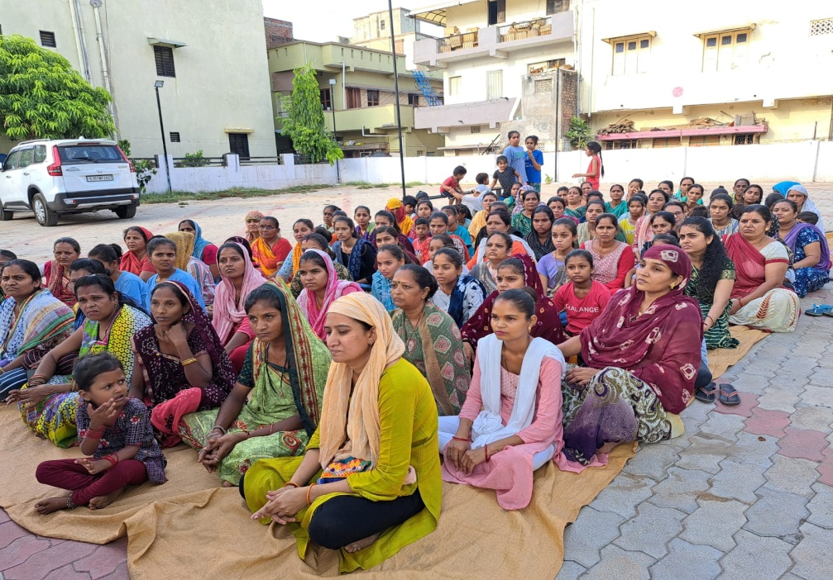

Sabarkantha (Tribal area) ) Total Beneficiary : 1250
Date : 20/06/2024 to 10/09/2024 total 27 Place
