PARAKH TRUST

ANNAUL
REPORT
2022-2023

PARAKH TRUST
Ambawadi, Bar Bangla,
Ta.Himathanagar,Dist.Sabarkantha(Gujarat)

  - VISION
Women Children have been Disadvantaged and
Marginalized to Connect them with the Mainstream

MISION
Seva Sahay Siddhi is the mission mantra of the organization
to bring about social and collective development.

About Us
Parakh Trust was established in 29th January 1994 with the aim of social development
(unlistment ). It has been able to get expected result by doing development activities in different economic,
social and education consistently. So make this dream come true , all the people involved with this
organization including trustee , Secretary and the president as well as workers have immense work .In
order to do good of common person . The Trust has in collaboration with the government participated in
various government scheme At the same time the trust it self he organized training program and workshop
to train the people so that they can be self reliant and do their activity them selves the organization has
spread it wing with interior areas state and tried to satisfy the desire of the people invites in remote areas
It has tried it lead best to give all kind of support and guidance to the common men so that He / she can not
Remain behind in the first developing society all over the world . Government has also helped to trust in
makes people aware about different program . The Trust has been primarily in active against the program for
women Atrocity save girl child campaign preventing killing of girl baby from taking birth abortion of women
violence against women etc. the trust has participated actively in the government sponsored programmes
like kanya Kelvin,women empowerment,Krishi Ruth etc.The helping the Government to spared the awareness
among people The trust has also helped women of different section by providing loans from the bank .

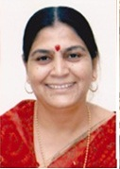
Kaushlyakuvarba Parmar
Founder-Member

Parakh Sanstha was established with the noble aim of all-round development of women and children in the society with the aim of social harmony service and assistance and today the seed of Parakh has become a banyan tree and stands strong as the voice of oppressed women and children in the society. I am proud to participate in this complex work of service from various dimensions. In the coming time, the organization will always be ready and striving to start a new chapter in the social sector and remove the inequality in the society and women can lead a better life.

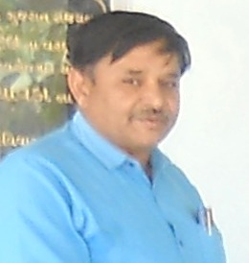
Sureshbhai Patel
President

It is a matter of great honor for me to join Parakh Institute which is dedicated to service achievement and assistance. More than ten thousand widows got an opportunity to work with the dedicated workers of the organization in providing pension, self-employment training and benefiting the exploited women and children schemes of the government. I will always strive to take this work of the organization to a new height.

Detailed Activities of Trust

(1) District multipurpose woman welfare centre , Himmatnagar
The trust is running this centre in the 09th Taluka of Sabarkantha district This centre is sponsored by the commissioner women and child development Gandhinar under this programme women has provided guidance on legal aid social health , employment and career development Main Activities of this centre – legal aid in collaboration with

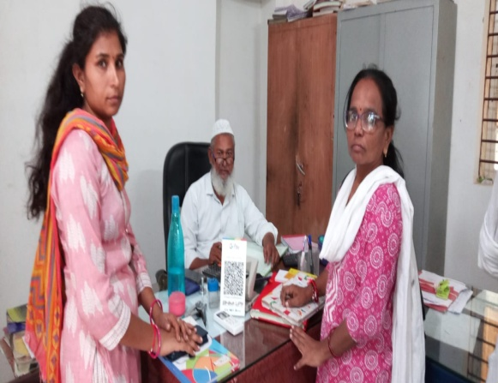
Work done
S.No | Work done | Beneficiares
1 | Govt. scheme | 177
2 | Legal Aid | 076
3 | Oriented Employment (Rojagar) | 046
4 | others | 435
5 | Samajik | 1524
 | Total | 2158

Work done under different Govt. scheme

S.No | Govt.Sceme | Beneficiares
1 | Widow-help | 45
2 | Old-age help | 13
3 | Neradhay vrudh sahay | 00
4 | Medical Aid | 00
5 | National Family Sahay | 03
6 | Women’s Self-Reliance | 06
7 | Sant surdas | 00
8 | Kunvarbainu mamerau yojana | 07
9 | Human Dignity | 00
10 | Palk Mata-Pita | 00
11 | Valhi Dicer Yojana | 02
12 | Pandit Dindyal aavas yojana | 01
 | Total | 77
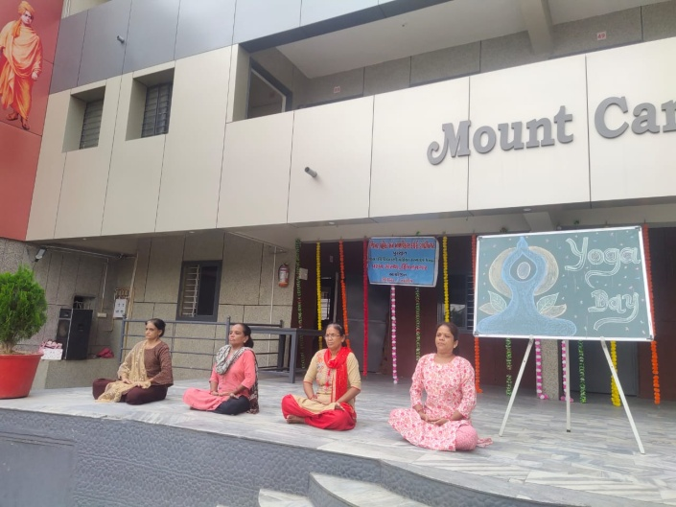
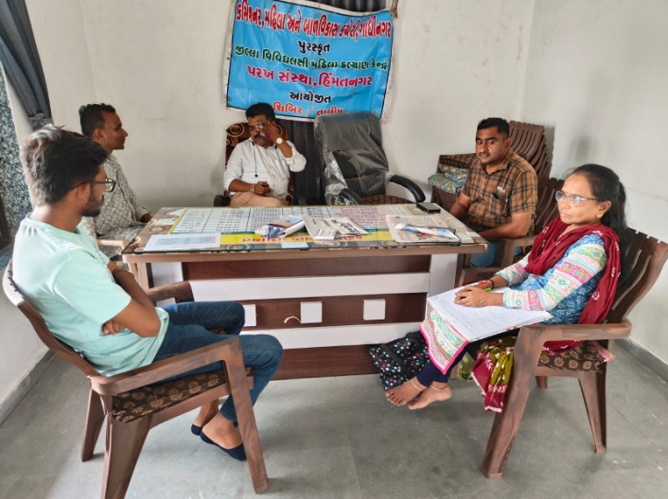
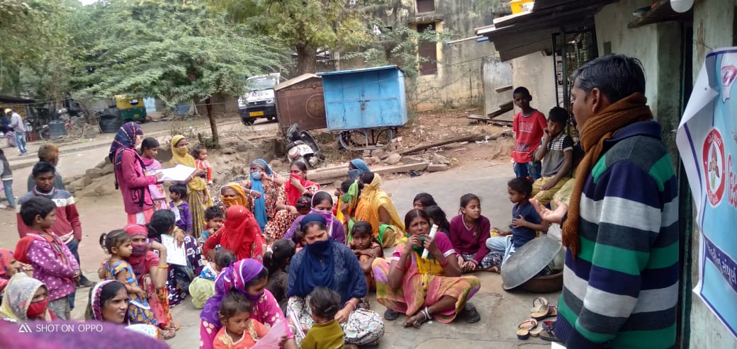

(2) Vividhlakshi Mahila Kalyan Kendra, Talod,
Under this programme women of different sections are provided with guidance, training and made aware about different subject like self-help group saving and team spirit, health aware newsstand presently development.
Since August 2006,the trust has three this centre provided information in to 99 village out of total 106 village the details is as under.
S.No | Work done | Beneficiares
1 | Govt. scheme | 064
2 | Legal Aid | 016
3 | Employment oriented | 127
4 | others | 076
5 | Samajik | 1413
 | Total | 1696
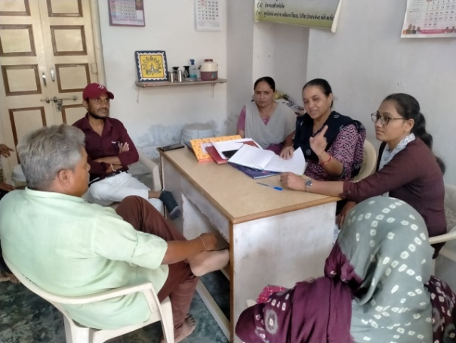

(3) Vividhlakshi Mahila Kalyan Kendra ,Bhilod Workdone
S.No | Work done | Beneficiares
1 | Govt. scheme | 066
2 | Legal Aid | 038
3 | Employment oriented | 300
4 | Others | 1946
5 | Samajik | 0109
 | Total | 2459
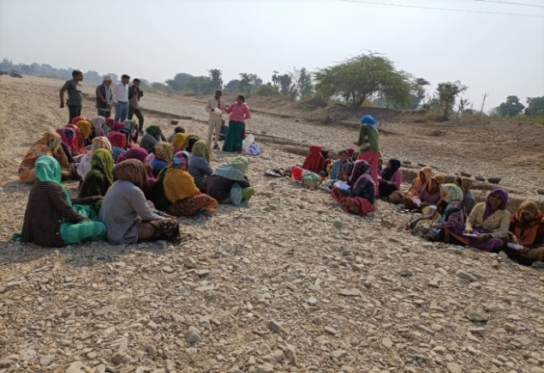
Under this programme women of different sections are provided with guidance, training and made aware about different subject like self – hel group saving and team spirit, health awareness and presently development. Since March 2009,the trust has three this centrerovided information in to 92 village out of total 96 village the details is as under.

(4) Vividhlakshi Mahila Kalyan Kendra , Dahegam, Work done

Under this programme women of different sections are provided with guidance ,training and made aware about different subject like self-help group saving and team spirit ,health awareness and presently development. Since March 2009,the trust has three this centre provided information in to 101
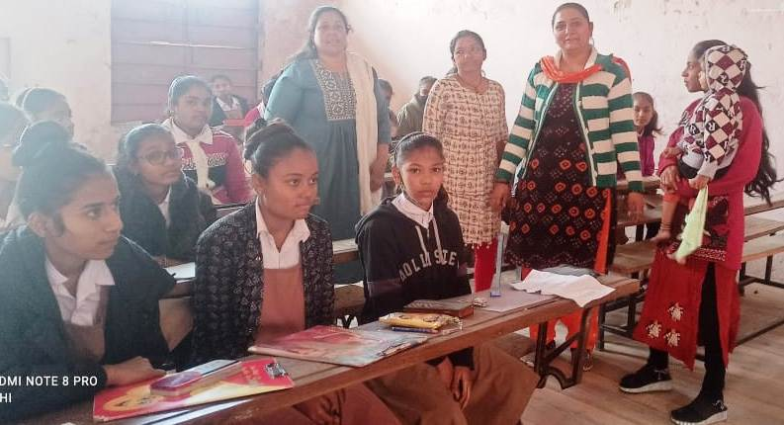
village out of total 90 village the details is as under.
S.No | Work done | Beneficiares
1 | Govt. scheme | 054
2 | Legal Aid | 029
3 | Employment oriented | 112
4 | Others | 457
5 | Samajik | 1168
 | Total | 1820

(5) Beti-Bachao Abhiyan and Kanya-Kelvan
To create awareness among the people by arranging the meetings, camps and conferences at the village,taluka and district level and bringing this cause to the limelight. When this natural balance has been disrupted and disturbed, Parakh has made the sincere and sustained endeavor in focusing among the people on the possible disastrous fallout of the imbalanced sex –ratio and contributed substantially.
Under Kanya Kelvani, Parakh actively participated in the Shala Praveshotsav and Kanya kelvani rath yatra. During 2003 at the shala Praveshotsav of Arjanpura in Himatnaga r taluka Pinkal was given rs.1000 of vidya laxmi bond on the spot by the secretary of Parakh for which 5 students of the primary school had been nominated. Besides this, in presence of state project director Mr. Sharma Parakh adopted a cuddly little flower like daughter Pinkal.Presently Parakh provides the study materials and uniform to Pinkal.Parakh has accepted the responsibility of higher education of Pinkal

(6) “One Stop Cente r (OSC)” Aravalli & Gandhinagar
The Ministry of Women and Child Development will provide support to the State Governments As well as the office of women and child officer ,Arvalli & Gandhinagar
The objectives of the Scheme are: (i) To provide integrated support and assistance to women affected by violence, both in private and public spaces under one roof. (ii) To facilitate immediate, emergency and non-emergency access to a range of services including medical, legal, psychological and counselling support under one roof to fight against any forms of violence against women.
OSC Arvalli Case type Details
S. No | Year | Case Details
S. No | Year | Domestic Violence | Rape | Missing | Sexual Harresment | Others | Total
1 | November-19 to March-2020 | 18 | 02 | 02 | 01 | 00 | 23
2 | April -2020 to March-2021 | 57 | 01 | 27 | 01 | 01 | 87
3 | April -2021 to March-2022 | 79 | 00 | 19 | 00 | 02 | 100
4 | April -2022 to March-2023 | 94 | 00 | 24 | 00 | 37 | 155
 | Total | 248 | 03 | 72 | 02 | 40 | 365
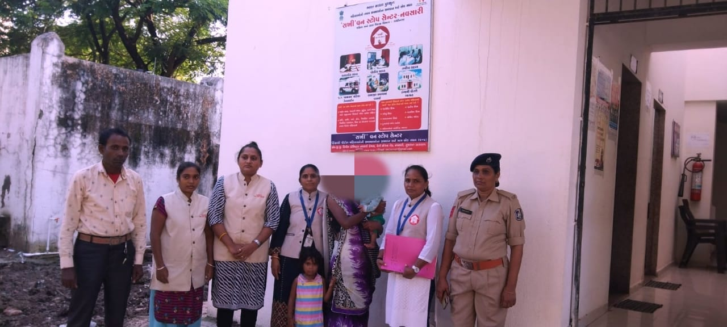
Success Story
1. Name: Vagari Shgilpaben Kishanbhai
2. Age: 32
3. Address: At: 12 Pandit dindyalnagar,Navsari
Dist: Navsari
4. State: Gujarat

Date- On 14/09/2022 night at
Sakhi One Stop Center run by Parakh Sanstha,
181 Women Helpline provided shelter to mentally
disturbed woman along with two daughters. They were seen roaming in the area of ​​Gajan toll tax and reported to 181 women helpline by a vigilant citizen. 181 team put them here for shelter.
Interventions by “Sakhi” One Stop Center:
Ben was given medical treatment at Civil Hospital Himmatnagar by the staff of Sakhi One Stop Center and counseled as his mental condition improved and it was learned that he is a native of Navsari. So the police station there was contacted and Sakhi One Stop Center Navsari was searched for his family but as the financial condition of his family was not good, OSC's vehicle was seized by the police and resettled with his family at Sakhi One Stop Center Navsari.

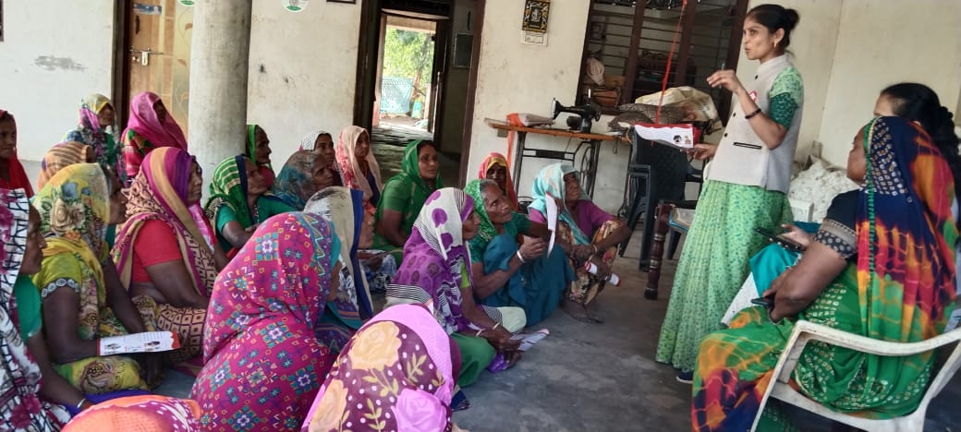
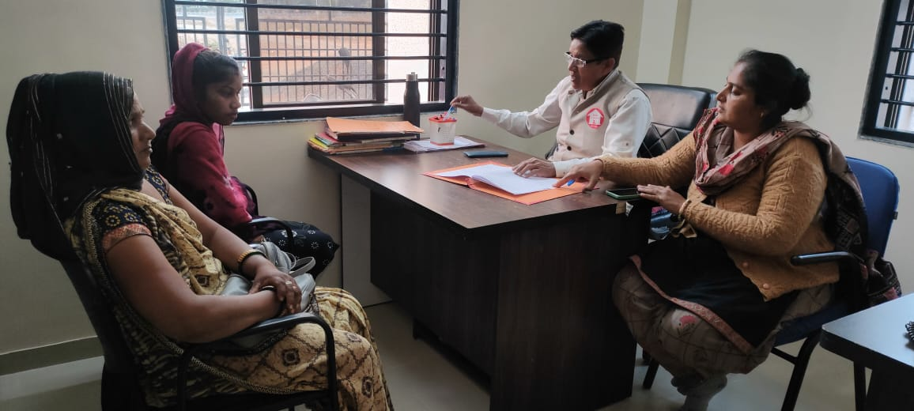

OSC Gandhinagar Case type Details
Year | Case Details
Year | Domestic Violence | Rape | Missing | Sexual Harresment | Others | Total
January-2020 to March-2020 | 15 | 01 | 02 | 00 | 00 | 18
April-2020 to March-2021 | 82 | 12 | 17 | 00 | 06 | 117
April-2021 to March-2022 | 95 | 10 | 21 | 01 | 07 | 134
April-2022 to March-2023 | 139 | 06 | 19 | 00 | 20 | 184
Total | 331 | 29 | 59 | 01 | 33 | 453

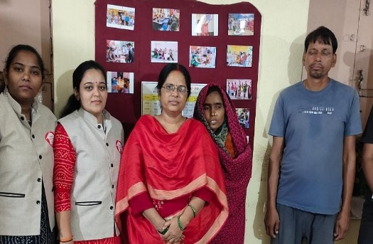
1) Name Radhaben Pramodji Luhar (Vishwakarma)
2) Age: 35
3) Village : Keshopur
4) Which State : Bihar. District : Lakhisarai
5) Detailed information on women affected by violence:

Radhaben Pramodji Blacksmith (Vishwakarma) had come to Ahmedabad from Bihar by railway coming to Ahmedabad, he reached Gandhinagar by wandering, a vigilant person helped his sister with the help of a team of 181.
were sent to Gandhinagar Centre.
While counseling Radhaben, it was found that she is mentally ill, by looking at her language and dress, it was found that she is from Bihar, with the help of
Lakhisarai police station in Bihar, her family was traced and after contacting her family, her husband was called to OSC Gandhinagar, as her son is mentally ill. Also, since his financial condition was not good, he could not come to OSC Gandhinagar in Gujarat, so he was called to OSC in Lakhisarai and re-established
Radhaben by 2 employees of OSC Gandhinagar.
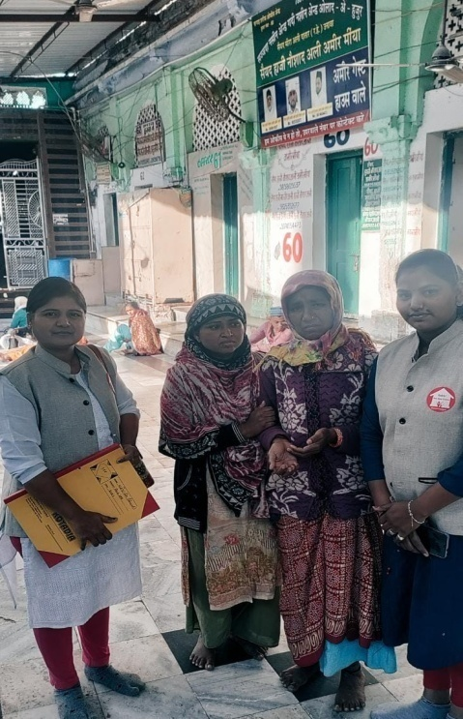
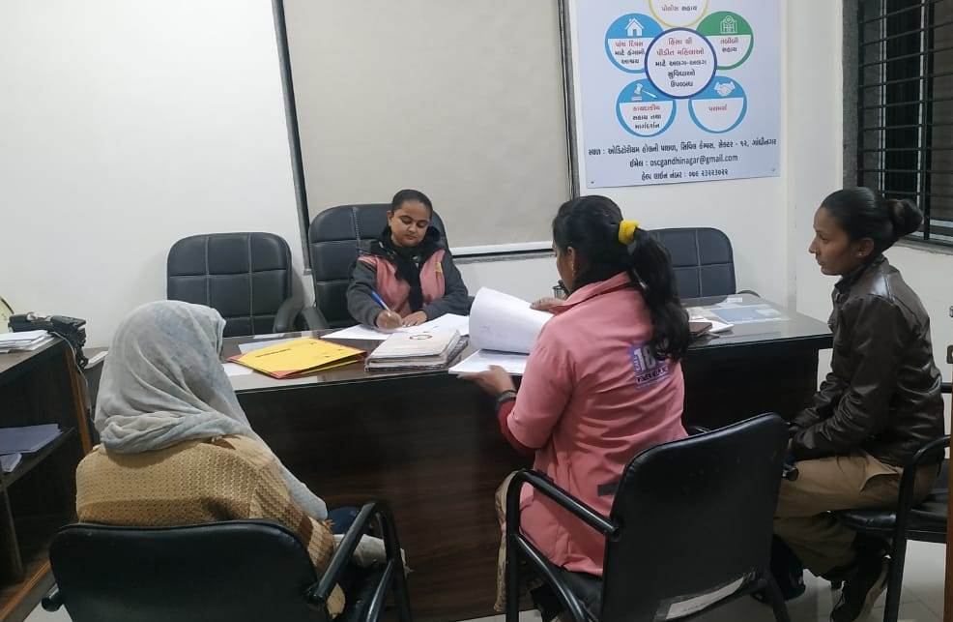

- Childline Arvalli -1098
The Department of women and child ,New Dellhi and Child line India Foundation, Mumbai has appointed by Parakh Trust for Arvalli Dist under which CHILDLINE 1098 is a phone number that spells hope for millions of children across India. It is a 24-hour a day, 365 days a year, free, emergency phone service for children in need of aid and assistance. We not only respond to the emergency needs of children but also link them to relevant services for their long-term care and rehabilita

Grass roots level outreach with children and concerned adults:
previous year: April - 2022 to March -2023

Target Group | No. contacted | Nature of Outreach | Number of Programmes
PCO owners | 0 | 0 | 0
Railway station | 0 | 0 | 0
Bus stops | 17 | 19 | 12
Shelter children | 15 | 15 | 4
Cinema halls | 26 | 30 | 12
Parks | 22 | 20 | 8
Tourist places | 14 | 20 | 9
Religious places | 40 | 45 | 22
Schools | 44 | 44 | 23
Slums | 219 | 235 | 72
Others | 341 | 175 | 65
Total

Along with Aravalli Child Line team and Ganeshpura Primary School Anganwadi worker, organized nutrition month program in Shikarwadi area of ​​Malpur taluka Street children of Modasa , Dolpur village Bapunagar, Kasba In this program, Children And his mother Anganwadi Worker was Participet. Child line Aravalli told the parents about the awakening of the mothers and about the nutritious food from Anganwadi. The Anganwadi worker gave information about new children's admissions and nutritional food. In today's program, children were given Sukhadi food from the Anganwadi. Child Line Aravalli distributed fruits to all the children and mothers

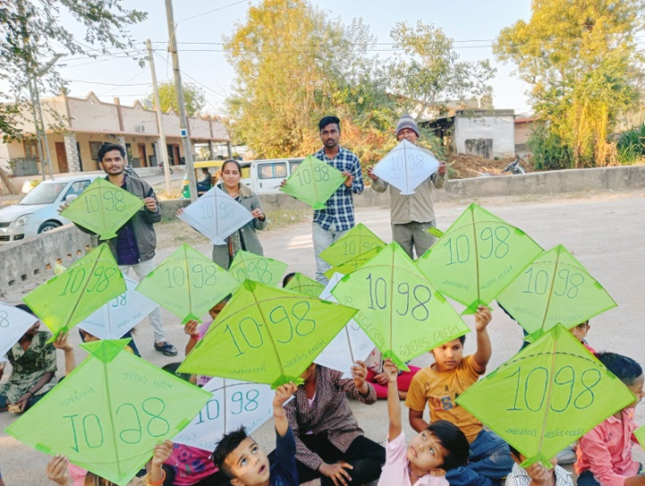
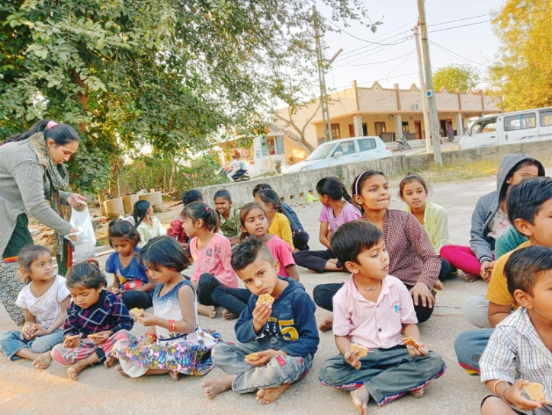

- Nation Mental Health Programme.
Performance of targeted interventions
Due to today's fast-paced life and competition, and in terms of jobs and business, we are taking the most damage to mental health, so taking care of mental health becomes very necessary. Government has started District Mental Health Program under National Mental Health Programme.
As per the approved PIP for the year: 2022-23 under the “National Mental Health Program” (NMHP) by the office of District NCD Cell, Sabarkantha,the institute has been asked to carry out targeted intervention activities in rural areas of Talod, Prantij, Himmatnagar and Idar taluks of Sabarkantha district,Arvalli,Palnpur and Mahesana district all taluka and Government/Semi Government offices for various mental illnesses related to mental health in community sector in urban areas, Officials/employees of local Swaraj institutions, industrial units, public places and schools, colleges, milk societies, service cooperative societies and Asha workers and Anganwadi, Tedagar worker sisters, youths, youths have been assigned the task of imparting information about mental health.
Date.19/01/23 under National Mental Health Program (NMHP). Village:- OPD Civil Hospital Idar Dr. Tabiyad Sir

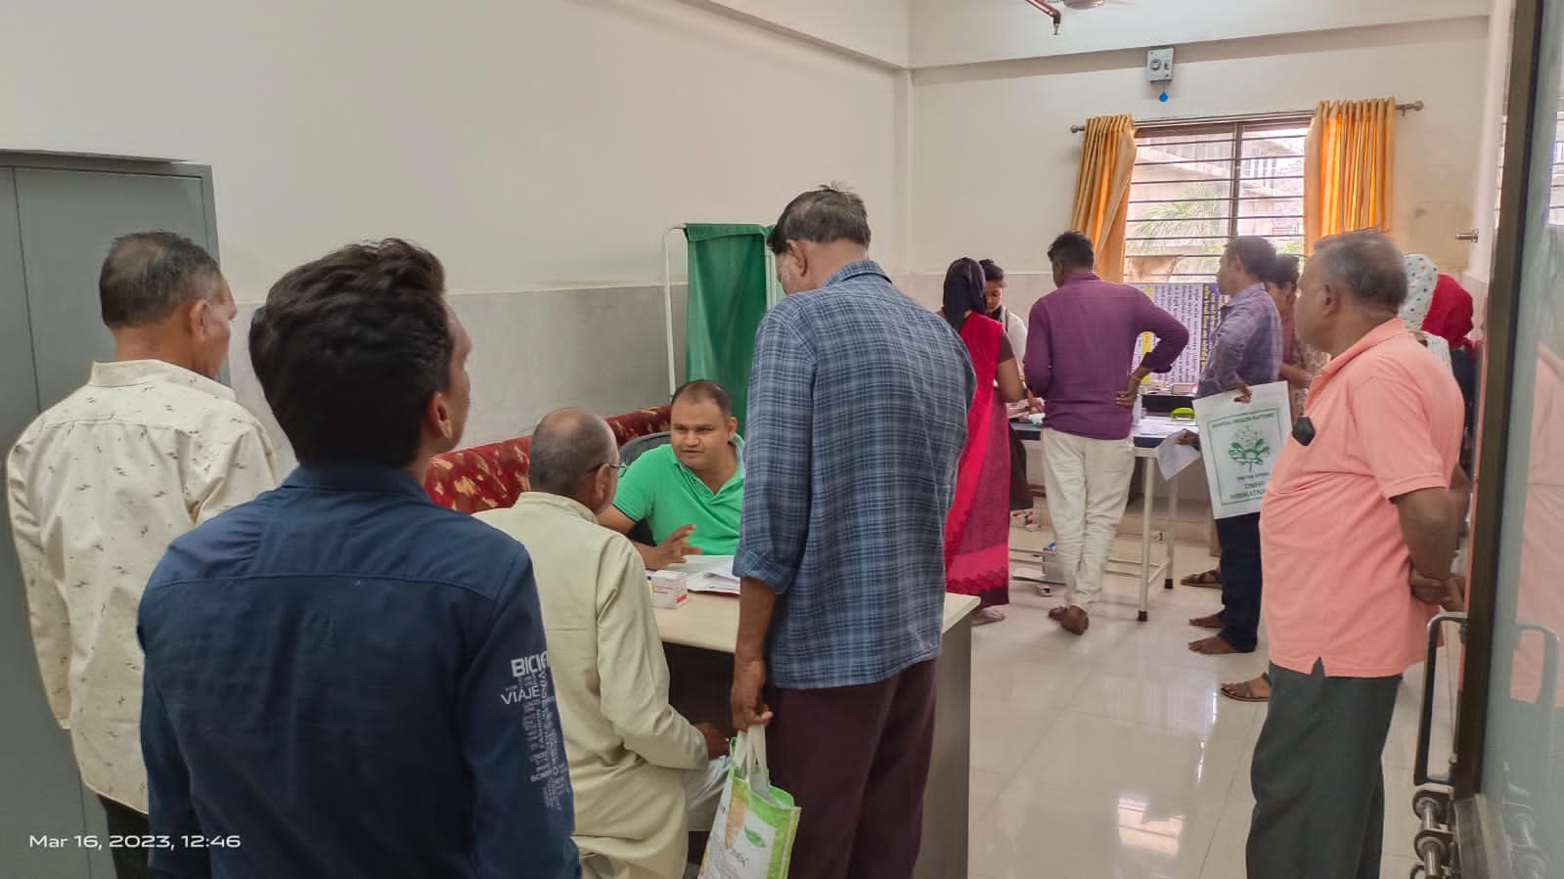
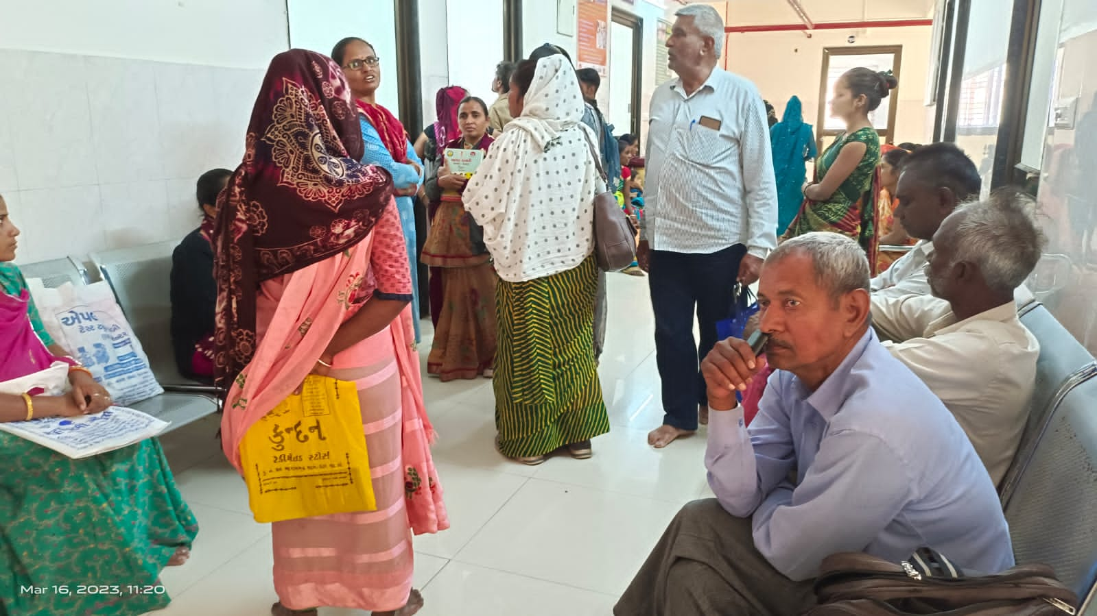

Date. 27/01/23 under (NMHP) Date. 10/02/23 under (NMHP)
Radosan Primary School,Dist. Palanpur Village: Margardshan at ITI Umta, Dist.Mehsana
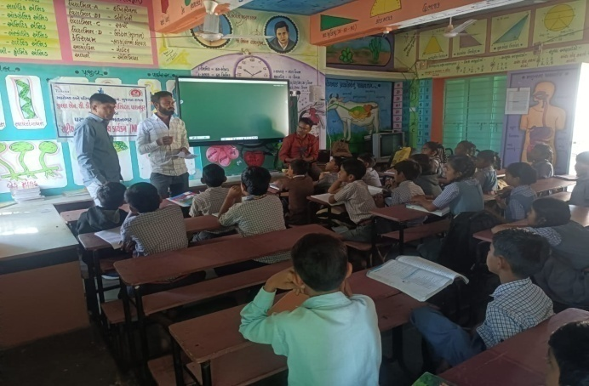
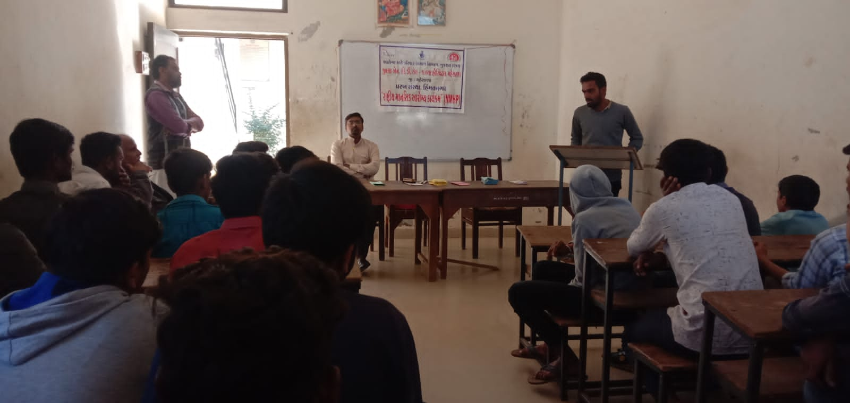

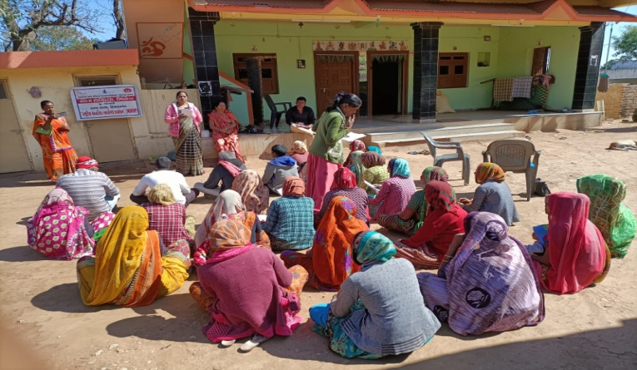

Date. 01/02/23 under (NMHP)
Village:-Mota Kantharia,
Dist. Aravalli

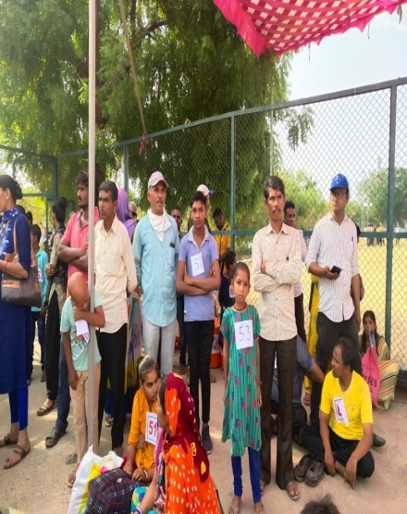
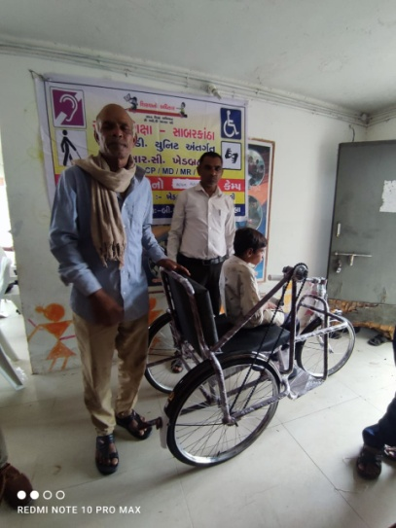
(9) Integrated Education Scheme,
Rashtriy Madhyamic shiksha Abhiyan
(SSA)(IEDSS) Gandhinagar

Integrated education means the children
bearing various types of disabilities can
educate themselves staying with their families
and studying in the general school of the
village of their on area

S.N. | Years | Facility Grant
1 | 2021-22 | 121
2 | 2021-22 | 121
3 | 2022-23 | 093
The benefits out of the allotted assistance to the handicapped children
To make survey to primary school to secondary and Higher Secondary School (1 to 12)
To Provide Medical Certificate to Disabled Children of their categories.
To Give Admission in his nearest School (Primary/Secondary/higher Secondary)
To give benefit by Govt Schemes to every disabled.
- The physically handicapped child can acquire education with the help of tricycle, callipers, crutches properly and effectively .Apart from it children can deal with other children of their own area amicably
- The help of M.R. Educational kit enhances the interest of learning among the children. The pragmatic training received by the children and the knowledge obtained thereby facilitate the children to achieve mental and physical development through effective expression. The help of hearing aid and educational kit develop in the hearing- impaired child the hearing capacity. The hearing impaired child bails out of the inferiority complex of deafness by getting acquainted with the sounds of the surroundings and developing concepts with the average children with the help of hearing-aid
(10) Baxipanch Kumar Chhatralay:
The Parakh institution has got grant in aid Baxi Panch Kumar Chhatralay from 1998 Through the social welfare, Department . Under which, in the year 2022 – 2023 50 students were given the facilities of lodging and boarding free of charge.The student living in the hostel are studying in the schools suitable to them. The hildren are being given educational articles as per their requirements. Over and above, planning for tours and picnics are also being arranged.

(11) Education Health and Population awareness programme

with the co-operation the prohibition and excise Department, the institution is in active working movement of the various programmes of freedom of addiction on the day of Gandhi Jayanti. The Parakh institution is doing many activities for social Health and for formation of awaiking society during the year in which includes freedom bringing out of addictrion campaigin save female child campaign programme for awareness regarding Aids, Girls Education Career,Employment Guidance Protection pollution.
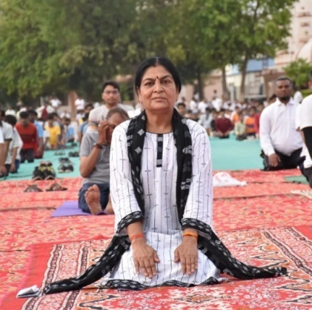
Remaining constantly active for eradicatio campaign,shibir of legal knowledge,consumer protection campaign through shibirs,meetings,ralley,pamphlets distribution etc.Duriong the year 2022-2023 , the activities as under were done.
No. | Details of programme | No. of Programme | Beneficiaries
1 | Leaving up of addiction | 01 | 075
2 | Environment Programme | 01 | 135
3 | Yoga day | 01 | 050
4 | Guide lines for career & employment | 02 | 300
5 | Pollution protection | 04 | 170
6 | Pre-knowledge of legal | 12 | 540

(12) The Parakh Institution has got approval as of consumer
Customer protection Mandal from the year 2005.Under this the institution is giving programmers of awareness programmers are beings arranged for bringing transparency. In the matters that the customer may not be cheated for the quality of goods mark for values of ,goods for weight and measurements etc. Taking complaints from the customers proper actions are being taken for its disposal. In the year 2022-23, the activities as shown below where taken on hand .
No | Date | Place | Number of Participate | Details programmes
1 | 19/12/2022 | Moti Demai | 035 | Shibir
2 | 20/12/2022 | Ambavadi Pr School | 110 | Rally
3 | 21/12/2022 | Sundragath | 030 | Seminar
4 | 22/12/2022 | Aadarsh Highschool | 110 | Kviz/Spardha
5 | 23/12/2022 | Rampura | 045 | Shibir
6 | 24/12/2022 | Balochpura | 095 | Seminar
7 | 25/12/2022 | Jamla Highschool | --- | Patrika Distribute
During the year total 94 programmers were arranged alike shippers, seminars, workshop, visual, meetings, Exhibition. – 15 Over and above this 53 complaints received from the customer -6140 .Pamphlates-8500 were distributed regarding awareness And celebration of 24, December. The number of programmers as unde
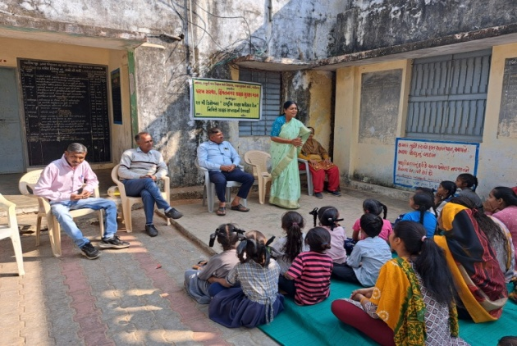
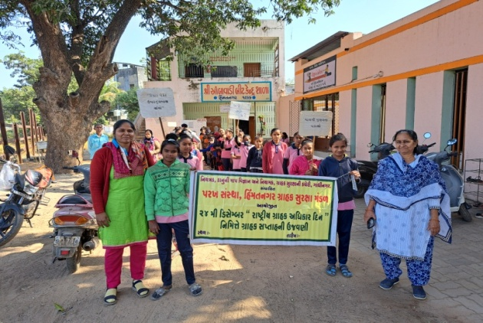

Celebration 15th March 2023 as customer rights Days for number of programmes as under:

No | Date | Place | Number of Participate | Details programmes
1 | 13/3/2023 | Gamadi | 25 | Shibir
2 | 14/3/2023 | Karanpur | 30 | Shibir
3 | 15/3/2023 | Gromor School Berana | 110 | Seminar
4 | 16/3/2023 | Rupal Hai.School | 70 | Rally
5 | 17/3/2023 | Aangiyol | 55 | Shibir
6 | 18/3/2023 | Sadha | 20 | Shibir
7 | 19/3/2023 | Bhavpur | --- | Patrika Distribute
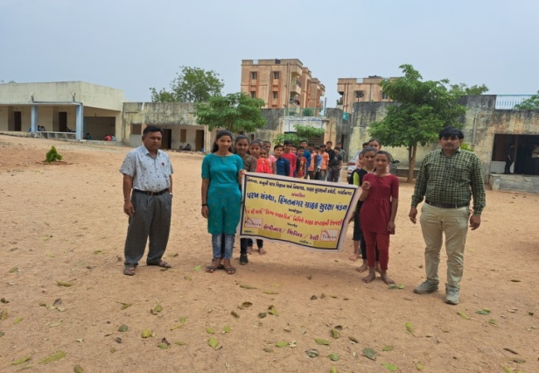
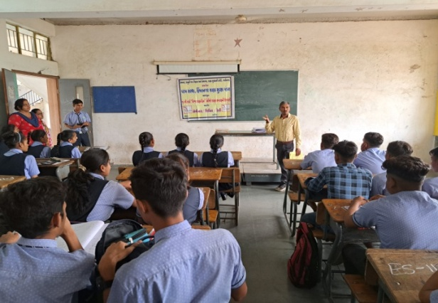

Details of Consumer Club
The Beginning of the Consumer Club for the purpose of young generation involve in this awareness programme of customer awareness for the whole state secondary School The 51 and college - 07 Consumer club allots to Parakh Trust in Sabarkantha and Arvlli district.

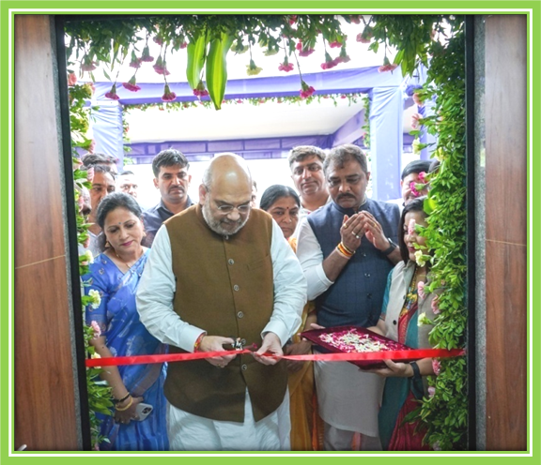
New building at
One Stop Center Gandhinagar
inaugurated by
Hon'ble Union Home Minister
Amitbhai Shah and
Minister for Women and
Children Manishaben Vakil

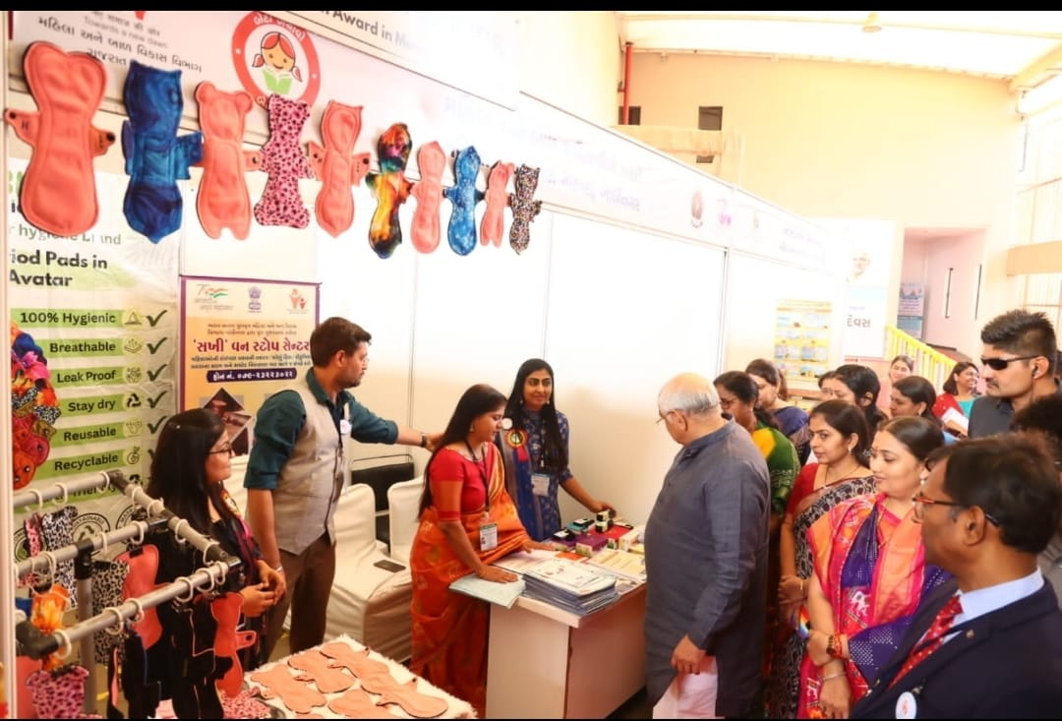

International Women's Day was
celebrated on 5/3/22 under which
stalled by Department of Women
and Child Development Hon.Chief
Minister Shri Bhupendrabhai Patel
Through CA o f OSC Gandhinagar
giving information about every
scheme of OSC and department

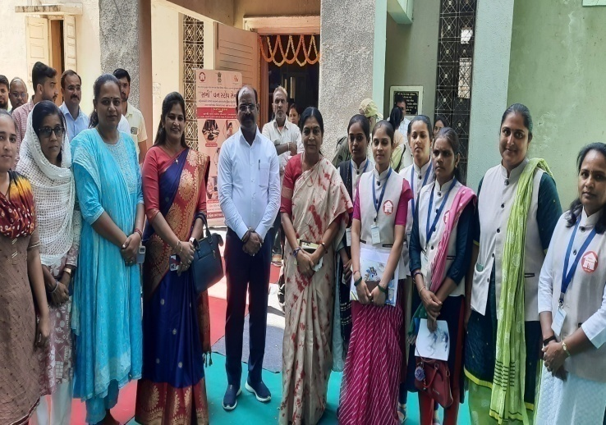

Hon'ble Minister of State
Shri Pradipbhai Parmar
and Municipal President Modasa
Organization Kausalyakunvarba and
OSC Staff Arvalli

