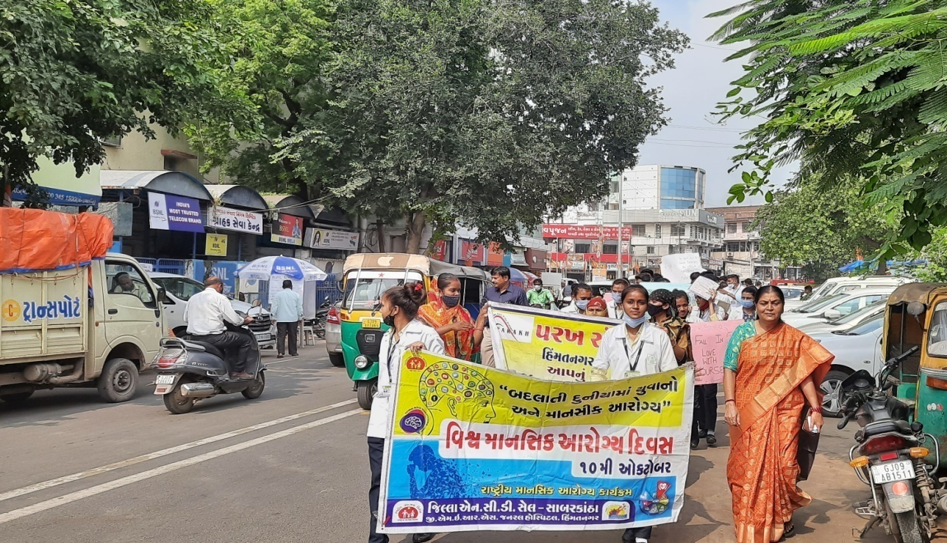
2021-22
PARAKH TRUST Ambawadi, Bar Bangla, Ta.Himathanagar,Dist.Sabarkantha Phon No.(02772)247941 Emil Id: parakhtrust@gmail.com

PARAKH TRSUT ANNUAL REPORT

Introduction

Parakh Trust was established in 29th January 1994 with the aim of social development
(unlistment ). It has been able to get expected result by doing development activities in different
economic, social and education consistently. So make this dream come true , all the people
involved with this organization including trustee ,Secretary and the president as well as workers
have immense work . In order to do good of common person . The Trust has in collaboration
with the government participated in various government scheme . At the same time the trust it
self he organized training program and workshop to train the people so that they can be self
reliant and do their activity them selves . the organization has spread it wing with interior areas
state and tried to satisfy the desire of the people . invites in remote areas . It has tried it lead
best to give all kind of support and guidance to the common men so that He/she can not remain
behind in the first developing society all over the world .Government has also helped to trust in
makes people aware about different program . The Trust has been primarily in active against the
program for women Atrocity save girl child campaign preventing killing of girl baby from taking
birth abortion of women violence against women etc. the trust has participated actively in the
government sponsored programmes like kanya Kelvin ,women empowerment ,Krishi Ruth etc.
The helping the Government to spared the awareness among people . The trust has also helped
women of different section by providing loans from the bank .

Network of the organization

The Parakh Trust is working all over the Gujarat state. However it has done must of it activities in
Sabarkantha , Arvalli , Amreli, junadh , Jamnagar, Porbandar, Ahemadvad , Patan ,chotaudepur
Dahod,Panchmahal , Gandinagar , Banaskantha and Kutch district etc.

  - Detailed Activities of Trust

(1) District multipurpose woman welfare centre , Himmatnagar
The trust is running this centre in the 09th Taluka of Sabarkantha district This centre is sponsored by the commissioner women and child development Gandhinar under this programme women has provided guidance on legal aid social health , employment and career development Main Activities of this centre – legal aid in collaboration with

Work done
S.No | Work done | Beneficiares
1 | Govt. scheme | 112
2 | Legal Aid | 089
3 | Oriented Employment (Rojagar) | 104
4 | others | 439
5 | Samajik | 1733
 | Total | 2477

Work done under different Govt. scheme

S.No | Govt.Sceme | Beneficiares
1 | Widow-help | 28
2 | Old-age help | 10
3 | Neradhay vrudh sahay | 13
4 | Medical Aid | 00
5 | National Family Sahay | 01
6 | Women’s Self-Reliance | 12
7 | Sant surdas | 00
8 | Kunvarbainu mamerau yojana | 07
9 | Human Dignity | 00
10 | Palk Mata-Pita | 04
11 | Valhi Dicer Yojana | 37
12 | Pandit Dindyal aavas yojana | 00
 | Total | 112
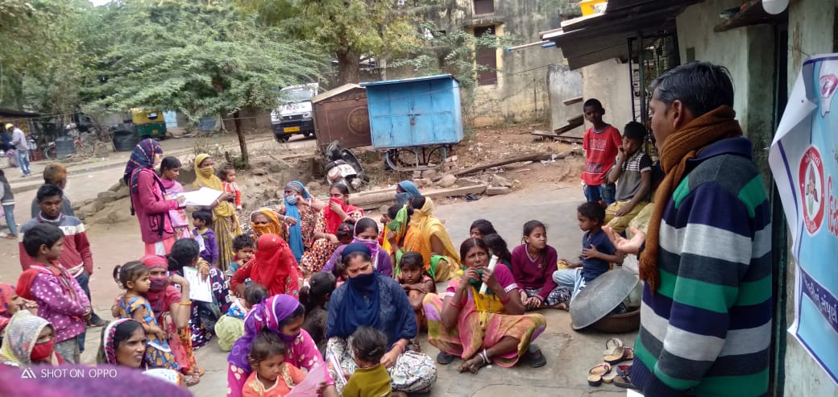
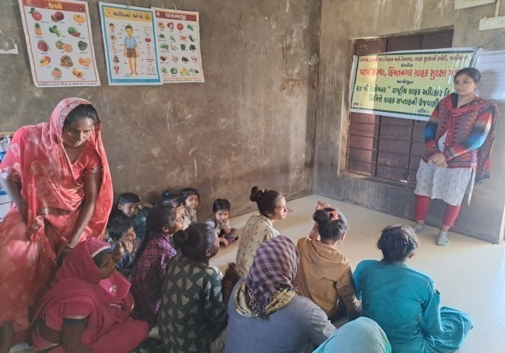
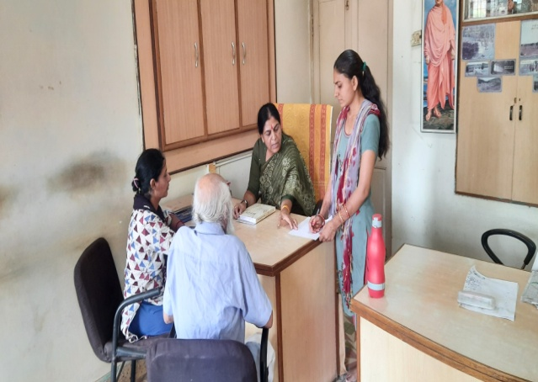

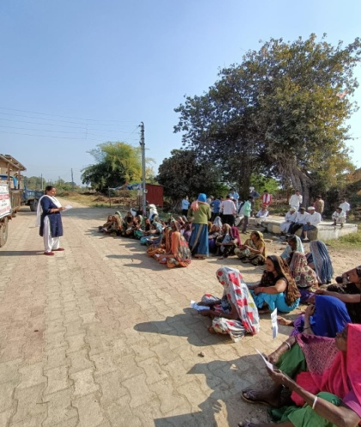
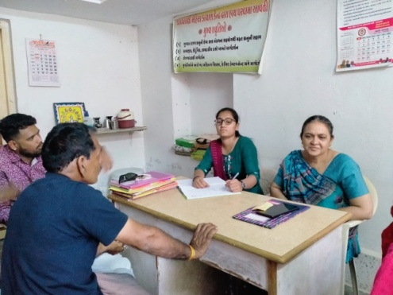
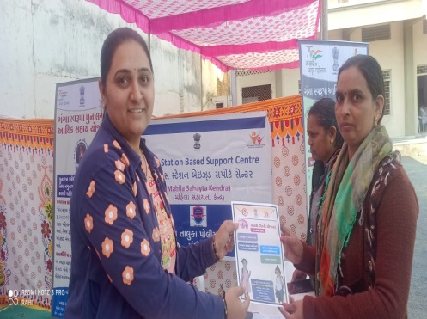

S.No | Work done | Beneficiares
1 | Govt. scheme | 108
2 | Legal Aid | 221
3 | Employment oriented | 308
4 | others | 174
5 | Samajik | 1829
 | Total | 2640
(2) Vividhlakshi Mahila Kalyan Kendra, Talod,
Under this programme women of different sections are provided with guidance, training and made aware about different subject like self-help group saving and team spirit, health aware newsstand presently development.
Since August 2006,the trust has three this centre provided information in to 96 village out of total 103 village the details is as under.

(3) Vividhlakshi Mahila Kalyan Kendra ,Bhilod Workdone
S.No | Work done | Beneficiares
1 | Govt. scheme | 123
2 | Legal Aid | 060
3 | Employment oriented | 200
4 | Others | 114
5 | Samajik | 2215
 | Total | 2712
Under this programme women of different sections are
provided with guidance, training and made aware about
different subject like self – hel group saving and team
spirit, health awareness and presently development.
Since March 2009,the trust has three this centre
provided information in to 88 village out of total 94 village thedetails is as under.

S.No | Work done | Beneficiares
1 | Govt. scheme | 200
2 | Legal Aid | 416
3 | Employment oriented | 047
4 | Others | 538
5 | Samajik | 2868
 | Total | 4069
(4) Vividhlakshi Mahila Kalyan Kendra , Dahegam, Work done

Under this programme women of different sections
are provided with guidance ,training and made aware
about different subject like self-help group saving and
team spirit ,health awareness and presently development.
Since March 2009,the trust has three this centre
provided information in to 104 village out of total 92 village
the details is as under.
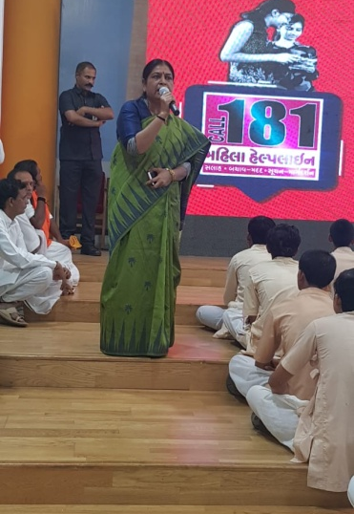
(5) Beti-Bachao Abhiyan and Kanya-Kelvan
To create awareness among the people by arranging the meetings, camps
and conferences at the village,taluka and district level and bringing this cause to the
limelight. When this natural balance has been disrupted and disturbed, Parakh
has made the sincere and sustained endeavor in focusing among the people on the
possible disastrous fallout of the imbalanced sex –ratio and contributed substantially.
Under Kanya Kelvani, Parakh actively participated in the Shala Praveshotsav
and Kanya kelvani rath yatra. During 2003 at the shala Praveshotsav of Arjanpura
in Himatnaga r taluka Pinkal was given rs.1000 of vidya laxmi bond on the spot by
the secretary of Parakh for which 5 students of the primary school had been nominated.
Besides this, in presence of state project director Mr. Sharma Parakh adopted a cuddly
little flower like daughter Pinkal.Presently Parakh provides the study materials and
uniform to Pinkal.Parakh has accepted the responsibility of higher education of Pinkal

(6) “One Stop Cente r (OSC)” Aravalli & Gandhinagar
The Ministry of Women and Child Development will provide support to the State Governments As well as the office of women and child officer ,Arvalli & Gandhinagar
The objectives of the Scheme are: (i) To provide integrated support and assistance to women affected by violence, both in private and public spaces under one roof. (ii) To facilitate immediate, emergency and non-emergency access to a range of services including medical, legal, psychological and counselling support under one roof to fight against any forms of violence against women.
OSC Arvalli Case type Details
S. No | Year | Case Details
S. No | Year | Domestic Violence | Rape | Missing | Sexual Harresment | Others | Total
1 | November-19 to March-2020 | 18 | 02 | 02 | 01 | 00 | 23
2 | April -2020 to March-2021 | 57 | 01 | 27 | 01 | 01 | 87
3 | April -2021 to March-2022 | 79 | 00 | 19 | 00 | 02 | 100
 | Total | 154 | 03 | 48 | 02 | 03 | 210
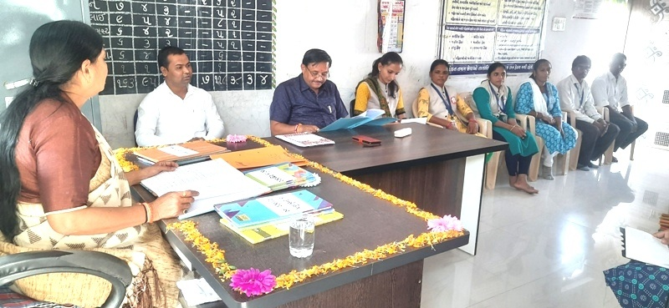
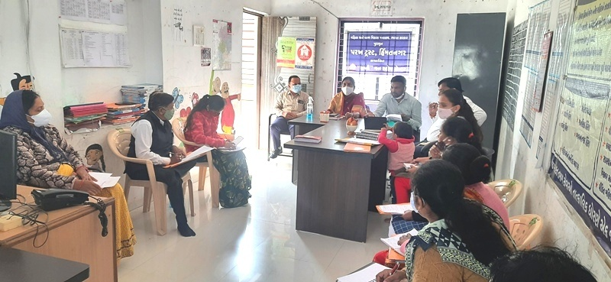

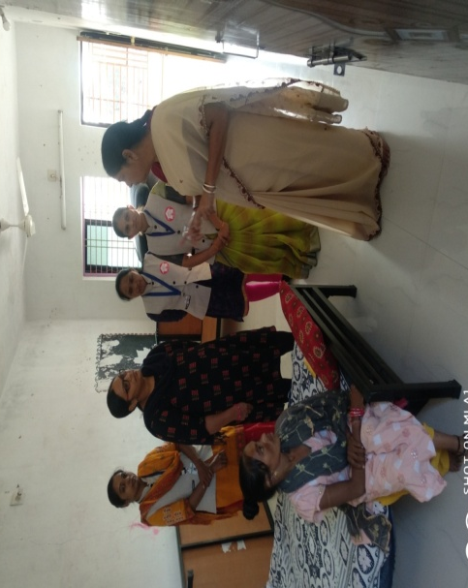

Success Story
1. Name: Bharavad Bhuriben Vishnubhai
2. Age: 35
3. Address: At: Hellodar Ta: Malpur,
Dist: Aravalli
4. State: Gujarat

On 12/10/2021, a woman referred by 181 Women Helpline
affected by domestic violence has beengiven shelter at
Sakhi One Stop Center, Aravalli, run by Parakh Trust.
During the2 years of their marriage, She had a son who gone a death after birth due to hisdeath their in-laws started physically and mentally torture to her. On 12/10/2021,she left home and reached at Malpur after being harassed by her husband and herfather-in-law came to search for her in Malpur. For her self-defense she call 181Women Helpline and Team 181 brought her to the Sakhi One Stop Center andsheltered here.She was given 7 days shelter Sakhi One Stop Center. And she,who underwent medical checkup, underwent necessary treatment and wasinformed, is 2 months pregnant. She has been rehabilitated after counseling her husband and in-laws.

OSC Gandhinagar Case type Details
Year | Case Details
Year | Domestic Violence | Rape | Missing | Sexual Harresment | Others | Total
January-2020 to March-2020 | 15 | 01 | 02 | 00 | 00 | 18
April -2020 to March-2021 | 82 | 12 | 17 | 00 | 06 | 117
April -2021 to March-2022 | 95 | 10 | 21 | 01 | 07 | 134
Total | 192 | 23 | 40 | 01 | 13 | 269

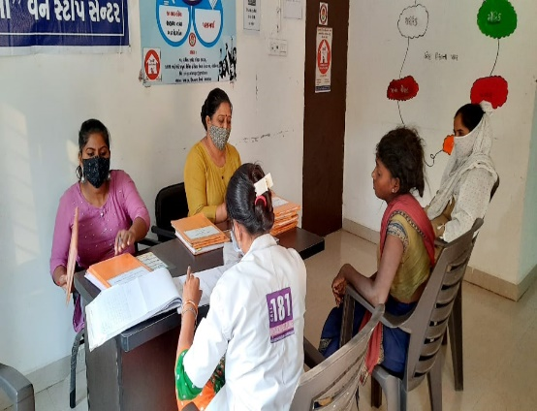
Success Story of OSC Gandhinagar
Story: 1
1) Name: Artiben Chiragkumar Carpenter
2) Age: 25
3) District: Gandhinagar
4) State : Gujarat

Preliminary information of the case
Artiben Suthar Asar got married 9 months ago of his own free will through a love relationship without the permission of his parents and with the permission of his in-laws. As Artiben's husband and mother-in-law were mentally and physically torturing her, she was spending her time doing private jobs. As the mother-in-law and husband refused to work, Artiben asked them to continue working, so the husband and mother-in-law left the house without a ticket as they were physically injured. Artiben sought help from both parties to make a compromise.
Artiben was given shelter for 2 days at Sakhi One Stop Center Gandhinagar and was given medical treatment. With the guidance and help of Parakh Trust Himmatnagar, the organization managing Sakhi One Stop Center Gandhinagar, the families of both sides of Artiben were called to the center for counseling and amicable settlement was made and they were consulted to get a job. Thank you to the staff and managing officials of Artiben Sakhi One Stop Center.
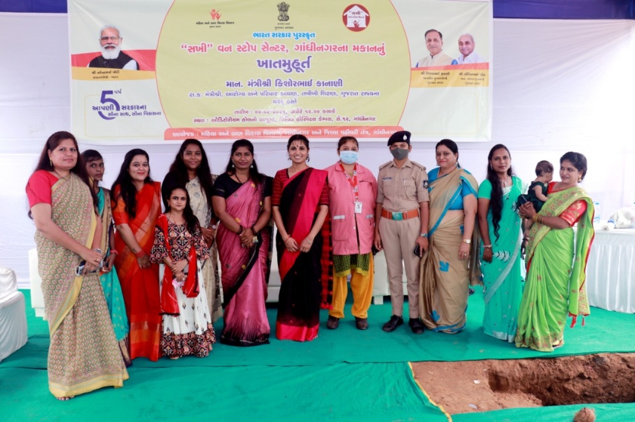
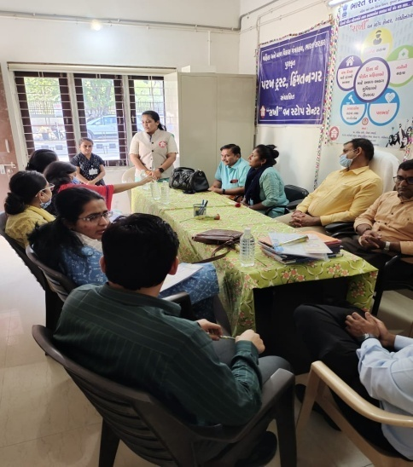

- Childline Arvalli -1098
The Department of women and child ,New Dellhi and Child line India Foundation, Mumbai has appointed by Parakh Trust for Arvalli Dist under which CHILDLINE 1098 is a phone number that spells hope for millions of children across India. It is a 24-hour a day, 365 days a year, free, emergency phone service for children in need of aid and assistance. We not only respond to the emergency needs of children but also link them to relevant services for their long-term care and rehabilita

Grass roots level outreach with children and concerned adults:
previous year: April - 2021 to March -2022

Target Group | No. contacted | Nature of Outreach | Number of Programmes
PCO owners | 00 | 00 | 00
Railway station | 00 | 00 | 00
Bus stops | 30 | 25 | 07
Shelter children | 22 | 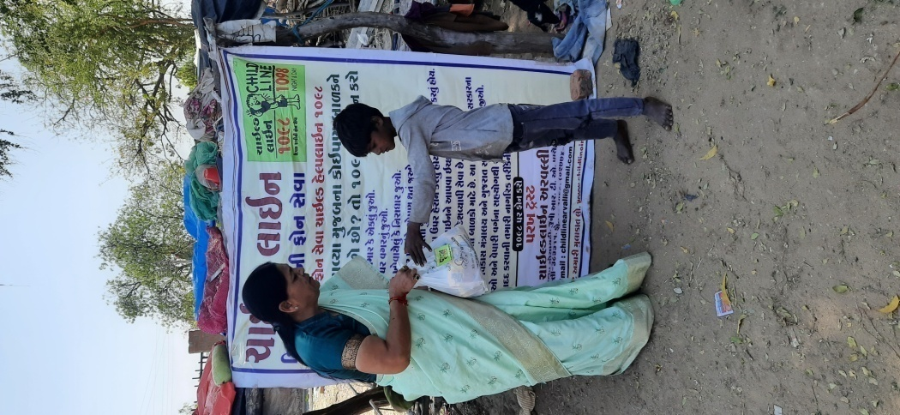  19 | 07
Cinema halls | 18 | 15 | 02
Parks | 15 | 14 | 12
Tourist places | 08 | 02 | 01
Religious places | 20 | 18 | 03
Schools | 30 | 32 | 08
Slums | 380 | 445 | 18
Others | 270 | 283 | 15
Total | 793 | 853 | 73

Details, if any, of innovations in CHILDLINE
Date | Area | Conduct Children | Adults
21-09-2021 | Bapunagar | 14 | 9
23-09-2021 | Kasba | 22 | 13
30-09-2021 | Ganeshpura | 30 | 14

Along with Aravalli Child Line team and Ganeshpura Anganwadi worker, organized nutrition month program in Bapunagar, Kasba, Ganeshpura Anganwadi. In this program, Children And his mother Anganwadi Worker was Participet. Child line Aravalli told the parents about the awakening of the mothers and about the nutritious food from Anganwadi. The Anganwadi worker gave information about new children's admissions and nutritional food. In today's program, children were given Sukhadi food from the Anganwadi. Child Line Aravalli distributed fruits to all the children and mothers
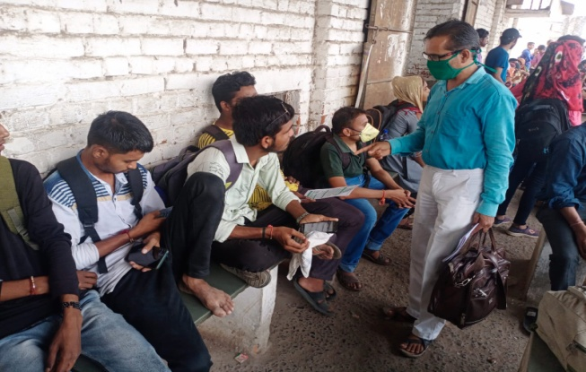
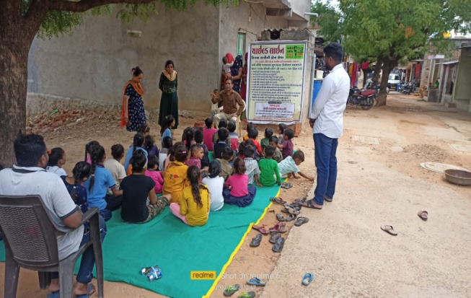

- Nation Mental Health Programme.
Performance of targeted interventions
Due to today's fast-paced life and competition, and in terms of jobs and business, we are taking the most damage to mental health, so taking care of mental health becomes very necessary. Government has started District Mental Health Program under National Mental Health Programme.
As per the approved PIP for the year: 2021-22 under the “National Mental Health Program” (NMHP) by the office of District NCD Cell, Sabarkantha,the institute has been asked to carry out targeted intervention activities in rural areas of Talod, Prantij, Himmatnagar and Idar taluks of Sabarkantha district. and Mahesana district all taluka and Government/Semi Government offices for various mental illnesses related to mental health in community sector in urban areas, Officials/employees of local Swaraj institutions, industrial units, public places and schools, colleges, milk societies, service cooperative societies and Asha workers and Anganwadi, Tedagar worker sisters, youths, youths have been assigned the task of imparting information about mental health.

Seminar organized at General Nursing School, Himmatnagar.

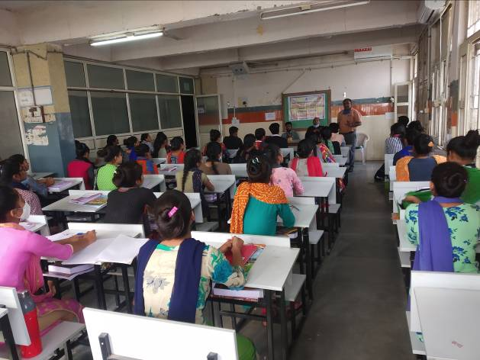
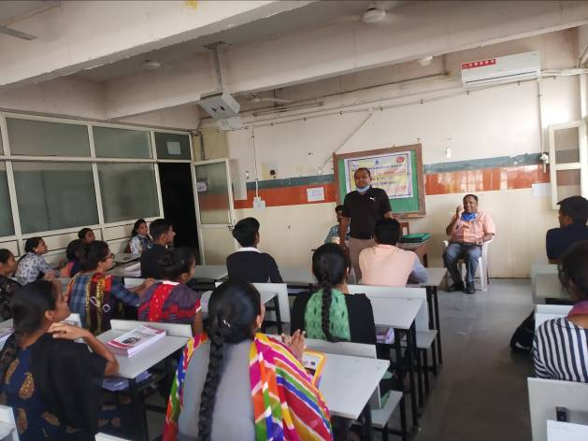

A meeting was organized at Deloli village of Mehsana taluka under the National Mental Health Program (NMHP). Dr. Alkesh Bhavsar Counselor Kishanbhai Sanstha President Sureshbhai Patel Village Sarpanch Shri Pravinbhai Patel was present.

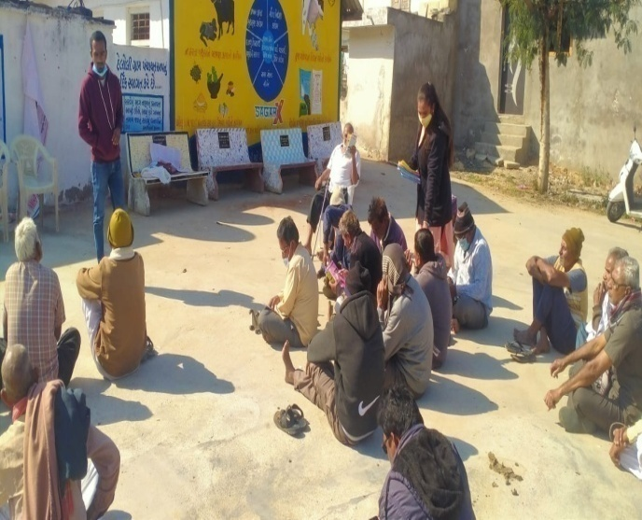
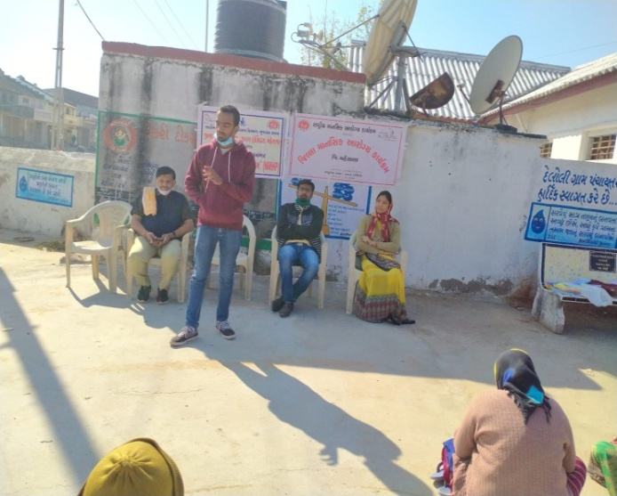

- Ministry of social Justice & Empowermen Department of Empowerment of persons with Disabilities, New Delhi
Awareness Generation and Publicity
Scheme for Persons with Disabilities under Street Plays
- To spread aweareness through street play in societyp
- To give wide publicity,including event based publicity etc..through electronic,print,film media,multimedia to the scheme,programmes.
- To create an elabing environment for social inclusion of the PWDs in all fields of life by providing equal opportunities,equality and social justice and to ensure confidence building in the PWDs sop that,they can realise their aspirations.
- To bring to the notice of all stake holders including PWDS and civil society about the legal rights of the PWDs as enshrined in the constitution PWDS Act-2016 and subordinate legislation.
- To promote awareness and to sensitize society with focus on remote and rural areas,on causes leading to disability and prevention through early detection. etc.
- To encourage volunteer action for ensuring effective implementation of the legal provision and welfare scheme meant for the PWDS.
- To develop content for rehabilitation of different types of disabilities.
- To provide awareness for support service.or to facilitate creation fo facilities conductive to the recreation of PWDs which may include deucative,medical religious tourism sports,etc.
- To promote activities for economic empowerment of PWDS like job fair.campaign,awarenesss on skill development etc.
- To support spreading awareness about universal accessibility by creating an enabling and barrier-free environment that include accessible buildings,accessible transport,accessible websites,and carrying out accessible audit.
- To promote relevantactivities ralating to creating awareness in the field of disability sector.

Disabilities under Street Plays,Sabarkanth dist Village

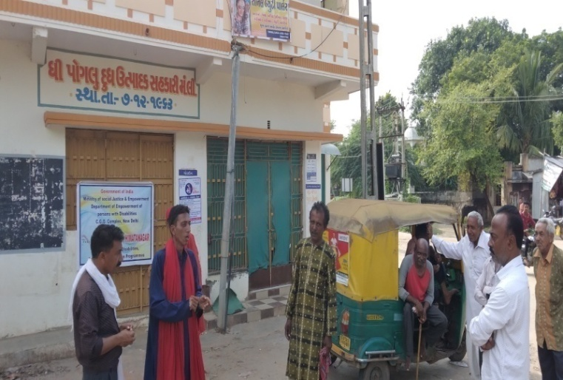

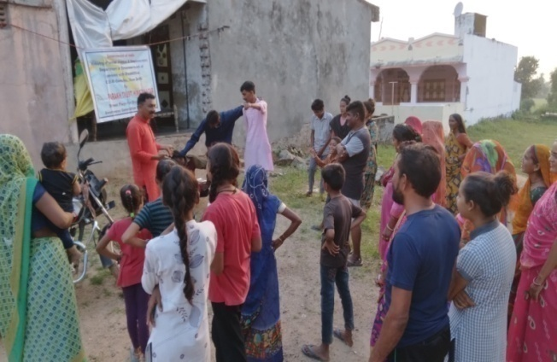
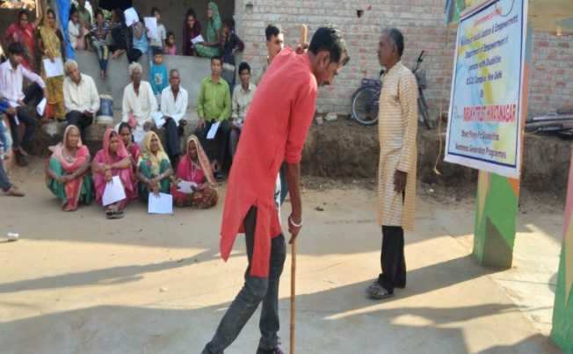

(10) Integrated Education Scheme,
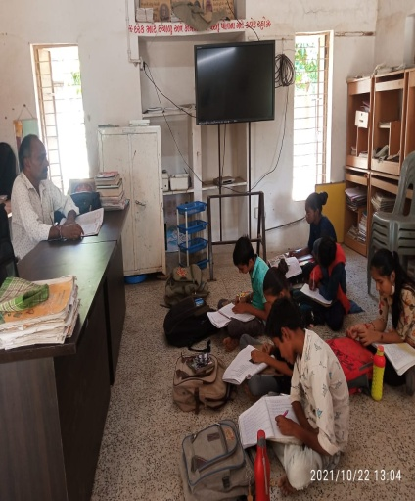
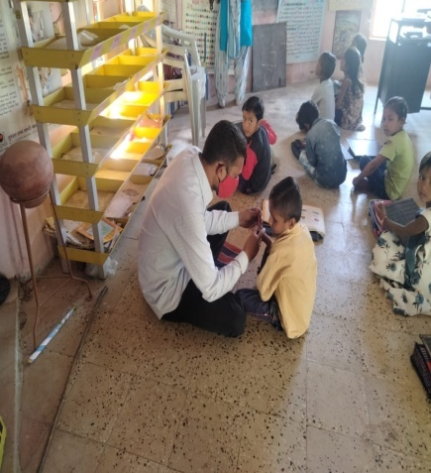
Rashtriy Madhyamic shiksha Abhiyan
(SSA)(IEDSS) Gandhinagar

Integrated education means the children
bearing various types of disabilities can
educate themselves staying with their families
and studying in the general school of the
village of their on area

S.N. | Years | Facility Grant
1 | 2019-20 | 035
2 | 2020-21 | 040
3 | 2021-22 | 121
The benefits out of the allotted assistance to the handicapped children
To make survey to primary school to secondary and Higher Secondary School (1 to 12)
To Provide Medical Certificate to Disabled Children of their categories.
To Give Admission in his nearest School (Primary/Secondary/higher Secondary)
To give benefit by Govt Schemes to every disabled.
- The physically handicapped child can acquire education with the help of tricycle, callipers, crutches properly and effectively .Apart from it children can deal with other children of their own area amicably
- The help of M.R. Educational kit enhances the interest of learning among the children. The pragmatic training received by the children and the knowledge obtained thereby facilitate the children to achieve mental and physical development through effective expression. The help of hearing aid and educational kit develop in the hearing- impaired child the hearing capacity. The hearing impaired child bails out of the inferiority complex of deafness by getting acquainted with the sounds of the surroundings and developing concepts with the average children with the help of hearing-aid
(9) Baxipanch Kumar Chhatralay:
The Parakh institution has got grant in aid Baxi Panch Kumar Chhatralay from 1998 Through the social welfare, Department . Under which, in the year 2021 – 2022 50 students were given the facilities of lodging and boarding free of charge.The student living in the hostel are studying in the schools suitable to them. The hildren are being given educational articles as per their requirements. Over and above, planning for tours and picnics are also being arranged.

(10) Education Health and Population awareness programme

with the co-operation the prohibition and excise Department, the institution is in active working movement of the various programmes of freedom of addiction on the day of Gandhi Jayanti. The Parakh institution is doing many activities for social Health and for formation of awaiking society during the year in which includes freedom bringing out of addictrion campaigin save female child campaign programme for awareness regarding Aids, Girls Education Career,Employment Guidance Protection pollution.
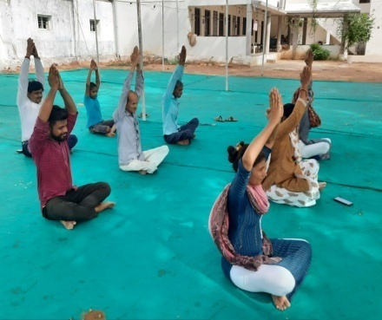
Remaining constantly active for eradicatio campaign,shibir of legal knowledge,consumer protection campaign through shibirs,meetings,ralley,pamphlets distribution etc.Duriong the year 2021-2022 , the activities as under were done.
No. | Details of programme | No. of Programme | Beneficiaries
1 | Leaving up of addiction | 01 | 085
2 | Environment Programme | 02 | 240
3 | Yoga day | 01 | 050
4 | Guide lines for career & employment | 02 | 700
5 | Pollution protection | 07 | 250
6 | Pre-knowledge of legal | 15 | 630

- The Parakh Institution has got approval as of consumer
Customer protection Mandal from the year 2005.Under this the institution is giving programmers of awareness programmers are beings arranged for bringing transparency. In the matters that the customer may not be cheated for the quality of goods mark for values of ,goods for weight and measurements etc. Taking complaints from the customers proper actions are being taken for its disposal. In the year 2021-22, the activities as shown below where taken on hand .
No | Date | Place | Number of Participate | Details programmes
1 | 21/12/2021 | Nikoda | 035 | Shibir
2 | 22/12/2021 | Parbada | 040 | Shibir
3 | 24/12/2021 | Pipalodi | 070 | Seminar
4 | 25/12/2021 | Balochpur | 030 | Shibir
5 | 26/12/2021 | Moti Demai | 045 | Shibir
6 | 27/12/2021 | Vagadi | --- | Patrika Distribute
7 | 28/12/2021 | Jamla Highschool | 200 | Rally
During the year total 94 programmers were arranged alike shippers, seminars, workshop, visual, meetings, Exhibition. – 18 Over and above this 51 complaints received from the customer -5970 .Pamphlates-8000 were distributed regarding awareness And celebration of 24, December. The number of programmers as unde

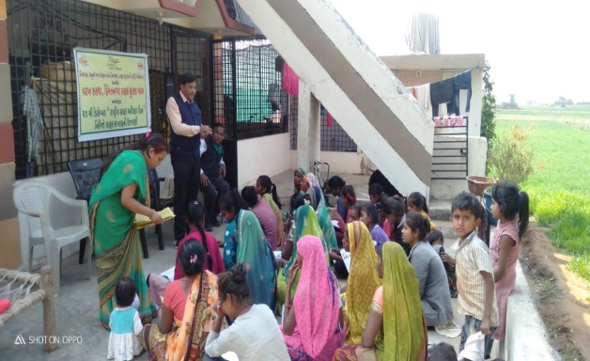
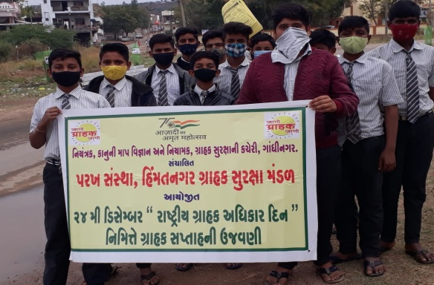

Celebration 15th March n2022 as customer rights Days for number of programmes as under:

No | Date | Place | Number of Participate | Details programmes
1 | 11/3/2021 | Kenpur | 25 | Shibir
2 | 12/3/2021 | Bhadaradi | 35 | Shibir
3 | 13/3/2021 | NavaBalavantpura Pra.School | 23 | Kviz/Spardha
4 | 14/3/2021 | Rajpur Pra.School | 180 | Rally
5 | 15/3/2021 | Roda | 45 | Seminar
6 | 16/3/2021 | Kodha Vasahat | 27 | Shibir
7 | 17/3/2021 | Amarapur | 20 | Patrika Distribute

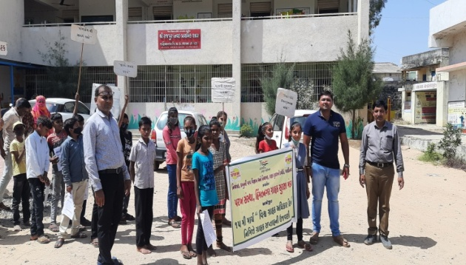
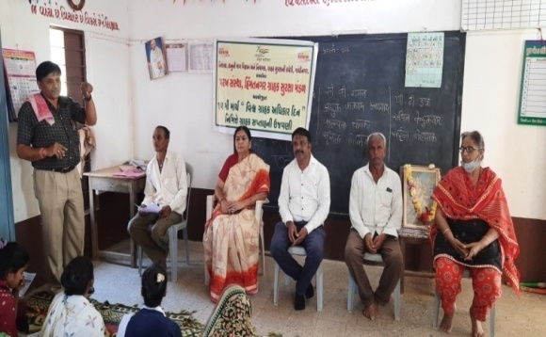

Details of Consumer Club
The Beginning of the Consumer Club for the purpose of young generation involve in this awareness programme of customer awareness for the whole state secondary School The 51 and college - 00 Consumer club allots to Parakh Trust in Sabarkantha and Arvlli district.

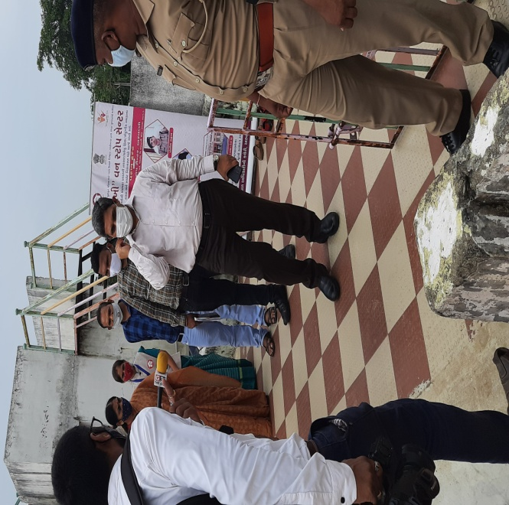

Collector Shri Aravalli on a greeting visit
to One Stop Center

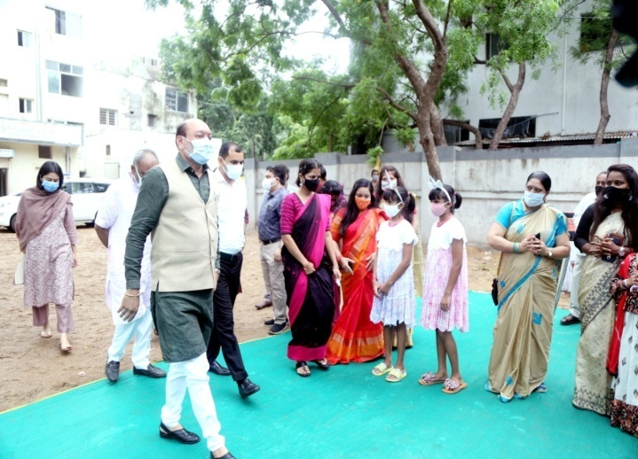

Hon'ble Minister Kishorebhai Kanani
at the inauguration of the new
building at One Stop Center Gandhinagar

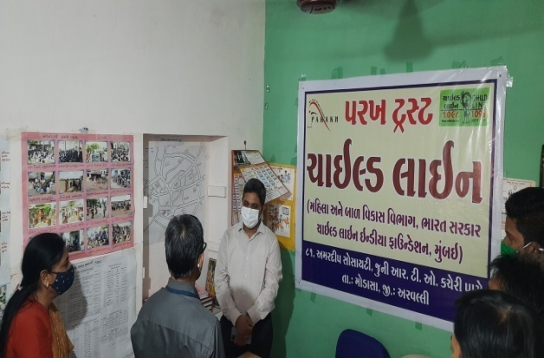

Collector visits Arvalli Childline

