PARAKH TRUST

ANNUAL REPOAT

YEAR - 2020-2021

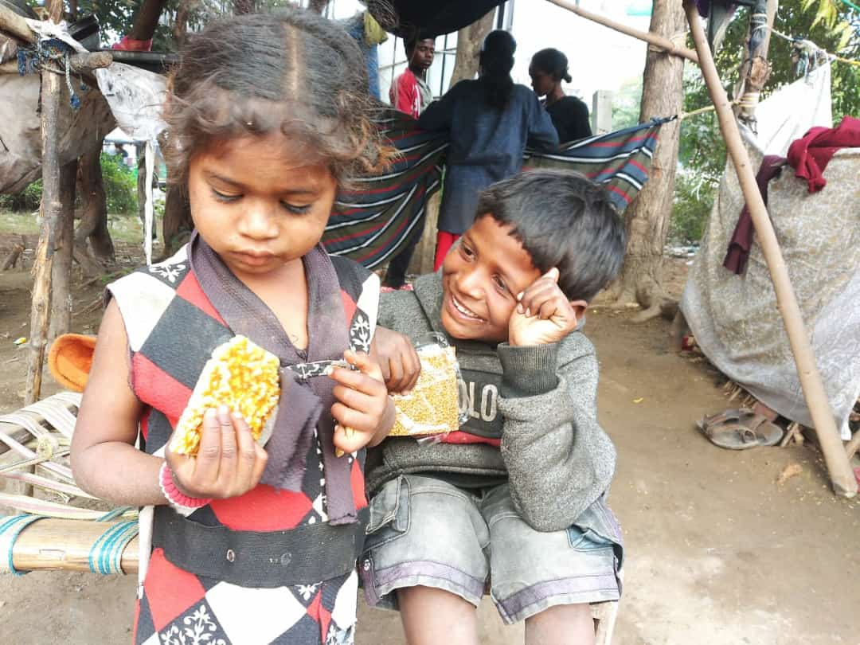

PARAKH TRUST
Ambawadi, Bar Bangla,
Ta.Himathanagar,Dist.Sabarkantha(Gujarat)

Phon No.(02772)247941

Introduction

Parakh Trust was established in 29th January 1994 with the aim of social development
(unlistment ). It has been able to get expected result by doing development activities in different
economic, social and education consistently. So make this dream come true , all the people
involved with this organization including trustee ,Secretary and the president as well as workers
have immense work . In order to do good of common person . The Trust has in collaboration
with the government participated in various government scheme . At the same time the trust it
self he organized training program and workshop to train the people so that they can be self
reliant and do their activity them selves . the organization has spread it wing with interior areas
state and tried to satisfy the desire of the people . invites in remote areas . It has tried it lead
best to give all kind of support and guidance to the common men so that He/she can not remain
behind in the first developing society all over the world .Government has also helped to trust in
makes people aware about different program . The Trust has been primarily in active against the
program for women Atrocity save girl child campaign preventing killing of girl baby from taking
birth abortion of women violence against women etc. the trust has participated actively in the
government sponsored programmes like kanya Kelvin ,women empowerment ,Krishi Ruth etc.
The helping the Government to spared the awareness among people . The trust has also helped
women of different section by providing loans from the bank .

Network of the organization

The Parakh Trust is working all over the Gujarat state. However it has done must of it activities in
Sabarkantha , Arvalli , Amreli, junadh , Jamnagar, Porbandar, Ahemadvad , Patan ,chotaudepur
Panchmahal , Gandinagar , Banaskantha and Kutch district etc.

  - Detailed Activities of Trust

(1) District multipurpose woman welfare centre , Himmatnagar
The trust is running this centre in the 09th Taluka of Sabarkantha district This centre is sponsored by the commissioner women and child development Gandhinar under this programme women has provided guidance on legal aid social health , employment and career development Main Activities of this centre – legal aid in collaboration with

Work done
S.No | Work done | Beneficiares
1 | Govt. scheme | 212
2 | Legal Aid | 055
3 | Oriented Employment (Rojagar) | 154
4 | others | 461
5 | Samajik | 1408
 | Total | 2290

Work done under different Govt. scheme

S.No | Govt.Sceme | Beneficiares
1 | Widow-help | 16
2 | Old-age help | 17
3 | Neradhay vrudh sahay | 08
4 | Medical Aid | 00
5 | National Family Sahay | 00
6 | Women’s Self-Reliance | 11
7 | Sant surdas | 02
8 | Kunvarbainu mamerau yojana | 09
9 | Human Dignity | 01
10 | Palk Mata-Pita | 00
11 | Valhi Dicer Yojana | 30
12 | Pandit Dindyal aavas yojana | 00
 | Total | 94
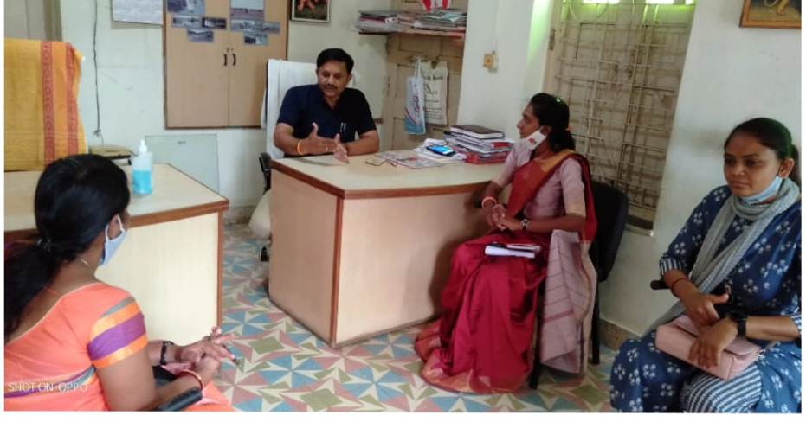
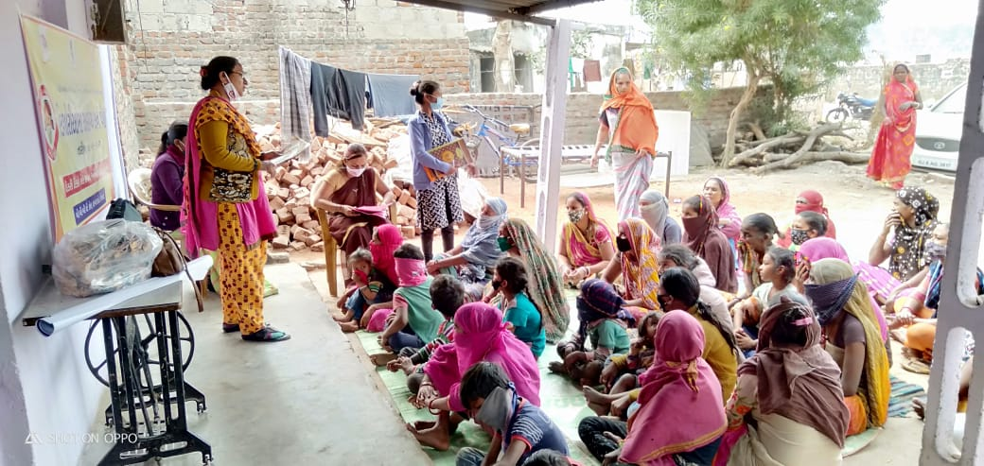
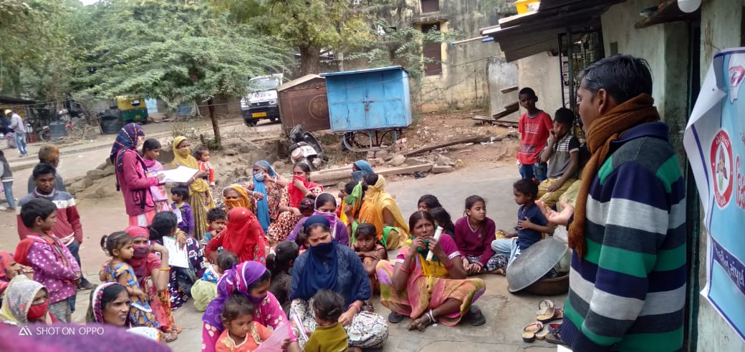

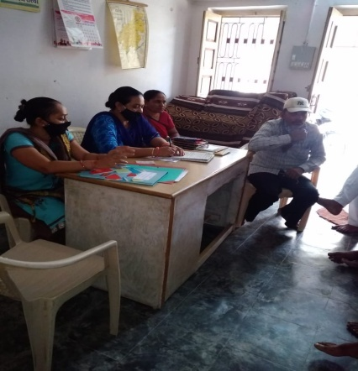
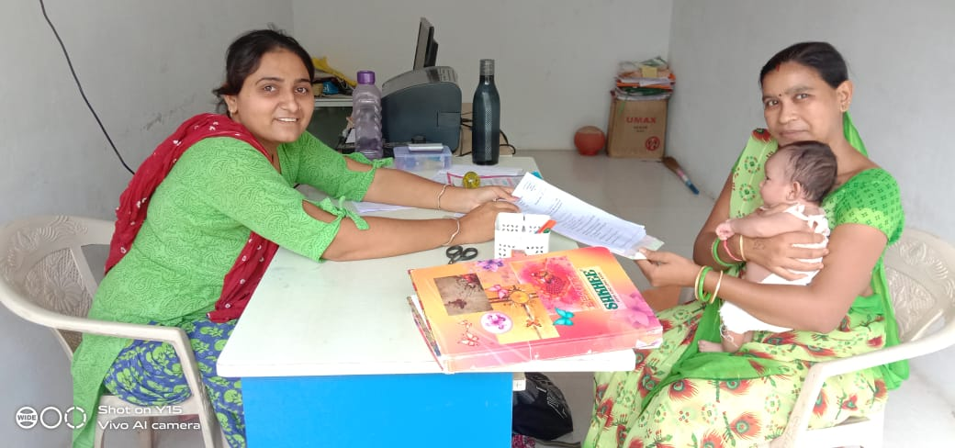
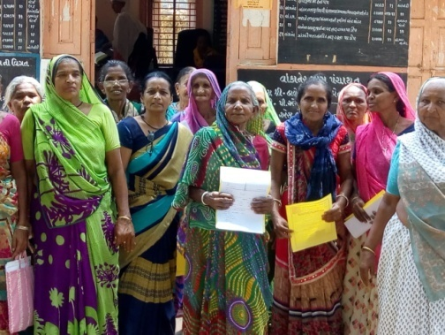

work done
S.No | Work done | Beneficiares
1 | Govt. scheme | 063
2 | Legal Aid | 013
3 | Employment oriented | 063
4 | others | 082
5 | Samajik | 1302
 | Total | 1523
(2) Vividhlakshi Mahila Kalyan Kendra, Talod,
Under this programme women of different sections are provided with guidance, training and made aware about different subject like self-help group saving and team spirit, health aware newsstand presently development.
Since August 2006,the trust has three this centre provided information in to 91 village out of total 96 village the details is as under.

(3) Vividhlakshi Mahila Kalyan Kendra ,Bhilod Workdone
S.No | Work done | Beneficiares
1 | Govt. scheme | 025
2 | Legal Aid | 030
3 | Employment oriented | 959
4 | Others | 1580
5 | Samajik | 336
 | Total | 2930
Under this programme women of different sections are
provided with guidance, training and made aware about
different subject like self – hel group saving and team
spirit, health awareness and presently development.
Since March 2009,the trust has three this centre
provided information in to 84 village out of total 90 village thedetails is as under.

S.No | Work done | Beneficiares
1 | Govt. scheme | 037
2 | Legal Aid | 245
3 | Employment oriented | 037
4 | Others | 498
5 | Samajik | 1702
 | Total | 2519
(4) Vividhlakshi Mahila Kalyan Kendra , Dahegam, Work done

Under this programme women of different sections
are provided with guidance ,training and made aware
about different subject like self-help group saving and
team spirit ,health awareness and presently development.
Since March 2009,the trust has three this centre
provided information in to 97 village out of total 87 village
the details is as under.
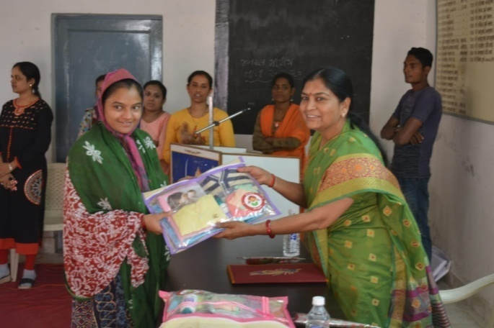
(5) Beti-Bachao Abhiyan and Kanya-Kelvan
To create awareness among the people by arranging the meetings, camps
and conferences at the village,taluka and district level and bringing this cause to the
limelight. When this natural balance has been disrupted and disturbed, Parakh
has made the sincere and sustained endeavor in focusing among the people on the
possible disastrous fallout of the imbalanced sex –ratio and contributed substantially.
Under Kanya Kelvani, Parakh actively participated in the Shala Praveshotsav
and Kanya kelvani rath yatra. During 2003 at the shala Praveshotsav of Arjanpura
in Himatnaga r taluka Pinkal was given rs.1000 of vidya laxmi bond on the spot by
the secretary of Parakh for which 5 students of the primary school had been nominated.
Besides this, in presence of state project director Mr. Sharma Parakh adopted a cuddly
little flower like daughter Pinkal.Presently Parakh provides the study materials and
uniform to Pinkal.Parakh has accepted the responsibility of higher education of Pinkal

(6) “One Stop Cente r (OSC)” Aravalli & Gandhinagar
The Ministry of Women and Child Development will provide support to the State Governments As well as the office of women and child officer ,Arvalli & Gandhinagar
The objectives of the Scheme are: (i) To provide integrated support and assistance to women affected by violence, both in private and public spaces under one roof. (ii) To facilitate immediate, emergency and non-emergency access to a range of services including medical, legal, psychological and counselling support under one roof to fight against any forms of violence against women.
OSC Arvalli Case type Details
S. No | Month | Case Details
S. No | Month | Domestic Violence | Rape | Missing | Sexual Harresment | Others | Total
1 | April-2020 | 02 | 00 | 00 | 00 | 00 | 02
2 | May-2020 | 02 | 00 | 02 | 00 | 00 | 04
3 | June-2020 | 04 | 00 | 00 | 00 | 01 | 05
4 | July-2020 | 08 | 01 | 01 | 00 | 00 | 10
5 | Aug-2020 | 02 | 00 | 01 | 00 | 00 | 03
6 | Sep-2020 | 05 | 00 | 02 | 00 | 01 | 08
7 | Oct-2020 | 04 | 00 | 04 | 00 | 00 | 08
8 | November-2020 | 09 | 00 | 01 | 00 | 00 | 10
9 | December-2020 | 06 | 00 | 02 | 00 | 00 | 08
10 | January-2021 | 03 | 00 | 02 | 00 | 00 | 05
11 | February-2021 | 06 | 00 | 06 | 01 | 00 | 13
12 | March-2021 | 06 | 00 | 04 | 00 | 00 | 10
 | Total | 57 | 01 | 25 | 01 | 02 | 86
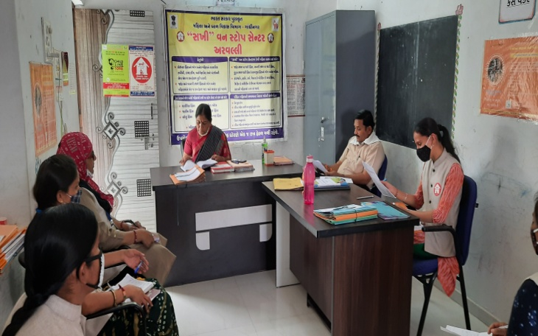
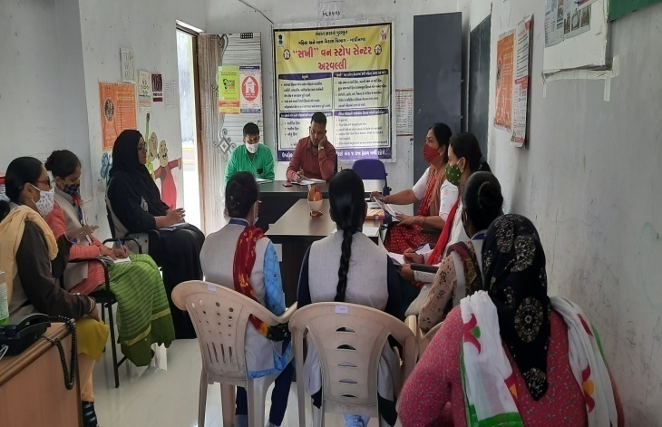

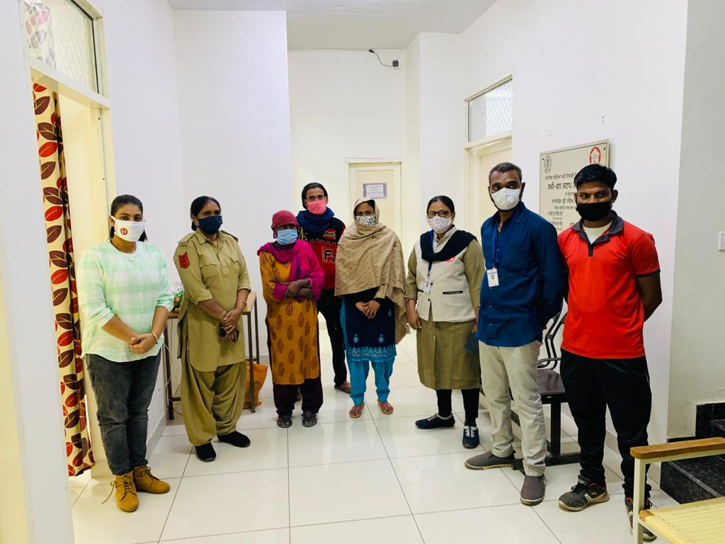
Story: 1

1. Name: Savarna BalveerSingh Bharad
2. Age: 48
3. District: Jalandhar, Adampur
4. State: Punjab

On 11/10/2020, a mentally weak woman
referred by 181 Women's Helpline was
given shelter at "Sakhi" One Stop Centre,
Aravalli run by Parakh Trust, Himmatnagar.
With the coordination of all the staff and by medical treatment she was interrogated and told that she is from Adampur in Jalandhar district of Punjab. As per information given by Savarna we contacted the "Sakhi" One Stop Centre Jalandhar, They explored all the information about Savarna and find her family. With the help of Jalandhar OSC, we made a video call with his family and they were reported she have been out of the house for 6 months in lockdown but they
Could not come to pick up the victim in Gujarat due to his poor financial condition. Therefore with the help of Aravalli OSC Staff and Jalandhar OSC has been Rehabilitated Savarna with her family.

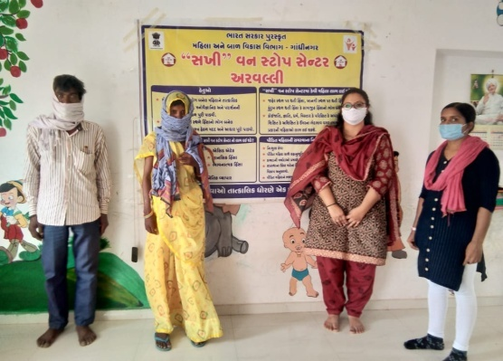
2. story-2
1. Name: Dhakad Motiyaben Pappubhogya
2. Age: 37
3. District: Tordarayasingpura, Tok
4. State: Rajasthan
On 25/05/2020 at 9:00 pm, 181 women helpline
gave shelter to an unstable brain victim at
“Sakhi” One Stop Center, Aravalli run by Parakh Trust.
In which, after interrogating motiya’s for 3 consecutive
days from the coordination of all the staff, she mentioned village named as khedulya and Lakshmipura. So that the names given by her searching on Google by Staff, shown from the state of Rajasthan. Then With help of ASI of Tok Police Station, he spoke to her on the phone with this information was sent to Sakhi One Stop Aravalli and her family was contacted through ASI of Tok Police Station.
Tok's ASI sent all the information as well as all the evidence of his identity and the missing report of motiya to OSC, Aravalli. Motiya’s husband was called to the OSC, Aravalli on 30/05/2019 and after 21 months she was reunited with her family

OSC Gandhinar Case type Details
S. No | Month | Case Details
S. No | Month | Domestic Violence | Rape | Missing | Sexual Harresment | Others | Total
1 | April-2020 | 06 | 00 | 00 | 00 | 00 | 06
2 | May-2020 | 05 | 01 | 00 | 00 | 00 | 06
3 | June-2020 | 03 | 01 | 02 | 00 | 00 | 06
4 | July-2020 | 04 | 00 | 02 | 00 | 01 | 07
5 | Aug-2020 | 03 | 00 | 02 | 00 | 02 | 07
6 | Sep-2020 | 08 | 00 | 01 | 00 | 01 | 10
7 | Oct-2020 | 02 | 00 | 00 | 00 | 05 | 07
8 | November-2020 | 06 | 00 | 00 | 00 | 04 | 10
9 | December-2020 | 08 | 00 | 00 | 00 | 03 | 11
10 | January-2021 | 09 | 00 | 00 | 00 | 09 | 18
11 | February-2021 | 06 | 01 | 00 | 00 | 00 | 07
12 | March-2021 | 17 | 03 | 00 | 00 | 02 | 22
 | Total | 77 | 06 | 07 | 00 | 27 | 117
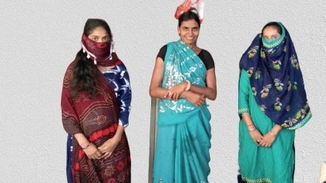
Success Story of OSC Gandhinagar
Story: 1
1. Name: shilaben mersingbhai surya
2. Age: 35 to 38
3. District: at- palasi ,janpad-thanka,
4. State: madhyapradesh.
Preliminary information of the case
Sheelaben Surya had left home about 2-3 months ago. She was found from Ramnagar village in Kalol taluka of Gandhinagar district and was contacted by the village sarpanch. Kalol police
station personnel inquired about the sister in the surrounding villages but their information was not received. In addition, the sister is mentally unstable / mentally retarded and cannot provide even basic information about herself or her whereabouts. He was placed at Sakhi-One Stop Center by Kalol Police Station on 19/08/2020.
Success in reuniting the family of a mentally retarded / mentally retarded sister from Palasi village in Madhya Pradesh through the Government of India's Digital India program.
The sister was frequently counselled by the centre administrators on duty at Sakhi-One Stop Centre as well as the case worker. It was very difficult to get information with her as she was mentally unstable. In the beginning, the sister sometimes declared Bharuch as her abode, sometimes as "Palasi" and sometimes as "Kuksi". But it was more difficult to find out which district these villages are in by searching on Google than talking to them. Because the sister spoke Gujarati, Hindi as well as any of her local languages. The dress and appearance of the sister seemed to be on the Dahod-Godhra side. Finally, after the tireless efforts of the staff of the center, the information of Palasi and Kukshi villages mentioned by the sister was obtained with the help of Google Map. Also, due to the Digital India program of the Government of India, the Secretary (Talati) of Palasi village was contacted with the help of the website of the Rural Development Department of the State of Madhya Pradesh. At the same time, with the help of a friend, it was learned that the displaced people of Narmada Dam in the state of Madhya Pradesh live in 'Naveria Gram Panchayat' of Kalol taluka of Panchmahal district. With the help of Dilipbhai, a resident of this village and displaced from Palasi village in Madhya Pradesh state, it was found out that the sister is from Palasi village. After asking for the details of the sister's Aadhaar card, it was confirmed that the sister is a resident of Palasi village in the state of Madhya Pradesh. The sister also had a telephone conversation with her brother Prakashbhai. According to the conversation with her brother, the sister has been mentally unstable since childhood and this sister had left home twice before. According to his brother, his family's financial situation is not good and he cannot afford to treat his sister mentally. And since they are farming, no one can take care of them at home. So they reunite Sheila sister; Can't take home. Her brother requested Sakhi - One Stop Center, Gandhinagar to arrange

for Sheelabahen to be treated at a mental health hospital. So that under the guidance of District Women and Child Development Officer as well as Parakh Institute, Dat. Arrangements were made for the sister to get mental health treatment at "Jai Ambe Mandabuddhi Mahila Samaj Seva Trust, Bayad" in Aravalli district on 9/08/2018. The trust provides medical check-ups as well as medical treatment to mentally challenged persons by government as well as private doctors with all basic facilities. The organization also makes efforts to reunite such mentally challenged persons with their families as their mental condition improves.
Sakhi – Sheela bahen was given shelter for a total of 8 (eight) days at the One Stop Center and special care was taken by the centre as she is mentally retarded. He could not speak a single sentence and it was difficult to understand if he spoke. What a dumb person is saying would be true without even thinking about it. Only with guidance can it be possible to identify a sister and reunite her with her family. In addition, at the request of the family, the Sakhi-One Stop Center has also been successful in arranging for the treatment of the sister so that her mental health can improve quickly.
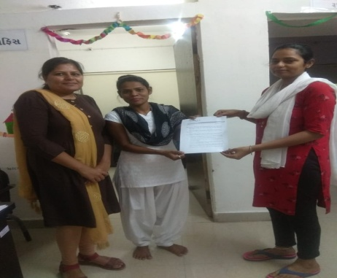
2. story-2

1. Name: Sujata pradipkumar sharma
2. Age: 29
3. District: Gandhinagar
4. State: Gujarat.

Preliminary information of the case;
Sujata Kumari Pradipkumar Sharma 121 Abhayam Helpline called Sakhi One Stop Center Gandhinagar and Adalaj Police Station transferred the woman to Sakhi One Stop Center Gandhinagar. From then on, her husband started harassing her for dowry and started threatening her for divorce. She was physically and mentally abused by her husband for dowry and was not even allowed to go to her pier. She was also mentally tortured by her husband for not having a child. She had been suffering from this for the last five years. But she was beaten unbearably by her husband and kicked out of the house and admitted to the hospital. Sujataben was shifted to Sakhi One Stop Center, Gandhinagar by the police as none of her relatives lived in Gujarat as her pier was in Jharkhand from the hospital.
Operation of Sakhi One Stop Center:
Sujataben was given four days shelter at Sakhi One Stop Center Gandhinagar and underwent medical treatment. With the help and guidance of Parakh Trust Himmatnagar, the organization which runs Sakhi One Stop Center Gandhinagar, Sujataben was appointed on temporary basis as a social worker under Gujarat Livelihood Promotion Urban Livelihood Mission Scheme. Sujataben was arranged by Sakhi One Stop Center to stay in Working Woman in Lockdown.
Follow up:
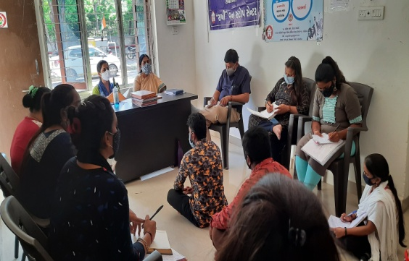
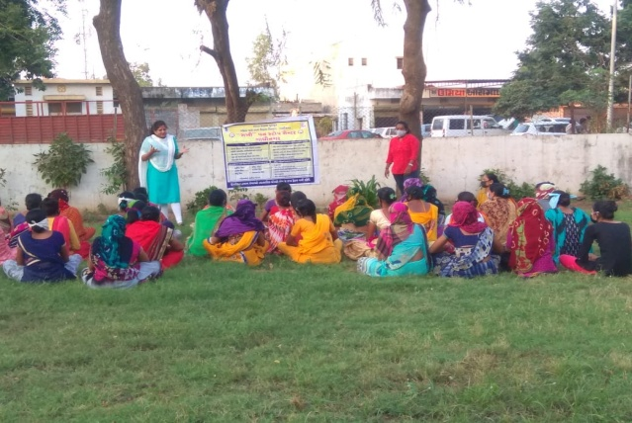
Sujataben is currently at her husband's house rather than a telephonic follow-up and is currently being treated well by her in-laws. Sujatamben thanked Sakhi One Stop Center and its staff and Parakh Institute.

- Childline Arvalli -1098
The Department of women and child ,New Dellhi and Child line India Foundation, Mumbai has appointed by Parakh Trust for Arvalli Dist under which CHILDLINE 1098 is a phone number that spells hope for millions of children across India. It is a 24-hour a day, 365 days a year, free, emergency phone service for children in need of aid and assistance. We not only respond to the emergency needs of children but also link them to relevant services for their long-term care and rehabilita

Grass roots level outreach with children and concerned adults:
previous year: April - 2020 to March -2021

Target Group | No. contacted | Nature of Outreach | 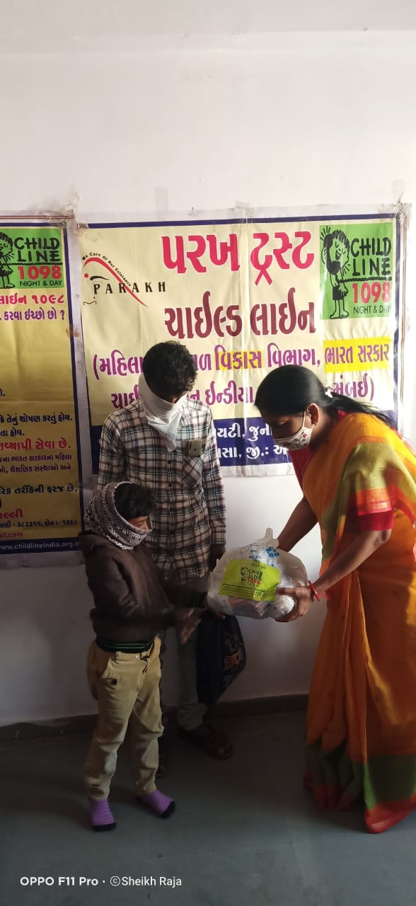  Number of Programmes
PCO owners | 00 | 00 | 00
Railway station | 00 | 00 | 00
Bus stops | 32 | 26 | 15
Shelter children | 08 | 08 | 08
Cinema halls | 12 | 10 | 09
Parks | 15 | 12 | 10
Tourist places | 07 | 05 | 05
Religious places | 18 | 14 | 10
Schools | 13 | 11 | 04
Slums | 294 | 304 | 211
Others | 360 | 356 | 262
Total | 759 | 1141 | 534

Details, if any, of innovations in CHILDLINE
Date | Area | Conduct Children | Adults
21-09-2020 | Bapunagar | 14 | 9
23-09-2020 | Kasba | 22 | 13
30-09-2020 | Ganeshpura | 30 | 14

Along with Aravalli Child Line team and Ganeshpura Anganwadi worker, organized nutrition month program in Bapunagar, Kasba, Ganeshpura Anganwadi. In this program, Children And his mother Anganwadi Worker was Participet. Child line Aravalli told the parents about the awakening of the mothers and about the nutritious food from Anganwadi. The Anganwadi worker gave information about new children's admissions and nutritional food. In today's program, children were given Sukhadi food from the Anganwadi. Child Line Aravalli distributed fruits to all the children and mothers
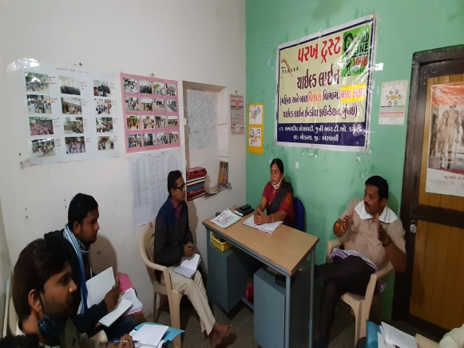
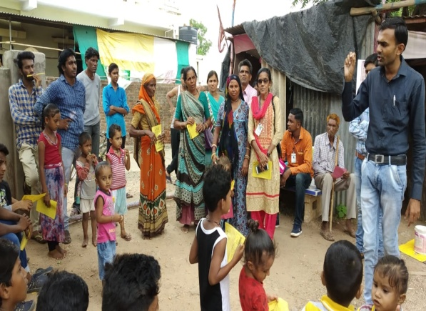

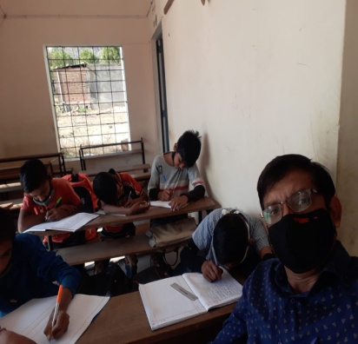
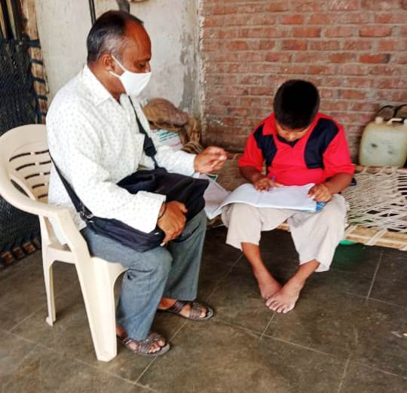
(8) Integrated Education Scheme,
Rashtriy Madhyamic shiksha Abhiyan
(SSA)(IEDSS) Gandhinagar

Integrated education means the children
bearing various types of disabilities can
educate themselves staying with their families
and studying in the general school of the
village of their on area

S.N. | Years | Facility Grant
1 | 2018-19 | 069
2 | 2019-20 | 035
3 | 2020-21 | 040
The benefits out of the allotted assistance to the handicapped children
To make survey to primary school to secondary and Higher Secondaty School (1 to 12)
To Provide Medical Certificate to Disabled Children of their categories.
To Give Admission in his nearest School (Primary/Secondary/higher Secondary)
To give benefit by Govt Schemes to every disabled.
- The physically handicapped child can acquire education with the help of tricycle, callipers, crutches properly and effectively .Apart from it children can deal with other children of their own area amicably
- The help of M.R. Educational kit enhances the interest of learning among the children. The pragmatic training received by the children and the knowledge obtained thereby facilitate the children to achieve mental and physical development through effective expression. The help of hearing aid and educational kit develop in the hearing- impaired child the hearing capacity. The hearing impaired child bails out of the inferiority complex of deafness by getting acquainted with the sounds of the surroundings and developing concepts with the average children with the help of hearing-aid
(9) Baxipanch Kumar Chhatralay:
The Parakh institution has got grant in aid Baxi Panch Kumar Chhatralay from 1998 Through the social welfare, Department . Under which, in the year 2020 – 2021 55 students were given the facilities of lodging and boarding free of charge.The student living in the hostel are studying in the schools suitable to them. The hildren are being given educational articles as per their requirements. Over and above, planning for tours and picnics are also being arranged.
- The Parakh Institution has got approval as of consumer

Customer protection Mandal from the year 2005.Under this the institution is giving programmers of awareness programmers are beings arranged for bringing transparency. In the matters that the customer may not be cheated for the quality of goods mark for values of ,goods for weight and measurements etc. Taking complaints from the customers proper actions are being taken for its disposal. In the year 2020-21, the activities as shown below where taken on hand .
During the year total 33 programmers were arranged alike shippers-12 seminar & webinar -04, meetings-06 , Street Meeting – 10 Pamphlates-5000 were distributed regarding awareness And celebration .

(11) Education Health and Population awareness programme

with the co-operation the prohibition and excise Department, the institution is in active working movement of the various programmes of freedom of addiction on the day of Gandhi Jayanti. The Parakh institution is doing many activities for social Health and for formation of awaiking society during the year in which includes freedom bringing out of addictrion campaigin save female child campaign programme for awareness regarding Aids, Girls Education Career,Employment Guidance Protection pollution.

Remaining constantly active for eradication o campaign,shibir of legal knowledge,consumer protection campaign through shibirs,meetings,ralley,pamphlets distribution etc.Duriong the year 2020-2021 , the activities as under were done.

No. | Details of programme | No. of Programme | Beneficiaries
1 | Leaving up of addiction | 01 | 090
2 | Environment Programme | 02 | 210
3 | Covid-19 Programme | 05 | 950
4 | Yoga day | 01 | 050
5 | Guide lines for career &employment | 03 | 650
6 | Pollution protection | 05 | 180
7 | Pre-knowledge of legal | 18 | 640
8 | Consumer protection campaign | 06 | 315

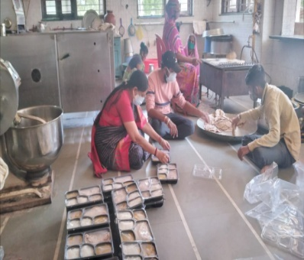
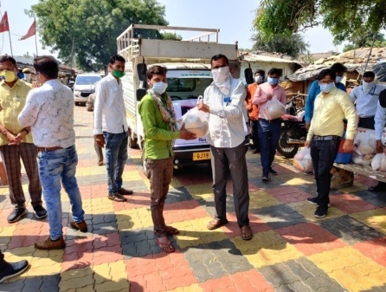
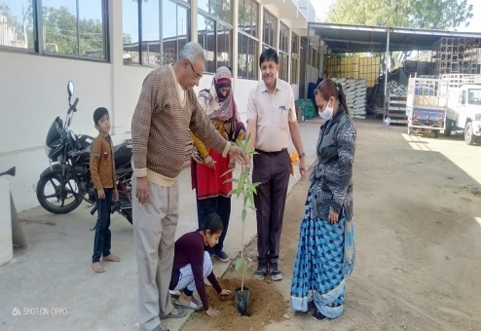
In Covid-19 parakh has Distributed Masks, Sanitizers as well as food kits and institution is going arranging special programmer again social basd customs and for addiction of tobacco ,wine, gambling. For this, institution is working by getting co-operation of youths, social workers ,volunteer and other social institutions

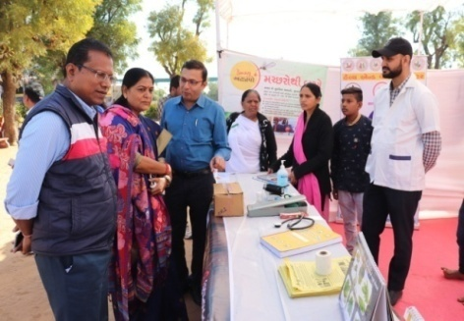
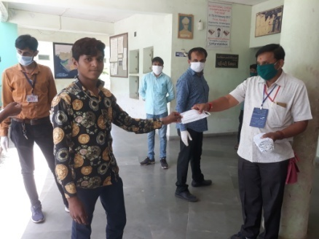
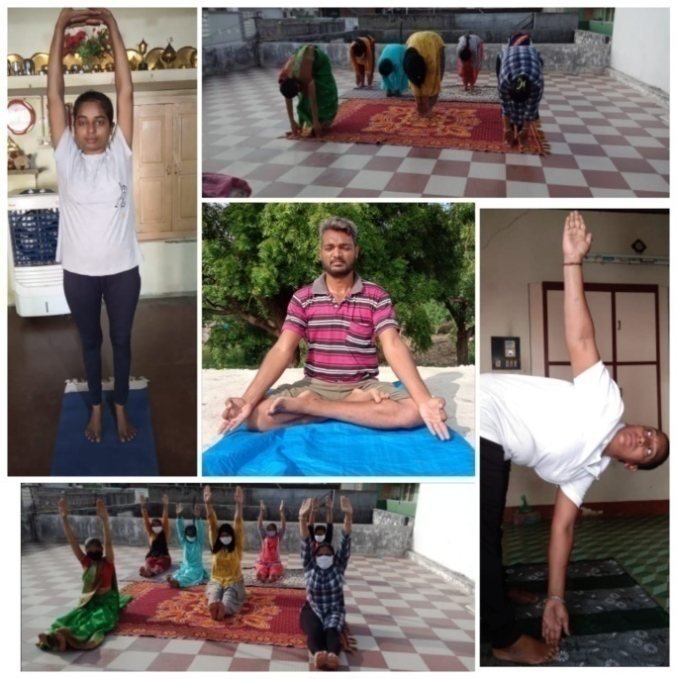

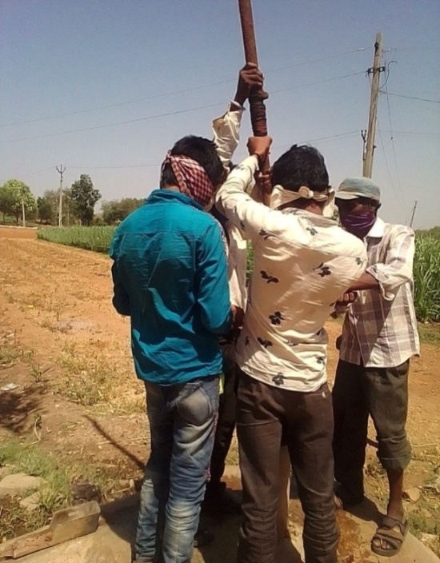
(12) Hand Pump Unit , Bhiloda
Gujarat Water supply And Sewerage Board, Gandhinagar
It is Useful for Tribal Areas People It is Organised
Reapering by Parakh Trust Teachnical Team -08 Hand
Pump Posina Villa 170 & 2650 Hand pump ring activity
tribal area ST Beneficiaries 755000 serves, Activity
under project sunshine 1998
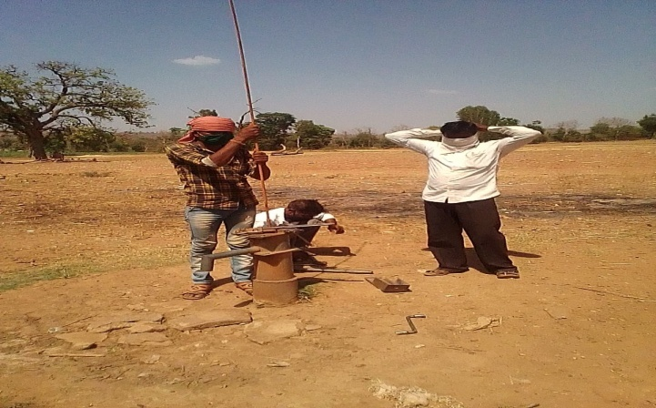

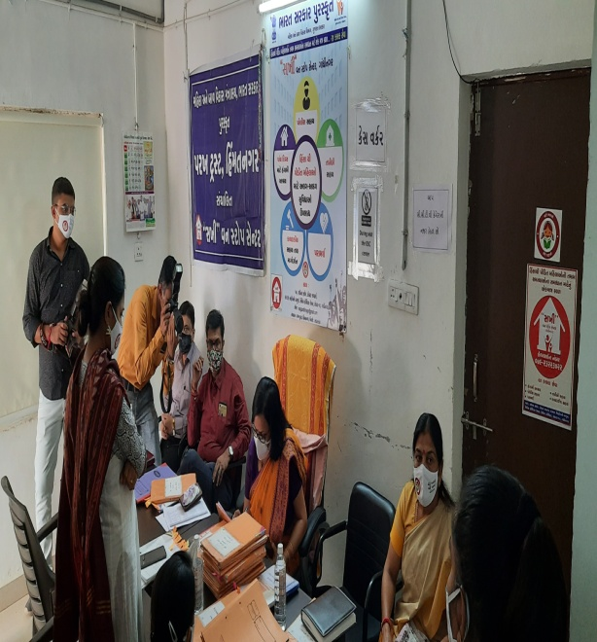

Manisha Kumari Visited the One Stop
Center (Commissioner Shree Women and
Child Development Department of
Govt of Gujarat

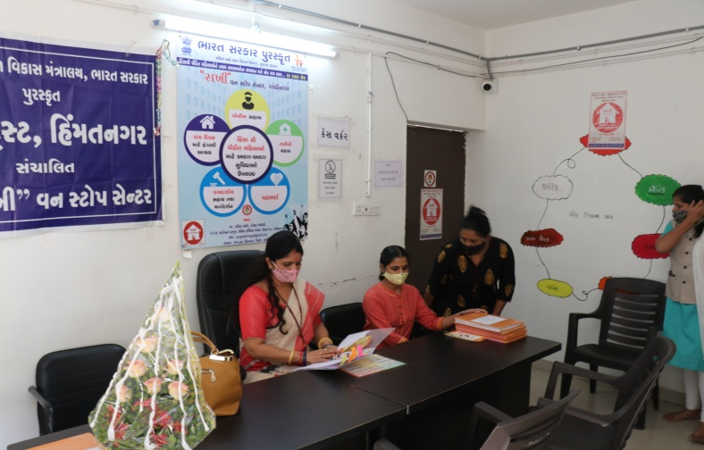

Dr Rajul Desai (Member of National
Commission for Women) visited One Stop
Center at Gandhinagar

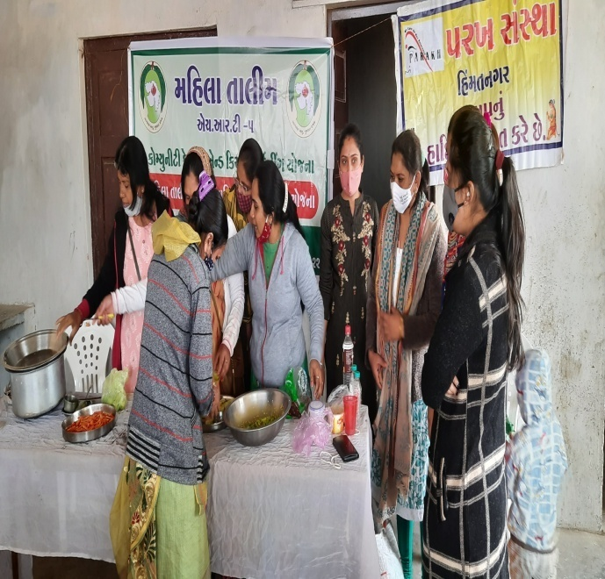

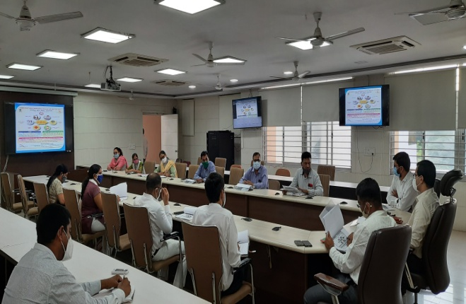

Review meeting of One Stop Center by
Collector at ,Aaravalli.

Training for women to Make Different
types fruit pickle organised by
Department of Horticulture and
Parakh Trust,Himatnagar

