PARAKH TRUST

ANNUAL REPOAT

YEAR - 2020-2021
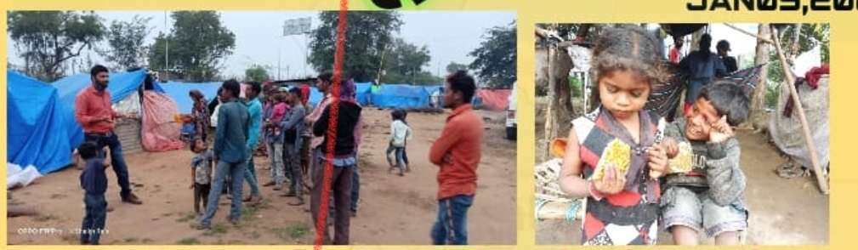
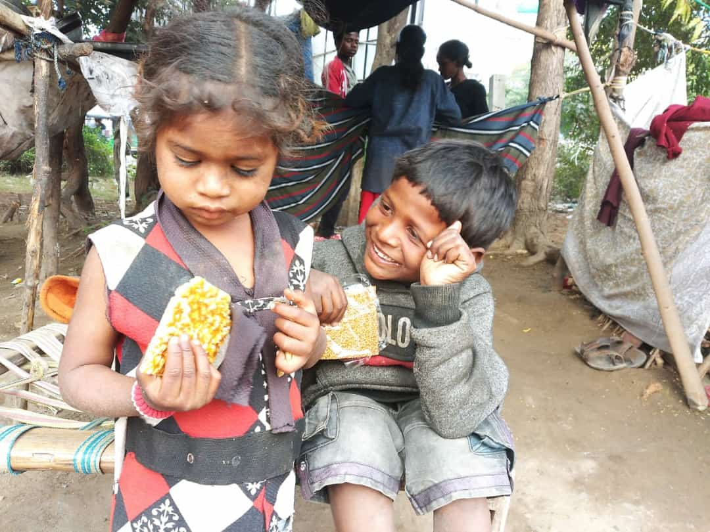

PARAKH TRUST
Ambawadi, Bar Bangla,
Ta.Himathanagar,Dist.Sabarkantha(Gujarat)

Phon No.(02772)247941

Introduction

Parakh Trust was established in 29th January 1994 with the aim of social development
(unlistment ). It has been able to get expected result by doing development activities in different
economic, social and education consistently. So make this dream come true , all the people
involved with this organization including trustee ,Secretary and the president as well as workers
have immense work . In order to do good of common person . The Trust has in collaboration
with the government participated in various government scheme . At the same time the trust it
self he organized training program and workshop to train the people so that they can be self
reliant and do their activity them selves . the organization has spread it wing with interior areas
state and tried to satisfy the desire of the people . invites in remote areas . It has tried it lead
best to give all kind of support and guidance to the common men so that He/she can not remain
behind in the first developing society all over the world .Government has also helped to trust in
makes people aware about different program . The Trust has been primarily in active against the
program for women Atrocity save girl child campaign preventing killing of girl baby from taking
birth abortion of women violence against women etc. the trust has participated actively in the
government sponsored programmes like kanya Kelvin ,women empowerment ,Krishi Ruth etc.
The helping the Government to spared the awareness among people . The trust has also helped
women of different section by providing loans from the bank .

Network of the organization

The Parakh Trust is working all over the Gujarat state. However it has done must of it activities in
Sabarkantha , Arvalli , Amreli, junadh , Jamnagar, Porbandar, Ahemadvad , Patan ,chotaudepur
Panchmahal , Gandinagar , Banaskantha and Kutch district etc.

  - Detailed Activities of Trust

(1) District multipurpose woman welfare centre , Himmatnagar
The trust is running this centre in the 09th Taluka of Sabarkantha district This centre is sponsored by the commissioner women and child development Gandhinar under this programme women has provided guidance on legal aid social health , employment and career development Main Activities of this centre – legal aid in collaboration with

Work done
S.No | Work done | Beneficiares
1 | Govt. scheme | 264
2 | Legal Aid | 237
3 | Oriented Employment (Rojagar) | 213
4 | others | 558
5 | Samajik | 2813
 | Total | 4085

Work done under different Govt. scheme

S.No | Govt.Sceme | Beneficiares
1 | Widow-help | 138
2 | Old-age help | 22
3 | Neradhay vrudh sahay | 15
4 | Medical Aid | 00
5 | National Family Sahay | 02
6 | District udhyog Kendra aid | 03
7 | Sant surdas | 02
8 | Kunvarbainu mamerau yojana | 60
9 | Maamrutam card | 00
10 | Palk Mata-Pita | 02
11 | Valhi Dicer Yojana | 17
12 | Pandit Dindyal aavas yojana | 03
 | Total | 264
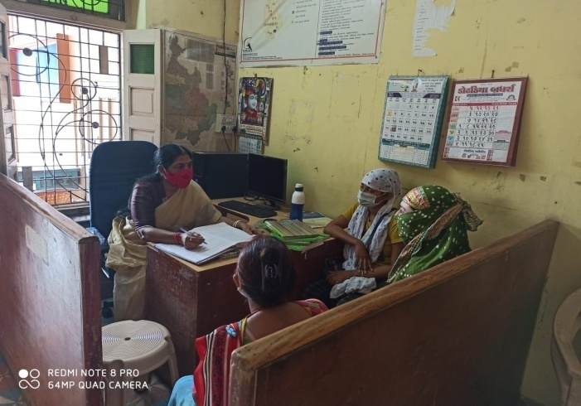
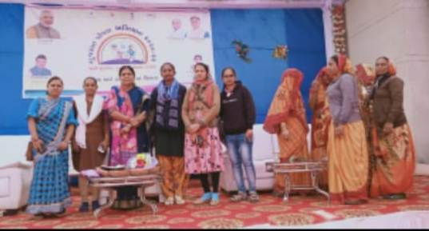

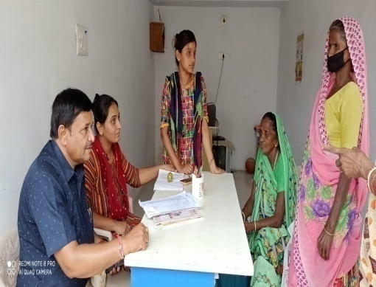
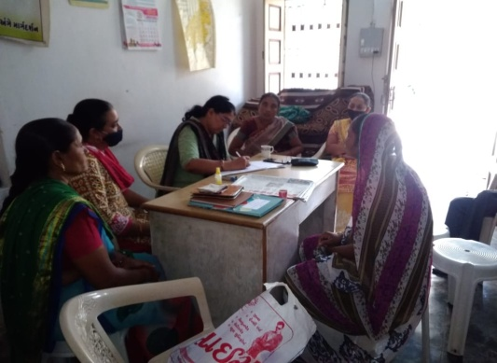
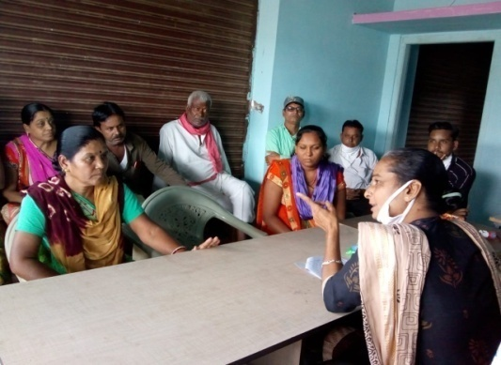

work done
S.No | Work done | Beneficiares
1 | Govt. scheme | 124
2 | Legal Aid | 221
3 | Employment oriented | 124
4 | others | 108
5 | Samajik | 2005
 | Total | 2458
(2) Vividhlakshi Mahila Kalyan Kendra, Talod,
Under this programme women of different sections are provided with guidance, training and made aware about different subject like self-help group saving and team spirit, health aware newsstand presently development.
Since August 2006,the trust has three this centre provided information in to 91 village out of total 96 village the details is as under.

(3) Vividhlakshi Mahila Kalyan Kendra ,Bhilod Workdone
S.No | Work done | Beneficiares
1 | Govt. scheme | 105
2 | Legal Aid | 041
3 | Employment oriented | 572
4 | Others | 1362
5 | Samajik | 476
 | Total | 2556
Under this programme women of different sections are
provided with guidance, training and made aware about
different subject like self – hel group saving and team
spirit, health awareness and presently development.
Since March 2009,the trust has three this centre
provided information in to 84 village out of total 90 village thedetails is as under.

S.No | Work done | Beneficiares
1 | Govt. scheme | 20
2 | Legal Aid | 11
3 | Employment oriented | 01
4 | Others | 14
5 | Samajik | 4229
 | Total | 4275
(4) Vividhlakshi Mahila Kalyan Kendra , Dahegam, Work done

Under this programme women of different sections
are provided with guidance ,training and made aware
about different subject like self-help group saving and
team spirit ,health awareness and presently development.
Since March 2009,the trust has three this centre
provided information in to 97 village out of total 87 village
the details is as under.
(5) Beti-Bachao Abhiyan and Kanya-Kelvan
To create awareness among the people by arranging the meetings, camps and conferences at the village,taluka and district level and bringing this cause to the limelight. When this natural b
alance has been disrupted and disturbed, Parakh has made the sincere and sustained endeavor in focusing among the people on the possible disastrous fallout of the imbalanced sex –ratio and contributed substantially.
Under Kanya Kelvani, Parakh actively participated in the Shala Praveshotsav and Kanya kelvani rath yatra. During 2003 at the shala Praveshotsav of Arjanpura in Himatnagar taluka Pinkal was given rs.1000 of vidya laxmi bond on the spot by the secretary of Parakh for which 5 students of the primary school had been nominated. Besides this, in presence of state project director Mr. Sharma Parakh adopted a cuddly little flower like daughter Pinkal.Presently Parakh provides the study materials and uniform to Pinkal.Parakh has accepted the responsibility of higher education of Pinkal

(6) “One Stop Cente r (OSC)” Aravalli & Gandhinagar
The Ministry of Women and Child Development will provide support to the State Governments As well as the office of women and child officer ,Arvalli & Gandhinagar
The objectives of the Scheme are: (i) To provide integrated support and assistance to women affected by violence, both in private and public spaces under one roof. (ii) To facilitate immediate, emergency and non-emergency access to a range of services including medical, legal, psychological and counselling support under one roof to fight against any forms of violence against women.
OSC Arvalli Case type Details
S. No | Month | Case Details
S. No | Month | Domestic Violence | Mentally ill | Sexual Violence against Children | Others | Total
1 | November-2019 | 02 | -- | -- | 01 | 03
2 | December-2019 | 04 | -- | -- | 01 | 05
3 | January-2020 | 02 | -- | -- | 01 | 03
4 | February-2020 | 03 | -- | -- | 03 | 06
5 | March-2020 | 07 | -- | -- | -- | 07
 | Total | 18 | -- | -- | 06 | 24
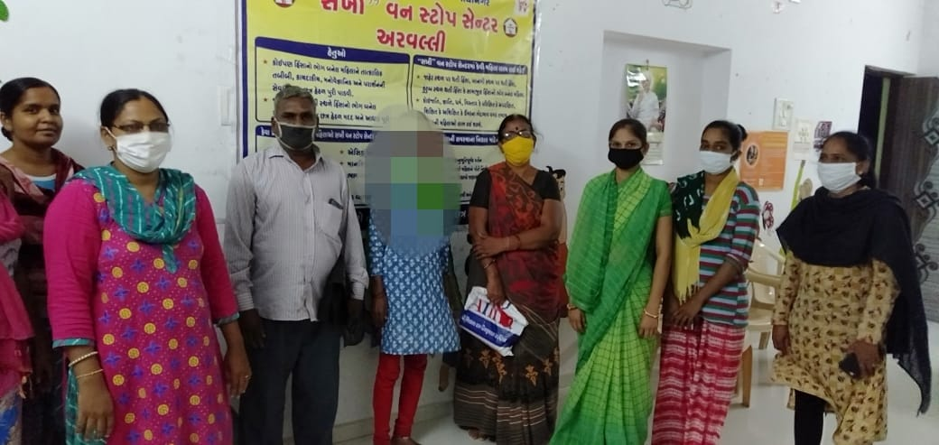
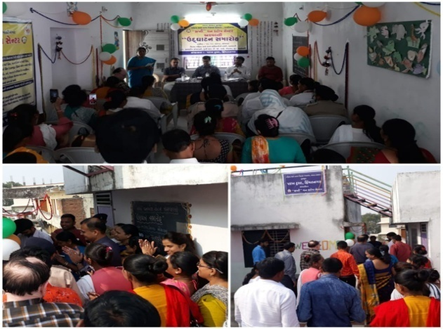

OSC Gandhinagar Case type Details
S. No | Month | Case Details
S. No | Month | Domestic Violence | Mentally ill | Sexual Violence against Children | Others | Total
1 | January-2020 | 06 | -- | -- | 00 | 06
2 | February-2020 | 03 | -- | -- | 01 | 04
3 | March-2020 | 07 | 01 | -- | -- | 08
 | Total | 16 | 01 | -- | 01 | 18
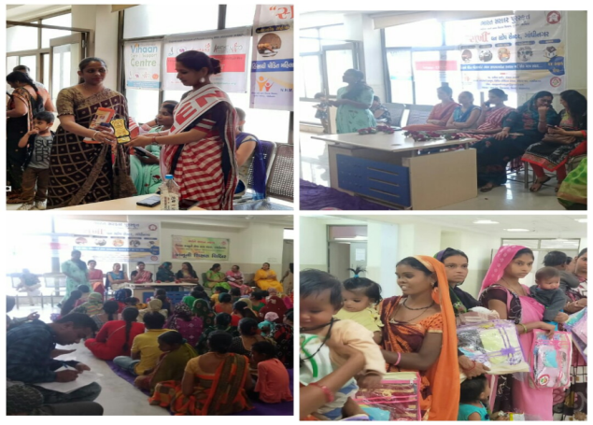
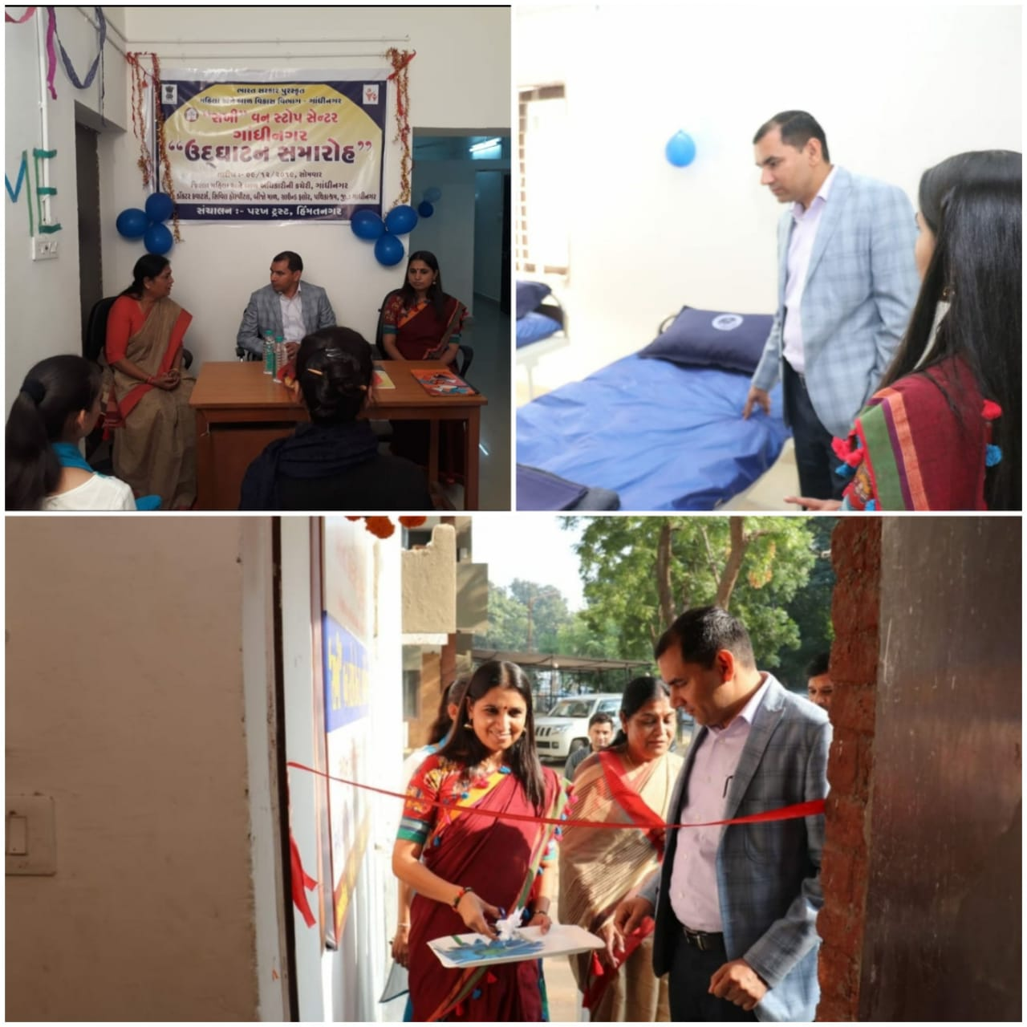

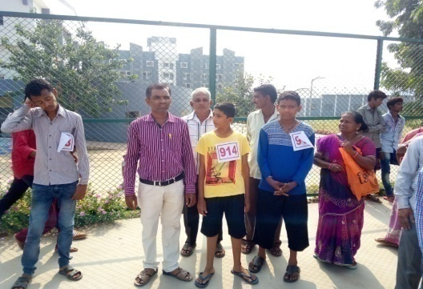
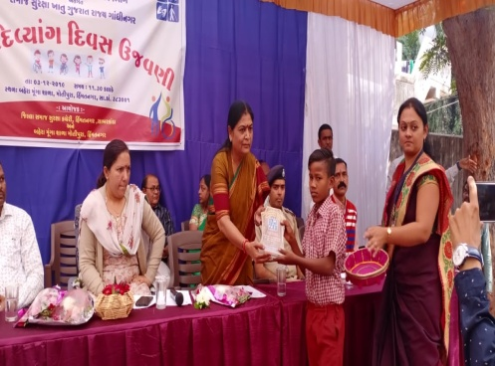
(7) Integrated Education Scheme,
Rashtriy Madhyamic shiksha Abhiyan
(RMSA)(IEDSS) Gandhinagar
Integrated education means the children
bearing various types of disabilities can
educate themselves staying with their families
and studying in the general school of the
village of their on area

S.N. | Years | MR  kit | Hearing aids | Crutches | Calipers | Tricycle | Edu.kit | Escort  Allowance | Facility Grant
1 | 2004-05 | 08 | 10 | 45 | -- | 15s | 366 | --
2 | 2005-06 | 28 | 18 | 60 | 05 | 30 | 425 | 23
3 | 2006-07 | 62 | 26 | 30 | 05 | 29 | 577 | 26
4 | 2007-08 | 75 | 61 | 27 | 12 | 17 | 641 | 25
5 | 2008-09 | 78 | 65 | 31 | 16 | 26 | 701 | 47
6 | 2009-10 | 07 | 05 | 01 | -- | 02 | 030 | --
7 | 2010-11 | -- | 05 | -- | -- | -- | 035 | --
8 | 2011-12 | 02 | 03 | 01 | -- | 01 | 053 | --
9 | 2012-13 | -- | -- | -- | -- | -- | 046 | 16
10 | 2013-14 | -- | -- | -- | -- | -- | 073 | -- | 73
11 | 2014-15 | -- | -- | -- | -- | -- | 079 | -- | 79
12 | 2015-16 | -- | -- | -- | -- | -- | 090 |  | 90
13 | 2016-17 | -- | -- | -- | -- | -- | 071 | -- | 071
14 | 2017-18 | -- | -- | -- | -- | -- |  | -- | 070
15 | 2018-19 | -- | -- | -- | -- | -- | -- | -- | 069
The benefits out of the allotted assistance to the handicapped children
- The physically handicapped child can acquire education with the help of tricycle, callipers, crutches properly and effectively .Apart from it children can deal with other children of their own area amicably.
- The help of M.R. Educational kit enhances the interest of learning among the children. The pragmatic training received by the children and the knowledge obtained thereby facilitate the children to achieve mental and physical development through effective expression. The help of hearing aid and educational kit develop in the hearing- impaired child the hearing capacity. The hearing impaired child bails out of the inferiority complex of deafness by getting acquainted with the sounds of the surroundings and developing concepts with the average children with the help of hearing-aid

(8) Baxipanch Kumar Chhatralay:
The Parakh institution has got grant in aid Baxi Panch Kumar Chhatralay from 1998
Through the social welfare, Department . Under which, in the year 2019 – 2020
40 students were given the facilities of lodging and boarding free of charge.
The student living in the hostel are studying in the schools suitable to them.
The hildren are being given educational articles as per their requirements. Over and
above, planning for tours and picnics are also being arranged.
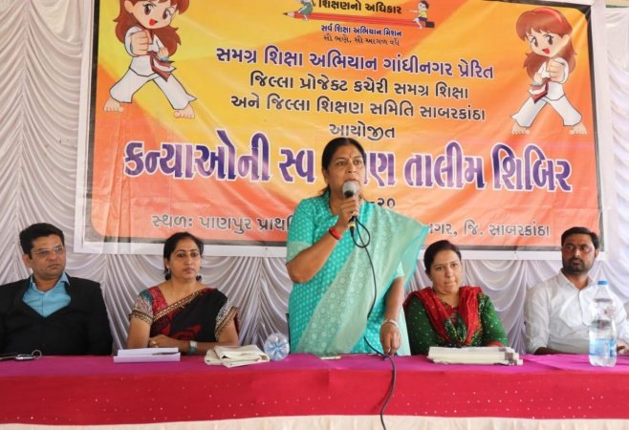
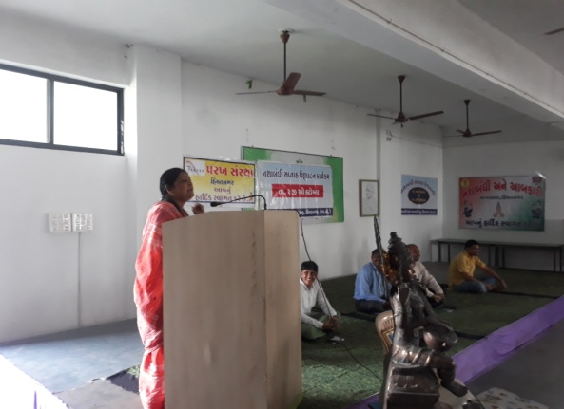

- The Parakh Institution has got approval as of consumer

Customer protection Mandal from the year 2005.Under this the institution is giving programmers of awareness programmers are beings arranged for bringing transparency. In the matters that the customer may not be cheated for the quality of goods mark for values of ,goods for weight and measurements etc. Taking complaints from the customers proper actions are being taken for its disposal. In the year 2019-20, the activities as shown below where taken on hand .
During the year total 70 programmers were arranged alike shippers, seminars, workshop, visual, meetings, Exhibition. – 13 Over and above this 41 complaints received from the customer -5628 .Pamphlates-9000 were distributed regarding awareness And celebration of 24, December. The number of programmers as under:
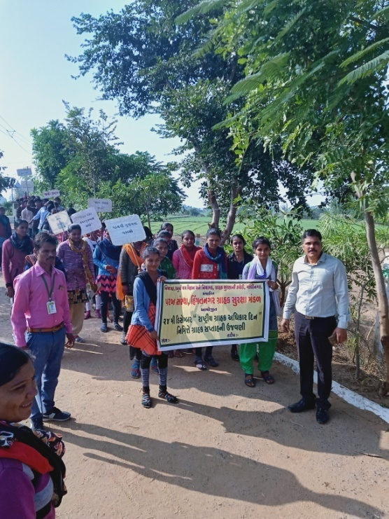
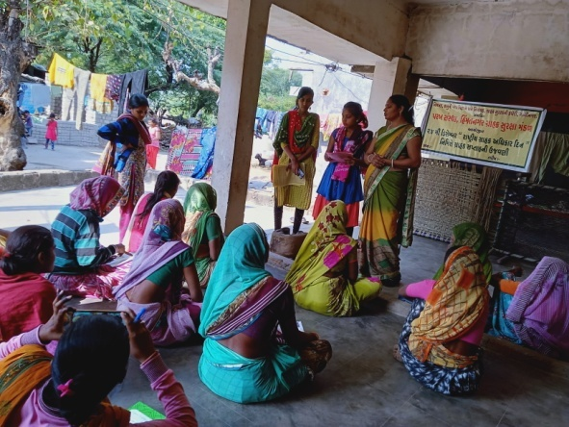
No | Date | Place | Number of  Participate | Details programmes
1 | 21/12/2019 | Vakatapur | 085 | Shibir
2 | 23/12/2019 | Himatapur | 190 | Rally
3 | 24/12/2019 | Likhi | 165 | Seminar
4 | 25/12/2019 | Gadha | 090 | Shibir
5 | 26/12/2019 | Ghan Ganga Highschool | 145 | Rally
6 | 27/12/2019 | Sachodar | 070 | Seminar
7 | 28/12/2019 | Pipodar | -- | Patrika Distribute

Celebration 15th March n2020 as customer rights Days for number of programmes as under:

No | Date | Place | Number of  Participate | Details programmes
1 | 12/3/2020 | Vanajaravas | 25 | Shibir
2 | 13/3/2020 | Chapatiya | Patrika Distribute | Patrika Distribute
3 | 14/3/2020 | Katavad | 30 | Shibir
4 | 15/3/2020 | Tajapuri | 45 | Seminar
5 | 16/3/2020 | Ashokpura | Patrika Distribute | Patrika Distribute Shibir
6 | 17/3/2020 | Abavadi | Patrika Distribute | Patrika Distribute Rally
7 | 18/3/2020 | Polajpur | 20 | Seminar
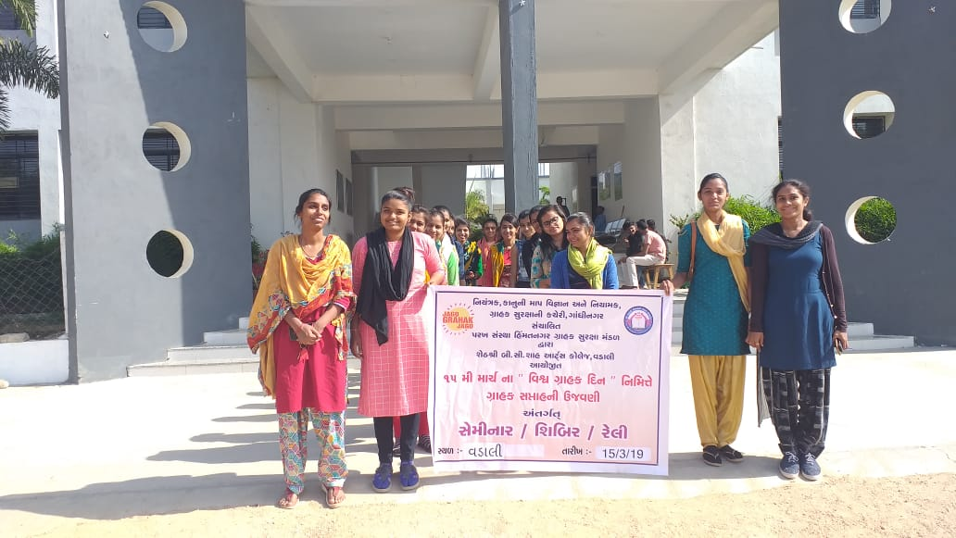
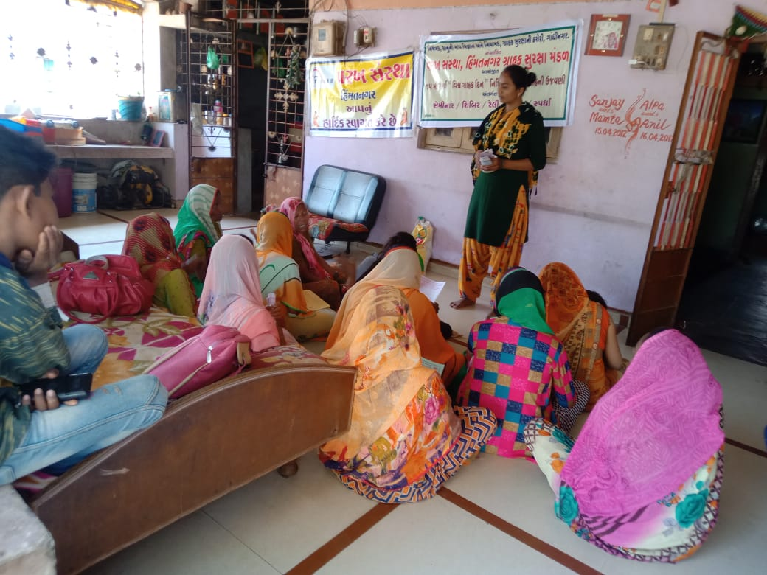

Details of Consumer Club
The Beginning of the Consumer Club for the purpose of young generation involve in this awareness programme of customer awareness for the whole state secondary School The 52 and college - 20 Consumer club allots to Parakh Trust in Sabarkantha and Arvlli district.

- Education Health and Population awareness programme

with the co-operation the prohibition and excise Department, the institution is in active working movement of the various programmes of freedom of addiction on the day of Gandhi Jayanti. The Parakh institution is doing many activities for social Health and for formation of awaiking society during the year in which includes freedom bringing out of addictrion campaigin save female child campaign programme for awareness regarding Aids, Girls Education Career,Employment Guidance Protection pollution.
:- Consrntration can be brought in children.

:- The children can get nourishing food.
Remaining constantly active for eradication of polio campaign,shibir of legal knowledge,consumer protection campaign through shibirs,meetings,ralley,pamphlets distribution etc.Duriong the year 2019-2020 , the activities as under were done.
No. | Details of programme | No. of Programme | Beneficiaries
1 | Leaving up of addiction | 02 | 0310
2 | Environment Programme | 07 | 0873
3 | AIDS awareness Programme | 00 | 000
4 | Female Education | 01 | 090
5 | Guide lines for career &employment | 09 | 0985
6 | Pollution protection | 10 | 0530
7 | Pre-knowledge of legal | 42 | 1205
8 | Consumer protection campaign | 13 | 1010

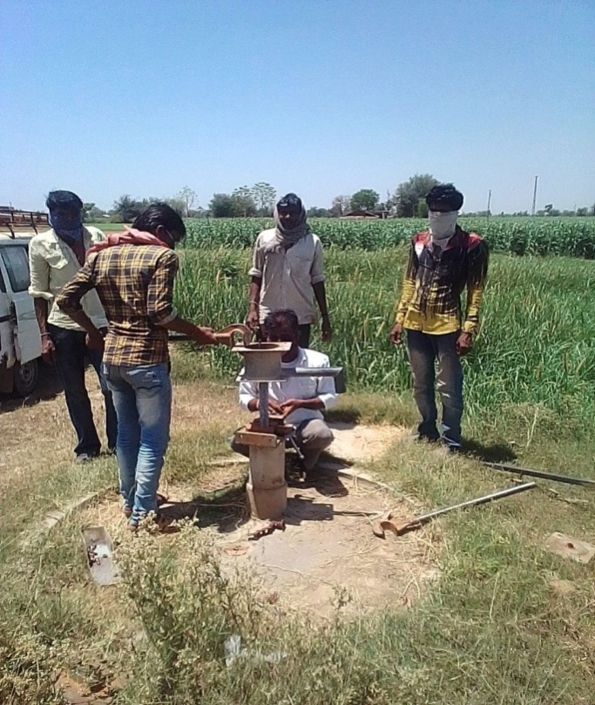
The parakh institution is going arranging special programmer again social basd customs and for addiction of tobacco ,wine, gambling. For this, institution is working by getting co-operation of youths, social workers ,volunteer and other social institutions
(11) Hand Pump Unit , Bhiloda
Gujarat Water supply And Sewerage Board, Gandhinagar
It is Useful for Tribal Areas People It is Organised
Reapering by Parakh Trust Teachnical Team -08 Hand
Pump Posina Villa 170 & 2650 Hand pump ring activity
tribal area ST Beneficiaries 77500 serves, Activity
under project sunshine 1998

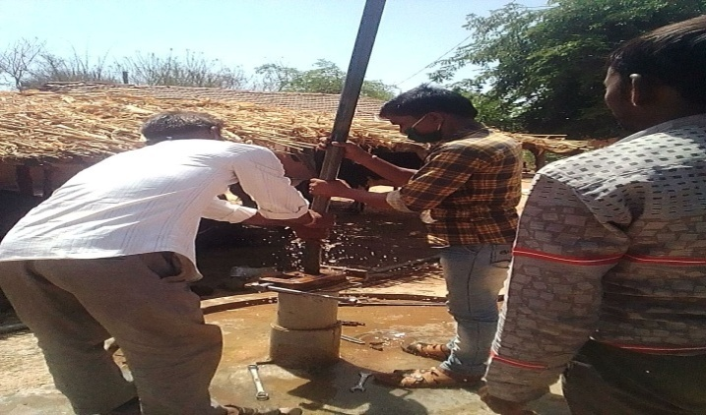

- Childline Arvalli -1098
The Department of women and child ,New Dellhi and Child line India Foundation, Mumbai has appointed by Parakh Trust for Arvalli Dist under which CHILDLINE 1098 is a phone number that spells hope for millions of children across India. It is a 24-hour a day, 365 days a year, free, emergency phone service for children in need of aid and assistance. We not only respond to the emergency needs of children but also link them to relevant services for their long-term care and rehabilitation.
Call statistics in the following format for the previous year: April - 2019 to March -2020
Types of Calls | April | May | June | July | Aug. | Sept. | Oct. | Nov. | Dec. | Jan. | Feb. | March

I. Interventions
Medical help |  |  |  |  |  | 2 | 1 | 1 | 4 | 5 | 5 | 7
Shelter |  |  |  |  |  | 2
Sponsorship |  |  |  |  |  | 1 | 2
II. Missing children
Child lost |  |  |  |  |  |  |  |  |  |  | 2
Parents asking help |  |  |  |  |  |  |  |  |  |  |  | 1
III. Emotional support and Guidance |  |  |  |  |  |  | 2 |  |  | 2 | 1 | 2
IV. Information
Information about CHILDLINE & volunteers |  |  |  |  |  |  | 1 | 2 | 1 | 1 |  | 1
V. Unclassified |  |  |  |  |  |  | 1 | 1
VI. Others Crank/fun/abusive |  |  |  | 1 | 1
Follow up calls |  |  |  | 2 | 6 | 13 | 16 | 18 | 20 | 28 | 36 | 25
Phone-testing calls |  |  |  | 43 | 77 | 70 | 79 | 64 | 56 | 91 | 75 | 60
Administrative |  |  | 6 | 7 |  |  | 2 | 1 | 4 | 2 | 3 | 3
Personal |  |  |  | 1 | 2 | 1 | 2 | 1 | 4 | 1 | 2 | 2
Other Intervention |  |  |  | 3 | 10 | 16 | 18 | 18 | 7 | 12 | 16 | 12
Total |  |  | 6 | 57 | 96 | 105 | 124 | 106 | 96 | 142 | 140 | 113

Grass roots level outreach with children and concerned adults:
Target Group | No. contacted | Nature of Outreach | Number of Programmes
PCO owners
Railway station
Bus stops | 23 | 20 | 8
Shelter children | 5 | 3 | 3
Cinema halls | 5 | 3
Parks | 9 | 9 | 3
Tourist places
Religious places | 7 | 7 | 5
Schools | 25 | 23 | 23
Slums | 205 | 193 | 123
Others | 145 | 137 | 97
Total | 425 | 395 | 262
