ANNUAL REPOAT

YEAR - 2015-16

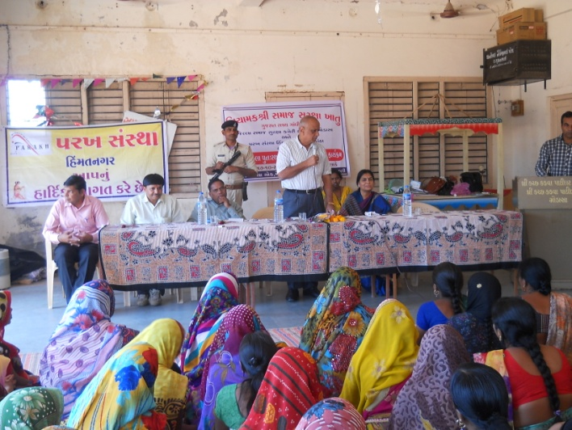

PARAKH SANSTHA
Ambawadi, Bar Bangla,
Ta.Himathanagar,Dist.Sabarkantha(Gujarat)

Phon No.(02772)247941-243142

  - Introduction
Parakh Trust was established in 29th January 1994 with the aim of social development
(unlistment ). It has been able to get expected result by doing development activities in different
economic, social and education consistently. So make this dream come true , all the people
involved with this organization including trustee ,Secretary and the president as well as workers
have immense work . In order to do good of common person . The Trust has in collaboration
with the government participated in various government scheme . At the same time the trust it
self he organized training program and workshop to train the people so that they can be self
reliant and do their activity them selves . the organization has spread it wing with interior areas
state and tried to satisfy the desire of the people . invites in remote areas . It has tried it lead
best to give all kind of support and guidance to the common men so that He/she can not remain
behind in the first developing society all over the world .Government has also helped to trust in
makes people aware about different program . The Trust has been primarily in active against the
program for women Atrocity save girl child campaign preventing killing of girl baby from taking
birth abortion of women violence against women etc. the trust has participated actively in the
government sponsored programmes like kanya Kelvin ,women empowerment ,Krishi Ruth etc.
The helping the Government to spared the awareness among people . The trust has also helped
women of different section by providing loans from the bank .

Network of the organization

The Parakh Trust is working all over the Gujarat state. However it has done must of it
activities in Sabarkantha , Arvlli , Surendrnagar, Amreli, junadh , Jamnagar , Porbandar,
Ahemadvad , Patan , Panchmahal , Gandinagar , Banaskantha and Kutch district etc.

  - Detailed Activities of Trust

1. District multipurpose woman welfare Centre  - Woman Self-Help Groups :Objectives  - Beti-Bachao Abhiyan and Kanya-Kelvani  - Women Training Cente | 2. Education Oriented Activities  - Baxipanch Kumar Chhatralay  - Dr.B A.Open Uni.Pro. Centre  - Integrated Education Scheme,  GCERT (IEDC cell )  - Ummid Programme (VTP)

3.Health Oriented Activities  - TB ACSM ACTIVITIES  - Polio Immunization  - Child Health, Awareness Programme,  - Save Girl-Child, Prevention of Killing of  Girl child in womb | 4.Environment Oriented  - Environment Protection Project  - Horticulture Mission  - Fruits Conservation  - Growing of Trees (Plantation

5.Economic Development Oriented  - Self Employment Training  - Water Research Programme  - Hand Pump Unit  - Urban Sanitation Programme:  - Check Dams  - L.I | 6.Social Development Oriented  - Consumer Protection  - Vyasan Mukti  7.Others Activities  - Multiple Training  - Misc.Work,Gettogathering

(1) District multipurpose woman welfare centre , Himmatnagar
The trust is running this center in the 09th Taluka ofSabarkantha district This centre is sponsored by the commissioner women and child development Gandhinar under this programme women has provided guidance on legal aid social health , employment and career development Main Activities of this centre – legal aid in collaboration with

Work done
S.No | Work done | 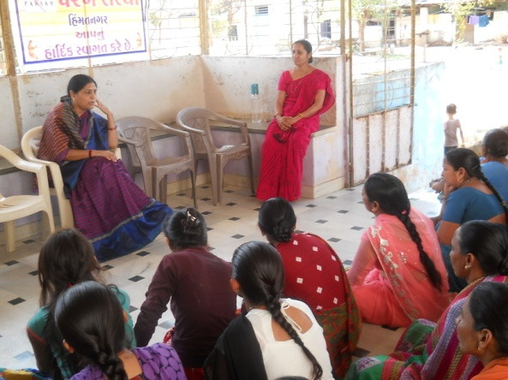  Beneficiares
1 | Govt. scheme | 058
2 | Legal Aid | 129
3 | Oriented Employment | 130
4 | others | 147
 | Total | 464

Work done under different Govt. scheme

S.No | Govt.Sceme | Beneficiares
1 | Widow-help | 24
2 | Old-age help | 22
3 | Handicapped Aid | 01
4 | Chirinjivi yojana | 04
5 | Employment oriented | 08
6 | Gardian Perants | 05
7 | National Family Sahay | 00
8 | Identicard | 00
9 | Medical Aid | 06
10 | District udhyog Kendra aid | 05
11 | Sant surdas | 09
12 | Kunvarbainu mamerau yojana | 10
 | Total | 93
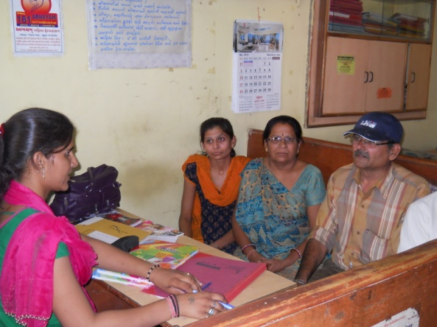
(2) Vividhlakshi Mahila Kalyan Kendra, Talod,
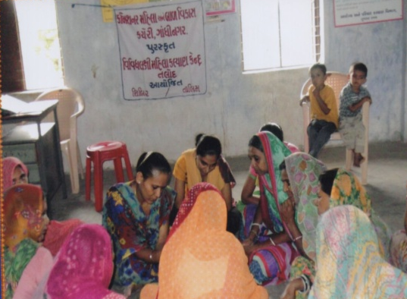
Under this programme women of different sections are
provided with guidance, training and made aware about different
subject like self-help group saving and team spirit,health awareness
and presently development.
Since August 2006,the trust has three this centre provided
information in to 83 village out of total 96 village the details is
as under.

Work done

S.No | Work done | Beneficiares
1 | Govt. scheme | 040
2 | Legal Aid | 019
3 | Employment oriented | 026
4 | others | 225
 | Total | 310

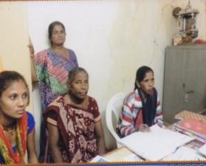
(3) Vividhlakshi Mahila Kalyan Kendra ,Bhilod
Under this programme women of different sections are provided with
guidance,training and made aware about different subject like self-help
group saving and team spirit,health awareness and presently development.
Since March 2009,the trust has three this centre
provided information in to 78 village out of total 90 village the
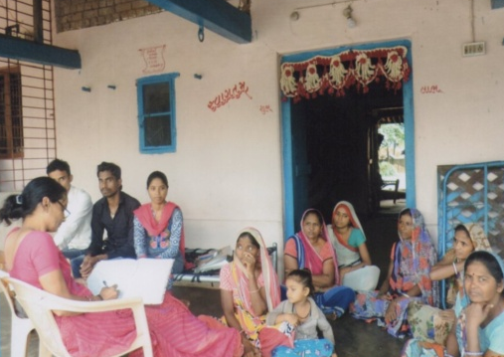
details is as under.
S.No | Work done | Beneficiares
1 | Govt. scheme | 061
2 | Legal Aid | 152
3 | Employment oriented | 123
4 | Others | 206
 | Total | 542
Work done

(4) Vividhlakshi Mahila Kalyan Kendra , Dahegam,
Under this programme women of different sections are provided with guidance,training and made aware about different subject like self-help group saving and team spirit,health awareness and presently development.
Since March 2009,the trust has three this centre provided information in to 91 village out of total 87 village the details is as under.

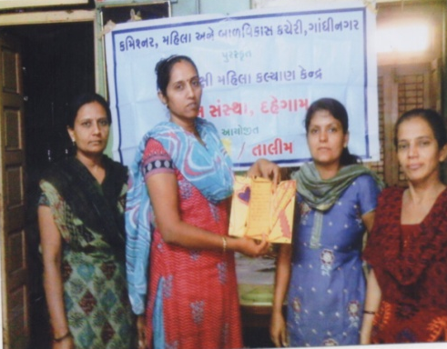
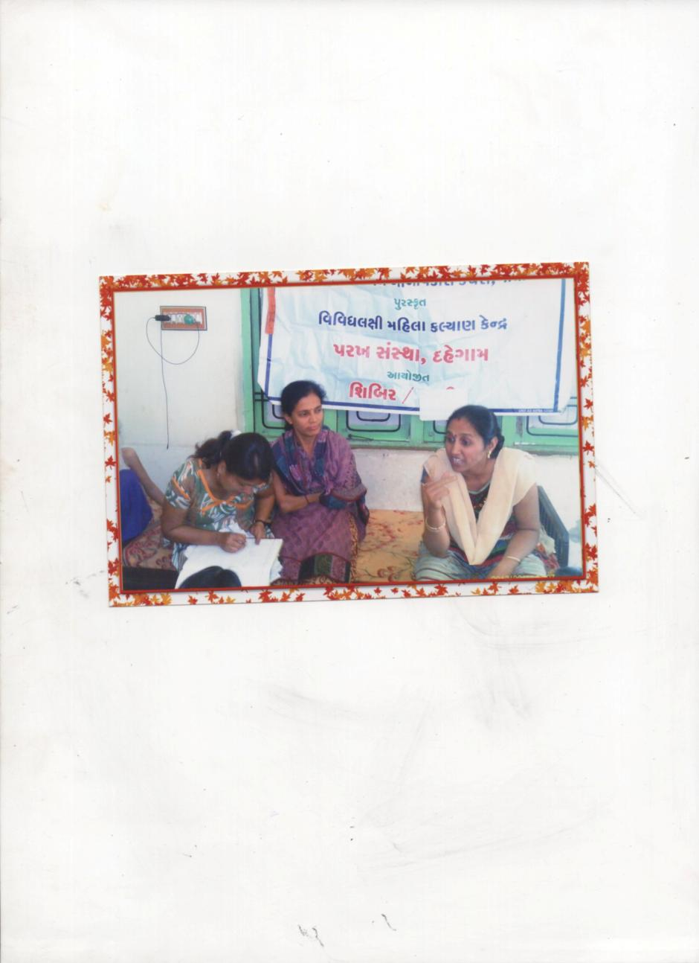
Work done
S.No | Work done | Beneficiares
1 | Govt. scheme | 018
2 | Legal Aid | 014
3 | Employment oriented | 112
4 | Others | 164
 | Total | 308

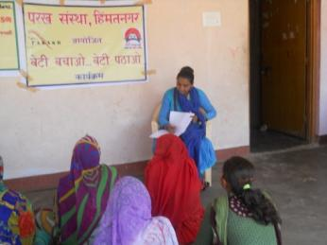
(6) Beti-Bachao Abhiyan and Kanya-Kelvan
To create awareness among the people by arranging the
meetings, camps and conferences at the village,taluka and district
level and bringing this cause to the limelight. When this natural b
alance has been disrupted and disturbed, Parakh has made the
sincere and sustained endeavor in focusing among the people on
the possible disastrous fallout of the imbalanced sex –ratio and
contributed substantially.
Under Kanya Kelvani, Parakh actively participated in the Shala Praveshotsav and Kanya kelvani rath yatra. During 2003 at the shala Praveshotsav of Arjanpura in Himatnagar taluka Pinkal was given rs.1000 of vidya laxmi bond on the spot by the secretary of Parakh for which 5 students of the primary school had been nominated. Besides this, in presence of state project director Mr. Sharma Parakh adopted a cuddly little flower like daughter Pinkal.Presently Parakh provides the study materials and uniform to Pinkal.Parakh has accepted the responsibility of higher education of Pinkal

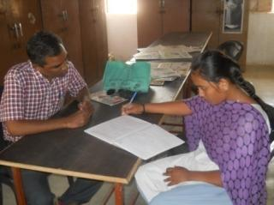
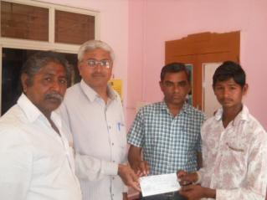

(9) Integrated Education Scheme,
GCERT (IEDC cell ), Gandhinagar
Integrated education means the children
bearing various types of disabilities can
educate themselves staying with their families
and studying in the general school of the
village of their on area

S.N. | Years | MR  kit | Hearing aids | Crutches | Calipers | Tricycle | Edu.kit | Escort  Allowance | Facility Grant
1 | 2004-05 | 08 | 10 | 45 | -- | 15 | 366 | --
2 | 2005-06 | 28 | 18 | 60 | 05 | 30 | 425 | 23
3 | 2006-07 | 62 | 26 | 30 | 05 | 29 | 577 | 26
4 | 2007-08 | 75 | 61 | 27 | 12 | 17 | 641 | 25
5 | 2008-09 | 78 | 65 | 31 | 16 | 26 | 701 | 47
6 | 2009-10 | 07 | 05 | 01 | -- | 02 | 030 | --
7 | 2010-11 | -- | 05 | -- | -- | -- | 035 | --
8 | 2011-12 | 02 | 03 | 01 | -- | 01 | 053 | --
9 | 2012-13 | -- | -- | -- | -- | -- | 046 | 16
10 | 2013-14 | -- | -- | -- | -- | -- | 073 | -- | 73
11 | 2014-15 | -- | -- | -- | -- | -- | 079 | -- | 79
12 | 2015-16 | -- | -- | -- | -- | -- | 090 |  | 90

The benefits out of the allotted assistance to the handicapped children
- The physically handicapped child can acquire education with the help of tricycle, callipers, crutches properly and effectively .Apart from it children can deal with other children of their own area amicably.
- The help of M.R. Educational kit enhances the interest of learning among the children. The pragmatic training received by the children and the knowledge obtained thereby facilitate the children to achieve mental and physical development through effective expression. The help of hearing aid and educational kit develop in the hearing- impaired child the hearing capacity. The hearing impaired child bails out of the inferiority complex of deafness by getting acquainted with the sounds of the surroundings and developing concepts with the average children with the help of hearing-aid

(7) Baxipanch Kumar Chhatralay:
The Parakh institution has got grant in aid Baxi Panch Kumar Chhatralay from 1998
Through the social welfare, V .Jati, Department .Under which, in the year 2015 - 16
40 students were given the facilities of lodging and boarding free of charge.
The student living in the hostel are studying in the schools suitable to them.
The hildren are being given educational articles as per their requirements. Over and
above, planning for tours and picnics are also being arranged.

(8) Dr.Babasaheb A.Open Uni.Programme Centre
Parakh has received this programmer centre since Feb,2005.The students willing receive the education facilities according to their convince in case of lack of time and materials
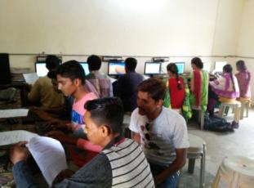
through distance education. The 20 variouscourses fo university
certificate degree diplomaand Post –graduation courses. The
Total 4340 studentsadmitted have studied in this institute
in the year 2015-16 students August – 68 CFN & BPP
February – 16 , in which the most of the students
after admission received training and passed as
the demand of the time.

- The Parakh Institution has got approval as of consumer

Customer protection Mandal from the year 2005.Under this the institution is giving programmers of awareness programmers are beings arranged for bringing transparency. In the matters that the customer may not be cheated for the quality of goods mark for values of ,goods for weight and measurements etc. Taking complaints from the customers proper actions are being taken for its disposal. In the year 2015-16, the activities as shown below where taken on hand .
During the year total 52 programmers were arranged alike shippers, seminars, workshop, visual, meetings, Exhibition. -04.Over and above this 25 complaints received from the customer -2912.Pamphlates-8500 were distributed regarding awareness And celebration of 24, December. The number of programmers as under:

No | Date | Place | Number of  Participate | 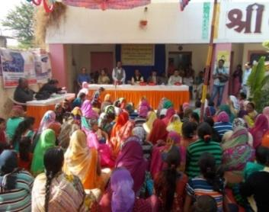  Details programmes
1 | 21/12/2015 | Parabada  Pri-School | 235 | Rallys
2 | 22/12/2015 | Piplodi Anganwadi Hall | 80 | Seminar
3 | 23/12/2015 | Navalpur  Pri-School | 270 | Rally
4 | 24/12/2015 | Bholeshwar Adarsh Pri-School | 285 | 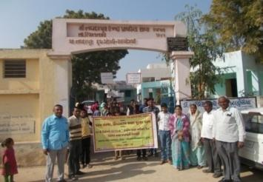  Seminar
5 | 28/12/2015 | Saroli Pri-School | 130 | Rally
6 | 29/12/2015 | Tajpuri Anganwadi-2 | 70 | Seminar
7 | 30/12/2015 | Derol | -- | Patrika Distribute

Celebration 15th March n2016 as customer rights Days for number of programmes as under:

No | Date | Place | Number of  Participate | Details programmes
1 | 12/3/2016 | Jitod | 70 | Seminar
2 | 14/3/2016 | Jitod Chapara | 40 | Seminar
3 | 15/3/2016 | Dolgadh | 110 | Seminar
4 | 16/3/2016 | Vaktapur | 40 | Seminar
5 | 17/3/2016 | Govindpura | 62 | Rally
6 | 18/3/2016 | Likhi | Patrika Distribute | Patrika Distribute
7 | 19/3/2016 | Kathvadiya | 50 | Shibir

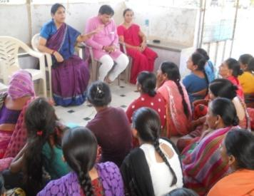
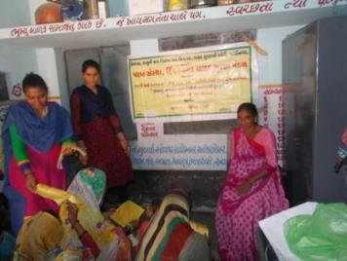
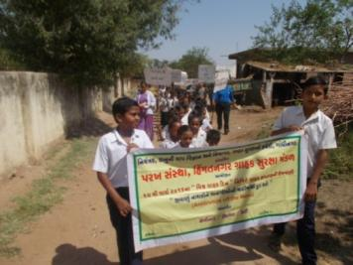

Details of Consumer Club
The Beginning of the Consumer Club for the purpose of young generation involve in this awareness programme of customer awareness for the whole state secondary School.The 25 Consumer club allots to Parakh Trust in Sabarkantha district.
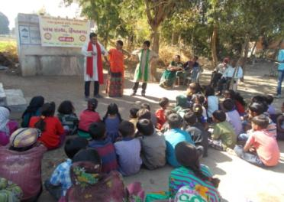
Details of Awareness Programme.: Street Play One Act Play

No | Place | Taluka | District
1 | Vasari | Bhiloda | Arvalli
2 | Narsoli(Naranpur) | Bhiloda | Arvalli
3 | Dholvani | Bhiloda | Arvalli
4 | Mohanpur | Bhiloda | Arvalli

IEC –Activities:-
Parakh Trust organised the different types of Activities for Awareness of people .:
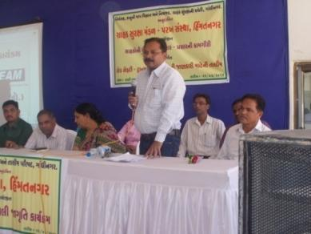
Customer Protection Mandal is working in the
Sabarkantha district under the Parakh Trust.We are
make different types of activities for people awareness.
Parakh Trust organised a Seminar for Road safety
programme for people awareness. In this Programme
legal expart, RTO Inspector ,Representative of District
Supply Officer , Controller Legal Metrology and
Director Consumer Affairs were Invited for the success
of programme . Representative of R.T.O Office
(Shri M.J.Zala)presentation a Slide projector and PPT
for the rules and Laws of Roads.
- Education Health and Population awareness programme

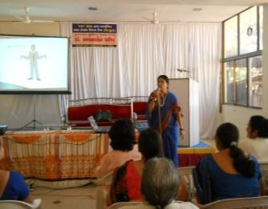
with the co-operation the prohibition and excise Department, the institution is in active working movement of the various programmes of freedom of addiction on the day of Gandhi Jayanti. The Parakh institution is doing many activities for social Health and for formation of awaiking society during the year in which includes freedom bringing out of addictrion campaigin save female child campaign programme for awareness regarding Aids,Girls Education Career,Employment Guidance Protection pollution.
:- Consrntration can be brought in children.

:- The children can get nourishing food.
Remaining constantly active for eradication of
polio campaign,shibir of legal knowledge,consumer
protection campaign through shibirs,meetings,ralley,pamphlets
distribution etc.Duriong the year 2015-16 , the activities as under were done.
No. | Details of programme | No. of Programme | Beneficiaries
1 | Leaving up of addiction | 07 | 0732
2 | Environment Programme | 12 | 1110
3 | AIDS awareness Programme | 01 | 0187
4 | Female Education | 07 | 0161
5 | Guide lines for career &employment | 14 | 0643
6 | Pollution protection | 09 | 0612
7 | Pre-knowledge of legal | 71 | 1666
8 | Consumer protection campaign | 23 | 2345
9 | Polio eradication campaign | 01 | 870
10 | Pamphlets distribution. | -- | 18500

The parakh institution is going arranging special programmer again social basd customs and for addiction of tobacco,wine,gambling.For this,institution is working by getting co-operation of youths,social workers,volunteer and other social institutions
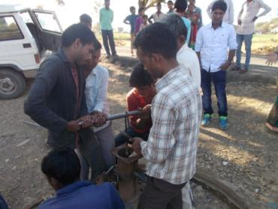
(12) Hand Pump Unit , Bhiloda
Gujarat Water supply And Sewerage Board, Gandhinagar
It is Useful for Tribal Areas People
It is Organised Reapering by
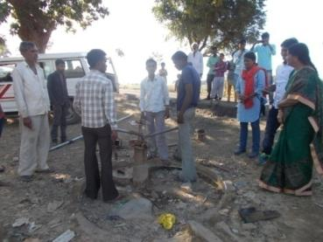
Parakh Trust Teachnical Team -08
Hand Pump Bhiloda Village
165 & 1230 Hand pump ,
Vijaynagar 85 & 980 and Malpur 62 & 795 Hand Pump Ripe
ring activity tribal area ST Beneficiaries 150250 serves,
Activity under project sunshine 1998

(13) TB ACSM ACTIVITIES
1. Community Meeting 2.School Activity
3. Sensitization Meeting 4.patient providers meeting
5.Heath Facility meting 6.TB Support Group Meeting
7.Mobilization of Local Political commitment and resources for TB
8.improved cases detection and treatment adherence
9.Empower people and Communities Affected by TB
10.Reduced Stigma and discrimination against persons Families Affected by TB

The NGO well be expected to coordinate with district RNTCP units to implement a minimum set of advocacy , communication and social mobilization interventions in district.

Community Meeting | School Activity | Sensitization Meeting | Dot’s Provides  Meeting | Total village | Total person  Participate
48 | 12 | 12 | 48 | 154 | 82,910

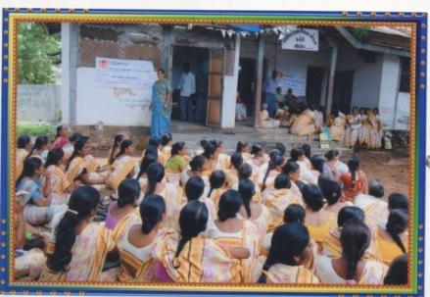
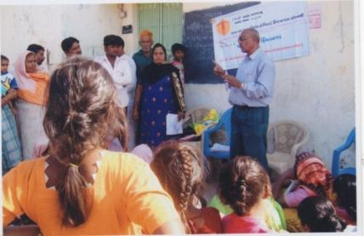

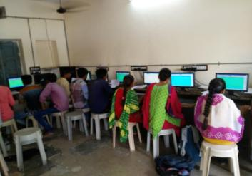
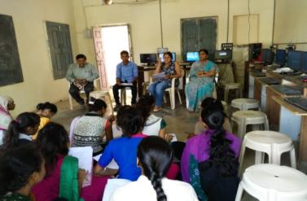

(14) V.T.P NULM Ummid Programme

Ummid Programme is organised Parakh trust for theurban areas poor and necessity educated boys and girls get employment .Boys and girls got employment andlives life and got respect in society and include main stream in society.so this programme is for the employment of urban areas educated boys and girls amd make capable them.
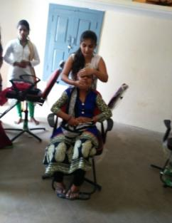
To give relexation of 5 years Urban areas boys and girls of age group of 14 to 35 and standard -5 Pass/10th Pass urban areas poor student, and get first priority to BPL beneficiaries, widow, disabled, orphan. Especially for the needs for the technical skilled syllabus for the criteria of less than standard 5 study and inclusion of 40% women beneficiaries.
S.No | Distic | Nagarpalika Name | Name of Trade | No of Beneficiaries
1 | Sabarkantha | Himmatnagar | Computer Tally | 25
 |  | ’’ | Beauty parlour L-1 | 25
 |  | ’’ | Garment Making | 25
 |  | Pratij | Beauty parlour L-1 | 20
 |  | ’’ | Garment Making | 20
 |  | Talod | Beauty parlour L-1 | 50
 |  | ’’ | Garment Making | 25
 |  | ’’ | Garment Making | 25

(15) IRIGATION SCHEME BY SARDAR SAROVAR NARMADA NIGAM LTD.
Life line of Gujarat of the Narmada is wide area of irrigation when limit of water storage. The irrigation development make wide for the purpose of agriculture area 5000 Hr wide area divide by different village service area (VSA) Narmada’s water provide by minor canal. Every village make (Piyat Sahkari Mandali) as apart of water Irrigation Management .So they can manage self water distribution for irrigation.They can awake the system of Co-operative mandli and his by laws rules and regulations.In this related they can make different types of committee that is ,Construction Committee, Accountant and for Legal Jutice. Above this information, for the beneficiaries farmer due to manage this work by NGO decided by Sardar Sarovar Narmada Nigam Limited, Gandhinagar.
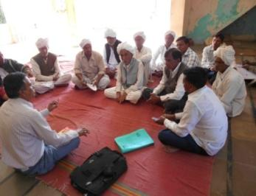
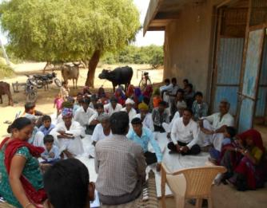
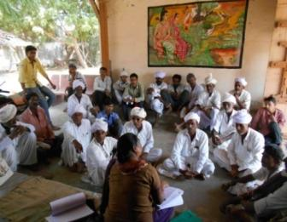
Sardar Sarovar Narmada Nigam Limited, Gandhinagar has allot to Parakh Trust the Banaskantha District atreas,

(16) Star Kids School : Beginning by Parakh Trust
K G-1 10 Children
K G-2 7 Children
5ZB 8=:8 lC\DTGUZ wJFZF JQF"vZ_!& YL GlJG :8FZ 5|FYlDS XF/F WMZ6 ! YL 5 U]HZFTL DFwIDGL GL X~VFT SZJFDF\ VFJ[,P

