ANNUAL REPORT

Year- 2013-14

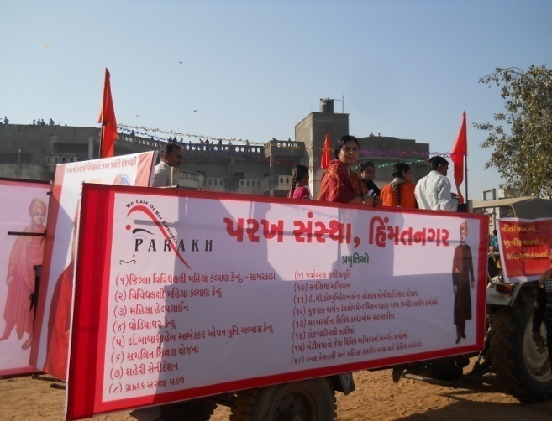

PARAKH SANSTHA
Ambawadi, Bar Bangla,
Ta.Himathanagar,Dist.Sabarkantha(Gujarat)
Phon No.(02772)247941-243142

  - Introduction
Parakh Trust was established in 29th January 1994 with the aim of social development (unlistment ). It has been able to get expected result by doing development activities in different economic, social and education consistently. So make this dream come true ,all the people involved with this organization including trustee ,Secretary and the president as well as workers have immense work . In order to do good of common person . The Trust has in collaboration with the government participated in various government scheme . At the same time the trust itself he organized training program and workshop to train the people so that they can be self reliant and do their activity themselves . the organization has spread it wing with interior areas state and tried to satisfy the desire of the people . invites in remote areas . It has tried it lead best to give all kind of support and guidance to the common men so that He/she can not remain behind in the first developing society all over the world .Government has also helped to trust in makes people aware about different program . The Trust has been primarily in active against the program for women Atrocity save girl child campaign preventing killing of girl baby from taking birth abortion of women violence against women etc.the trust has participated actively in the government sponsored programmes like kanya Kelvin ,women empowerment ,Krishi Ruth etc. The helping the Government to spared the awareness among people . The trust has also helped women of different section by providing loans from the bank .

Network of the organization

The Parakh Trust is working all over the Gujarat state. However it has done must of it
Activities in Sabarkantha , Surendrnagar, Amreli ,Arvalli,junadh, Ahemadvad Patan, Panchmahal,
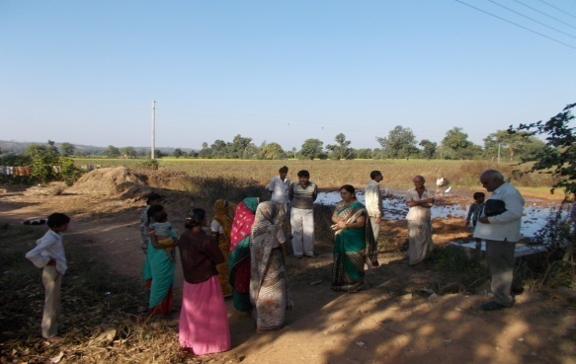
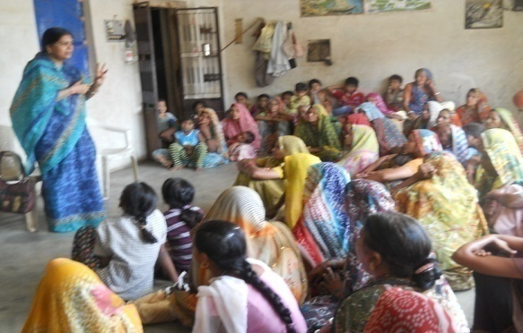
Gandinagar, Banaskantha and Kutch district etc

  - Detailed Activities of Trust

1. District multipurpose woman welfare Centre  - Woman Help line  - Woman Self-Help Groups :Objectives  - Beti-Bachao Abhiyan and Kanya-Kelvani  - Women Training Cente  - (STEP) | 2. Education Oriented Activities  - Baxipanch Kumar Chhatralay  - Dr.B A.Open Uni.Pro. Centre  - Integrated Education Scheme,  GCERT (IEDC cell  - Sarva Siksha Abhiyan  - Ummid Programme

3.Health Oriented Activities  - TB ACSM ACTIVITIES  - Polio Immunization  - Child Health, Awareness Programme,  - Save Girl-Child, Prevention of Killing of  Girl child in womb | 4.Environment Oriented  - Environment Protection Project  - Horticulture Mission  - Fruits Conservation  - Growing of Trees (Plantation
5.Economic Development Oriented  - Self Employment Training  - Water Research Programme  - Hand Pump Unit  - Urban Sanitation Programme:  - Check Dams  - L.I | 6.Social Development Oriented  - Consumer Protection  - Vyasan Mukti

7.Others Activities
- Multiple Training
- Misc.Work, Get to gathering

(1) District multipurpose woman welfare centre , Himmatnagar
The trust is running this center in the 13th Taluka of Sabarkantha district This centre is sponsored by the commissioner ,women and child development Gandhinagar under this programmer women has provided guidance on legal aid social health ,employment and career development
Main Activities of this centre -legal aid in collaboration with
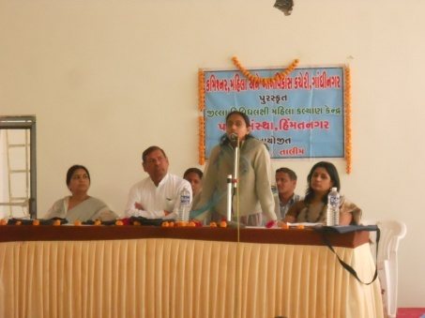
Work done
S.No | Work done | Beneficiares
1 | Govt. scheme | 400
2 | Legal Aid | 080
3 | Oriented Employment | 110
4 | others | 240
 | Total | 830

Work done under different Govt. scheme

S.No | Govt.Sceme | Beneficiares
1 | Widow-help | 00
2 | Old-age help | 04
3 | Handicapped Aid | 07
4 | Chirinjivi yojana | 15
5 | Employment oriented | 33
6 | Gardian Perants | 03
7 | National Family Sahay | 01
8 | Identicard | 01
9 | Medical Aid | 01
10 | District udhyog Kendra aid | 00
11 | Sant surdas | 12
12 | Kunvarbainu mamerau yojana | 15
 | Total | 91
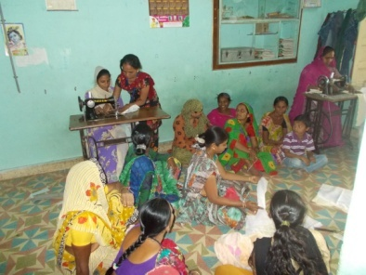
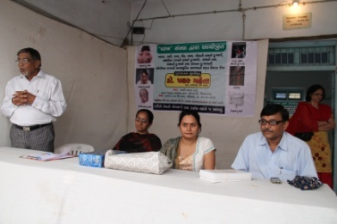
(2) Vividhlakshi Mahila Kalyan Kendra, Talod,
Under this programme women of different sections are provided with guidance,training and made aware about different subject like self-help group saving and team spirit,health awareness and presently development.
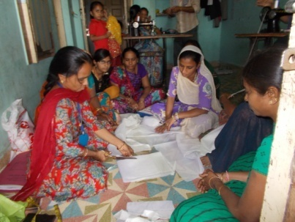
Since August 2006,the trust has three this centre provided information in to 83 village out of total 96 village the details is as under.
S.No | Work done | Beneficiares
1 | Govt. scheme | 344
2 | Legal Aid | 014
3 | Employment oriented | 027
4 | others | 408
 | Total | 803

Work done

(3) Vividhlakshi Mahila Kalyan Kendra ,Bhiloda
Under this programme women of different sections are provided with guidance,training and made aware about different subject like self-help group saving and team spirit,health awareness and presently development.
Since March 2009,the trust has three this centre provided information in to 78 village out of total 90 village the details is as under.
Work done
S.No | Work done | Beneficiares
1 | Govt. scheme | 000
2 | Legal Aid | 233
3 | Employment oriented | 218
4 | Others | 275
 | Total

(4) Vividhlakshi Mahila Kalyan Kendra , Dahegam,

Under this programme women of different sections are provided with guidance,training and made aware about different subject like self-help group saving and team spirit,health awareness and presently development.
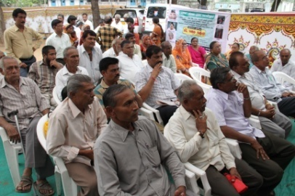
Since March 2009,the trust has three this centre provided information in to 91 village out of total 87 village the details is as under.
Work done
S.No | Work done | Beneficiares
1 | Govt. scheme | 161
2 | Legal Aid | 005
3 | Employment oriented | 826
4 | Others | 493
 | Total | 1485

(5) Woman Awarenes Programme :
S.No | Date | Place | Subject | Beneficiares
1 | 13/03/13 | Mathasuliya | Govt Schemes | 080
2 | 18/06/13 | Adpodara | Govt Schemes | 070
3 | 10/09/13 | Jamla | womans law | 100
4 | 18/11/13 | Vagelawas | Employment oriented | 080
5 | 02/01/14 | Kaniyol | Heath Information | 050

(6) Woman Help line :
The true her got the women helpline project from the Woman and Child development, New Delhi from 2006. Under the scheme women got telephonic guidance and help on their problem, further they are gain toll free number 1091 where they can send their problem. This service is available 24 hours. Under this the trust has received number cases so far
S.No | Details | Numbers
1 | Employment related | 021
2 | Legal | 044
3 | Social | 165
4 | Others | 170
 | Total | 400

(7) Skill up-gradation training programme by
Gujarat Women development Corporation Limited Gandhinagar.
This training programme for womens annual income up to 36000/- and age group
18 to 35 of rural and urban areas beneficiaries and training place areas below.
No | Dist | Name of Trade | No. of beneficiaries
1 | Sabarkantha | Beauty parlour | 2000
 |  | Readymade Garment | 0875
 |  | Embroidery | 0750
 |  | Detaantry.op | 0125
2 | Gandhinagar | Beauty parlour | 0250
 |  | Embroidery | 0050
 |  | Readymade Garment | 0125
3 | Maheshana | Beauty parlour | 0750
 |  | Readymade Garment | 0375
 |  | Embroidery | 0250
4 | Bharuch | Beauty parlour | 0375
 |  | Readymade Garment | 0250
 |  | Embroidery | 0250

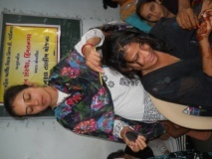
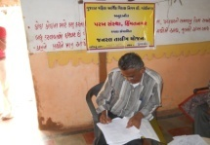
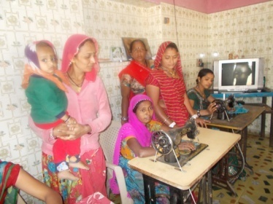
(8) Beti-Bachao Abhiyan and Kanya-Kelvani:
To create awareness among the people by arranging the meetings, camps and conferences at the village,taluka and district level and bringing this cause to the limelight. When this natural balance has been disrupted and disturbed,Parakh has made the sincere and sustained endeavor in focusing among the people on the possible disastrous fallout of the imbalanced sex –ratio and contributed substantially.
Under Kanya Kelvani, Parakh actively participated in the Shala Praveshotsav and Kanya kelvani rath yatra. During 2003 at the shala Praveshotsav of Arjanpura in Himatnagar taluka Pinkal was given rs.1000 of vidya laxmi bond on the spot by the secretary of Parakh for which 7 students of the primary school had been nominated. Besides this, in presence of state project director Mr. Sharma Parakh adopted a cuddly little flower like daughter Pinkal.Presently Parakh provides the study materials and uniform to Pinkal.Parakh has accepted the responsibility of higher education of Pinkal.
(9) RGPS Panchayati Training Prog.
Preface :
The Govt Derartment of Development Commissioner organised training programme for elected member of district panchayat,Taluka ppppppanchayatand Grampanchayat (PRI).This trainng programme managed by Parakh Trust,Himatnagar.Programme alloted for Gandhinagar district
This Training programme planing organised by offfice of the development commissioner developed a training module.This trainning programme make success by masters trainers,Parakh Trust make wide publicity for awareness of training programme.
Aim of training:
The main aim of this training programme is to make Govt PRI officers and elected members to find out solution for rural areas people and make administrative service transperancy.They can knows the Govt Schemes and programme for the people.They can learn how to raise partnership in PRI institute.
Details of Training Programme for theElected members & Govt officer of PRI by RPGS scheme.

Sr.no | Block Name | District Panchayat |  |  | Taluka Panchayat |  |  | Gram PAnchayat
 |  | No of Elected members | No of Govt Officers | Total | No of Elected members | No of Govt Officers | Total | No of Elected members | No of Govt Officers | Total | Total  members & Govt Officers
1 | Gandhi agar | 00 | 00 | 00 | 26 | 22 | 48 | 481 | 53 | 534 | 582
2 | Dagenham | 00 | 00 | 00 | 19 | 16 | 35 | 544 | 45 | 589 | 624
3 | Mansa | 00 | 00 | 00 | 19 | 02 | 21 | 439 | 33 | 472 | 493
4 | Kalol | 00 | 00 | 00 | 22 | 0 | 22 | 429 | 46 | 475 | 497
 | Total | 00 | 00 | 00 | 86 | 40 | 126 | 1893 | 177 | 2070 | 2196

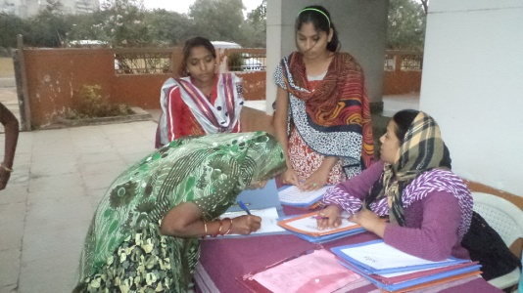
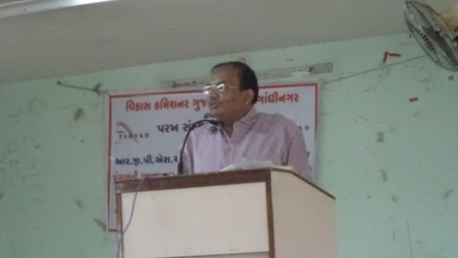
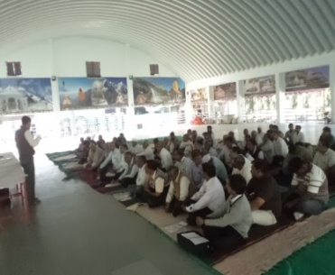
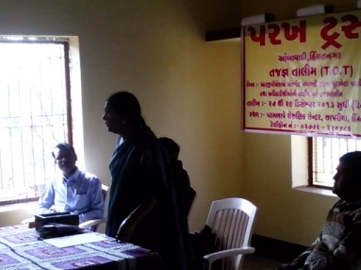

(11) Dr.Babasaheb A.Open Uni.Programme Centre.

Parakh has received this programmer centre since Feb,2005.The students willing receive the education facilities according to their convince in case of lack of time and materials through distance education. The 20 various courses fo university certificate, degree diploma and Post –graduation courses. The Total 4215 students admitted have studied in this institute in the year 2013-14 students August -63 & February – 62, in which the most of the students after admission received training and passed as the demand of the time.
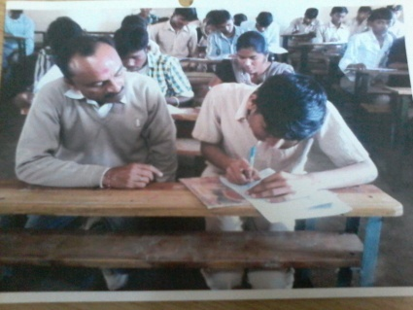
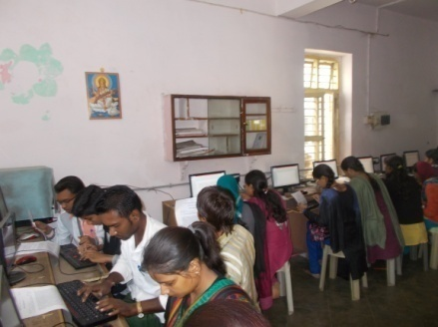
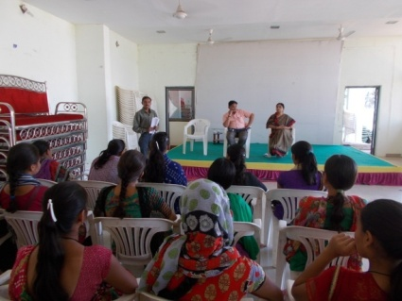

- Integrated Education Scheme, GCERT (IEDC cell ), Gandhinagar

Integrated education means the children bearing various types of disabilities can educate themselves staying with their families and studying in the general school of the village of their on area
S.N. | Years | MR  kit | Hearing aids | Crutches | Calipers | Tricycle | Edu.kit | Escort  Allowance
1. | 2004-05 | 08 | 10 | 45 | -- | 15 | 366 | --
2. | 2005-06 | 28 | 18 | 60 | 05 | 30 | 425 | 23
3. | 2006-07 | 62 | 26 | 30 | 05 | 29 | 577 | 26
4. | 2007-08 | 75 | 61 | 27 | 12 | 17 | 641 | 25
5 | 2008-09 | 78 | 65 | 31 | 16 | 26 | 701 | 47
6 | 2009-10 | 07 | 05 | 01 | -- | 02 | 030 | --
7 | 2010-11 | -- | 05 | -- | -- | -- | 035 | --
8 | 2011-12 | 02 | 03 | 01 | -- | 01 | 053 | --
9 | 2012-13 | -- | -- | -- | -- | -- | 046 | 16
10 | 2013-14 | -- | -- | -- | -- | -- | 073 | --

The benefits out of the allotted assistance to the handicapped children
- The physically handicapped child can acquire education with the help of tricycle, calipers, crutches properly and effectively .Apart from it children can deal with other children of their own area amicably.
- The help of M.R. Educational kit enhances the interest of learning among the children. The pragmatic training received by the children and the knowledge obtained thereby facilitate the children to achieve mental and physical development through effective expression. The help of hearing aid and educational kit develop in the hearing- impaired child the hearing capacity. The hearing impaired child bails out of the inferiority complex of deafness by getting acquainted with the sounds of the surroundings and developing concepts with the average children with the help of hearing-aid

(13) Baxipanch Kumar Chhatralay:
The Parakh institution has got grant in aid Baxi Panch Kumar Chhatralay from 1998
through the social welfare,V.Jati,Department .Under which,in the year 2013-14,totally
35 students were given the facilities of lodging and boarding free of charge.
The student living in the hostel are studying in the schools suitable to them. The
children are being given educational articles as per their requirements. Over and
above, planning for tours and picnics are also being arranged.

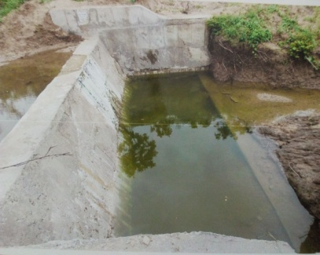
- Activities Pertaining to Irrigation (Check Dams)

The work of three check dams different places of the skim of village
Ashokpura, Mhobatpural of Himatnagar Taluka Job.No. 432 and Village
with sharing of public contribution the year:- 2013 -14 was done by the
executive Engineer’s office,irrigation Division, Himatnagar.And by this total
0460 acres of land of 2100 beneficiaries occupying land surrounding it got
the benefit of irrigation. And due to this check dams, the level of water has also
come put and the fertility of the land has increased.
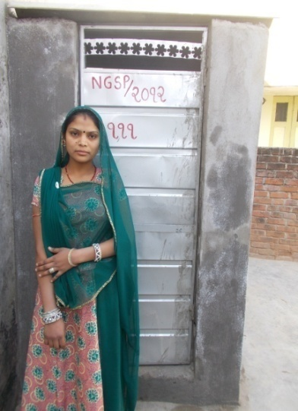
(15) Urban Sanitation Programme:
Aided by Gujarat Municipal Finance Board,
Gandhinagar low cost Lavatories are constructed at

S.No | Distic | Nagarpalika Name
1 | Sabarkantha | Himatnagar
 |  | Talod
2 | Ahemedabad | East Joan
3 | Surendrnagar | Surendrnagar

- The Parakh Institution has got approval as of consumer
protection Mandan from the year 2005.Under this the institution is giving programmers of awareness programmers are beings arranged for bringing transparency. In the matters that the customer may not be cheated for the quality of goods mark for values of ,goods for weight and measurements etc. Taking complaints from the customers proper actions are being taken for its disposal. In the year 2013-14, the activities as shown below where taken on hand .
During the year total 54 programmers were arranged alike shippers, seminars, workshop, visual, meetings, Exhibition. And celebration of 24, December. The number of programmers -07;celebrations 15th March number of programmer -07.Over and above this 24 complaints received from the customer -1705.Pamphlates-8500 were distributed regarding awareness.
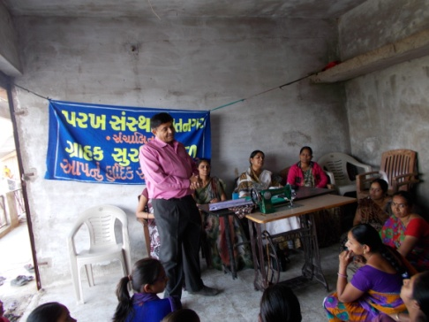
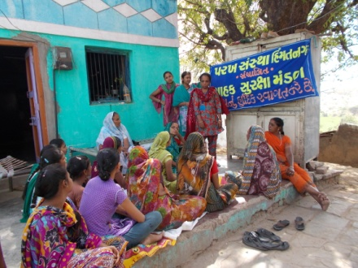

- Education Health and Population awareness programme
with the co-operation the prohibition and excise Department, the institution is in active working movement of the various programmes of freedom of addiction on the day of Gandhi Jayanti. The Parakh institution is doing many activities for social Health and for formation of awaiking society during the year in which includes freedom bringing out of addictrion campaigin save female child campaign programme for awareness regarding Aids,Girls Education Career,Employment Guidance Protection pollution.
:- Consrntration can be brought in children.
:- The children can get nourishing food
Remaining constantly active for eradication of polio campaign,shibir of legal knowledge,consumer protection campaign through shibirs,meetings,ralley,pamphlets distribution etc.Duriong the year 2013-14 , the activities as under were done.
No. | Details of programme | No. of Programme | Beneficiaries
1 | Leaving up of addiction | 12 | 1050
2 | Environment Programme | 10 | 0770
3 | AIDS awareness Programme | 00 | 0000
4 | Female Education | 05 | 0450
5 | Guide lines for career &employment | 13 | 0637
6 | Pollution protection | 18 | 1060
7 | Pre-knowledge of legal | 63 | 1500
8 | Consumer protection campaign | 22 | 2200
9 | Polio eradication campaign | 02 | 0050
10 | Pamphlets distribution. | -- | 19500

The parakh institution is going arranging special programmer again social basd customs and for addiction of tobacco,wine,gambling.For this,institution is working by getting co-operation of youths,social workers,volunteer and other social institutions.
(17) Hand Pump Unit , Bhiloda
Gujarat Water supply And Sewerage Board, Gandhinagar
It is Useful for Tribal Areas People
It is Organised Reapering by Parakh Trust Teachnical Team -08
Hand Pump Bhiloda Village 165 & 1172 Hand pump , Vijaynagar 85 & 955 and Malpur 62 & 610
Hand Pump Ripe ring activity tribal area ST Beneficiaries 136850 serves, Activity under project sunshine 1998
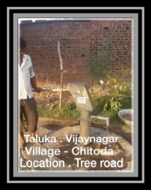
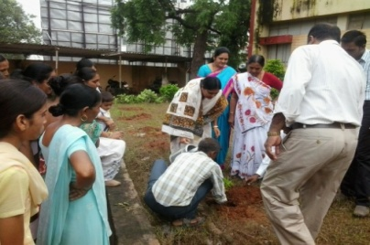
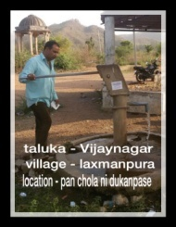

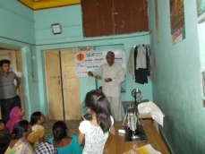
(18) TB ACSM ACTIVITIES
1. Community Meeting
2. School Activity
3. Sensitization Meeting
4.patient providers meeting
►Heath Facility meting
►TB Support Group Meeting
►Mobilization of Local Political commitment and resources for TB
►improved cases detection and treatment adherence
►Empower people and Communities Affected by TB
► Reduced Stigma and discrimination against persons Families Affected by TB

The NGO well be expected to coordinate with district RNTCP units to implement a minimum set of advocacy , communication and social mobilization interventions in district.
Community Meeting | School Activity | Sensitization Meeting | Dot’s Provides  Meeting | Total village | Total person  Participate
48 | 12 | 12 | 28 | 158 | 78,165

s19f Ummid Programme
Ummid Programme is organised Parakh trust for theurban areas poor and necessity educated boys and girls get employment.Boys and girls got employment andlives life and got respect in society and include main stream in society.so this programme is for the employment of urban areas educated boys and girls amd make capable them.
To give relexation of 5 years Urban areas boys and girls of age group of 18 to 35 and standard -5 Pass/Fail urban areas poor student,and get first priority to BPL beneficiaries,widow,disabled,orphan. Especially for the needs for the techical skilled syllabus for the criteria of less than standard 5 study and inclusion of 40% women beneficiaries.
S.No | Distic | Nagarpalika Name | Name of Trade | No of Beneficiaries
1 | Sabarkantha | Himmatnagar | M.S. Office | 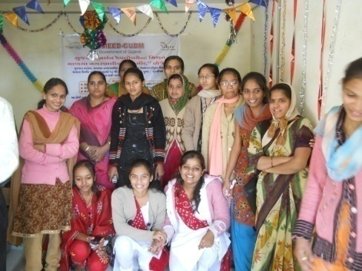  25
 |  | ’’ | Beauty parlor | 30
 |  | ’’ | Tailoring class | 25
 |  | ’’ | Embroidery | 25
 |  | Pratij | Rakhadi | 36
 |  | ’’ | Tailoring class | 36
 |  | Talod | M.S. Office | 32
 |  | ’’ | Catering | 40
 |  | ’’ | Motar Driving | 28
 |  | Vadali | Beauty parlor | 30
2 | Gandhinagar | Dahegam | Beauty parlor | 47
 |  | Pethapur | Embroidery | 50
3 | Junagadh | Talala | Beauty parlor | 29

s20f Gujarat water Resources Development Corporation-Gandhinagar
Division:G.W.R.Dn.Ahmedabad & Sub Dn : G.W.R.Himatnagar
Name of work : Construction of civi work of L.I.Scheme at Villge: Sulatanpur,Tal.Bayad
Dist.Sabarakantha M.O.U.No.15/2013-14 Parakh Trust.
- To make survey river and pond available water source
- To make R CC well on the bank of Vatrak River and lift water to provide beneficiaries.
- Todistribute water to beneficiaries for agriculture use by pipe-line.
- To make farmer mandali and elect president and secretary.
- This scheme is very useful for farmer and they developed wasteland and got lot of crop and make prosperous.
This scheme is implemented at sulatanpur, village Block Bayad.This irrigation Scheme developed 25 hector land and make economic prosperous.
