ANNUAL REPORT

Year- 2012-13

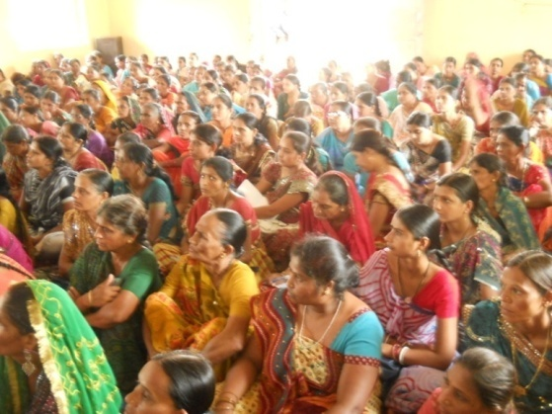

PARAKH SANSTHA
Ambawadi, Bar Bangla,
Ta.Himathanagar,Dist.Sabarkantha(Gujarat)

Introduction

Parakh Trust was established in 29th January 1994 with the aim of social development (unlistment ). It has been able to get expected result by doing development activities in different economic, social and education consistently. So make this dream come true ,all the people involved with this organization including trustee ,Secretary and the president as well as workers have immense work . In order to do good of common person . The Trust has in collaboration with the government participated in various government scheme . At the same time the trust it self he organized training program and workshop to train the people so that they can be self reliant and do their activity them selves . the organizationhasspreaditwing with interiorareasstateand tried tosatisfy the desire of the people . invites in remote areas . It has tried it lead best to give all kind of supportand guidance to the common men so that He/she can not remain behind in the first developing society all over the world .Government has also helped to trust in makes people aware about different program . The Trust has been primarily in active against the program for women Atrocity save girl child campaign preventing killing of girl baby from taking birth abortion of women violence against women etc.the trust has participated actively in the government sponsored programmes like kanya Kelvin ,women empowerment ,Krishi Ruth etc. The helping the Government to spared the awareness among people . The trust has also helped women of different section by providing loans from the bank .
Network of the organization

The Parakh Trust is working all over the Gujarat state. However it has done must of it activities in Sabarkantha , Surendrnagar, Amreli,junadh, ,Jamnagar, Porbandar, Ahemadvad Patan, Panchmahal, Gandinagar, Banaskantha and Kutch district etc.

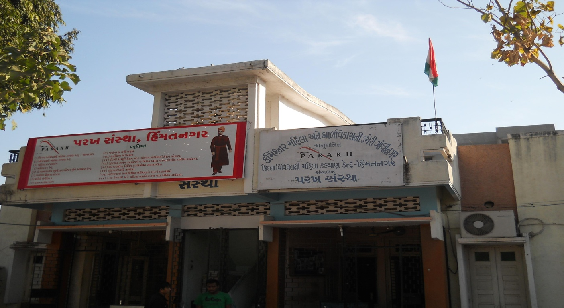

Detailed Activities Of Trust

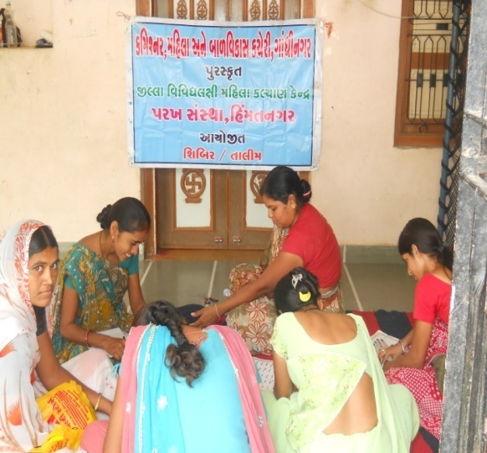
1. District multipurpose woman welfare Centre
Woman Help line
Woman Self-Help Groups :Objectives
Beti-Bachao Abhiyan and Kanya-Kelvani
Women Training Center
(STEP)

2. Education Oriented Activities

Baxipanch Kumar Chhatralay
Dr.Babasaheb A.Open Uni.Programme Centre
Integrated Education Scheme, GCERT (IEDC cell)
Sarva Siksha Abhiyan
Ummid Programme
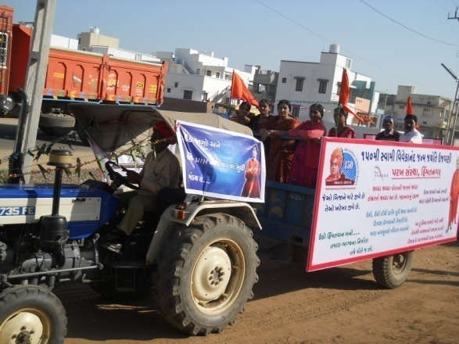
Out of School Children Report of House Hold Survey

3. Health Oriented Activities
TB ACSM ACTIVITIES
Polio Immunization
Child Health, Awareness Programme,
Save Girl-Child, Prevention of Killing of Girl child in womb

4. Environment Oriented
Environment Protection Project
Horticulture Mission
Fruits Conservation
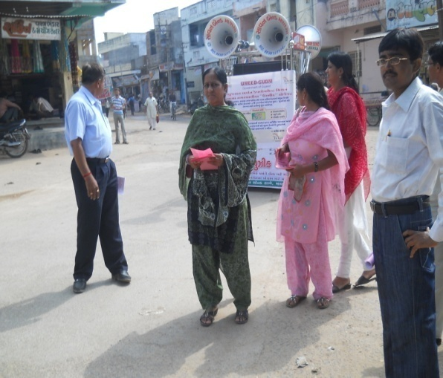
Growing of Trees (Plantation)

5.Economic Development Oriented
Self Employment Training
Water Research Programme
Hand Pump Unit
Urban Sanitation Programme:
Check Dams
L.I

6.Social Development Oriented
Consumer Protection
Vyasan Mukti

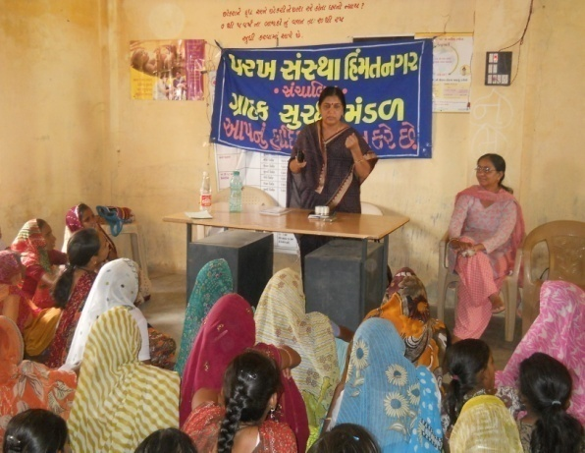
7.Others Activities
Multiple Training
Misc.Work, Get to gathering

- District multipurpose woman Welfarecentre, Himmatnagar

The trust is running this center in the 13th Taluka of Sabarkantha district This centre is sponsored by the commissioner, women and child development Gandhinagar under this programmer women has provided guidance on legal aid social health, employment and career development
Main Activities of this centre:

-legal aid in collaboration with

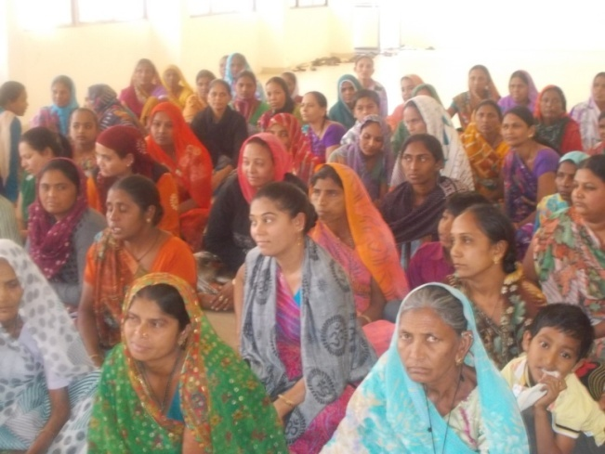
Work done

S.No | Work done | Beneficiares
1 | Govt. scheme | 434
2 | Legal Aid | 103
3 | Oriented Employment | 099
4 | others | 620
 | Total | 1256

Work done under different Govt. scheme

S.No | Govt.Sceme | Beneficiares
1 | Widow-help | 20
2 | Old-age help | 44
3 | Handicapped Aid | 06
4 | Chirinjivi yojana | 04
5 | Employment oriented | 33
6 | Gardian Perants | 02
7 | National Family Sahay | 06
8 | Identicard | 03
9 | Medical Aid | 01
10 | District udhyog Kendra aid | 05
11 | Sant surdas | 04
12 | Kunvarbainu mamerau yojana | 07
 | Total | 135

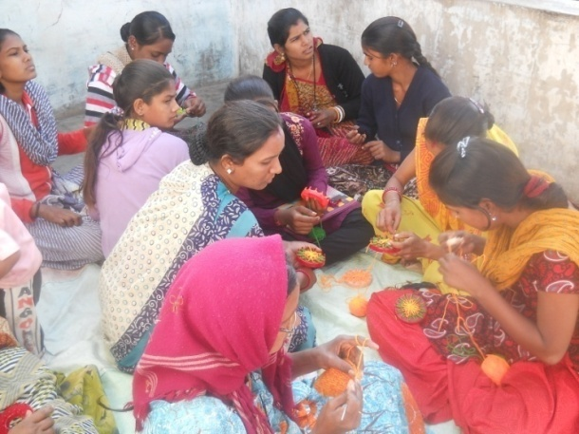

(2) Vividhlakshi Mahila Kalyan Kendra, Talod,

Under this programme women of different sections are provided with guidance,training and made aware about different subject like self-help group saving and team spirit,health awareness and presently development.
Since August 2006,the trust has three this centre provided information in to 83 village out of total 96 village the details is as under.

Work done
S.No | Work done | Beneficiares
1 | Govt. scheme | 395
2 | Legal Aid | 015
3 | Employment oriented | 045
4 | others | 410
 | Total | 865

(3) Vividhlakshi Mahila Kalyan Kendra, Bhiloda,

Under this programme women of different sections are provided with guidance,training and made aware about different subject like self-help group saving and team spirit,health awareness and presently development.
Since March 2009,the trust has three this centre provided information in to 78 village out of total 90 village the details is as under.

Work done
S.No | Work done | Beneficiares
1 | Govt. scheme | 221
2 | Legal Aid | 183
3 | Employment oriented | 191
4 | Others | 313
 | Total | 914

(4) Vividhlakshi Mahila Kalyan Kendra, Dahegam,

Under this programme women of different sections are provided with guidance,training and made aware about different subject like self-help group saving and team spirit,health awareness and presently development.
Since March 2009,the trust has three this centre provided information in to 91 village out of total 87 village the details is as under.

Work done

S.No | Work done | Beneficiares
1 | Govt. scheme | 869
2 | Legal Aid | 116
3 | Employment oriented | 190
4 | Others | 382
 | Total | 1557

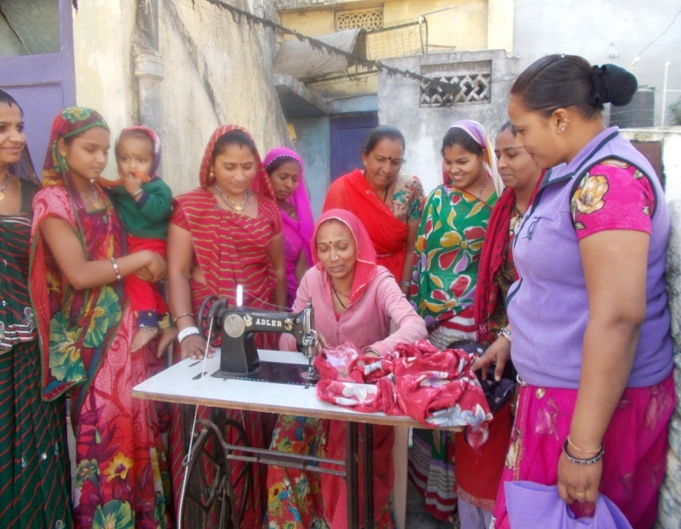
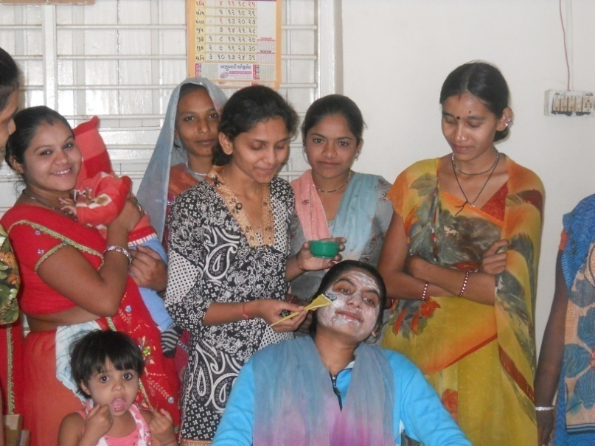

(5) Woman Awarenes Programme:

S.No | Date | Place | Subject | Beneficiares
1 | 09/03/12 | Ambawada | Govt Schemes | 100
2 | 15/06/12 | Gorawada | Govt Schemes | 050
3 | 12/09/12 | Motidemae | womans law | 060
4 | 16/11/12 | Karanpur. | Employment oriented | 030
5 | 05/01/13 | Kevan | Heath Information | 050
6 | 16/02/13 17/02/13 | Kachi Samaj vadi HMT | Women Awareness  Training | 300

(6) Woman Help line:

The true her got the women helpline project from the Woman and Child development, New Delhi from 2006. Under the scheme women got telephonic guidance and help on their problem, further they are gain toll free number 1091 where they can send their problem. This service is available 24 hours. Under this the trust has received number cases so far

S.No | Details | Numbers
1 | Employment related | 035
2 | Legal | 047
3 | Social | 162
4 | Others | 165
 | Total | 409

(7) STEP Government of India Ministry of women & child Development ,New Delhi.

Scheme of Support to Training and Employment Programme for women (STEP) for
Handicraft Project
No of beneficiaries 200.
Duration . Two years.
To develop self –confidence and awareness.
To provide job works for economic development of women.
To encourage women to develop professional skill in the field of handicraft.
To educate women for health and welfare.
To provide marketing support.

First Year Beneficiaries: 100
Second Year Beneficiaries: 100

S.No | Village | No of beneficiaries | S.No | Village | No of beneficiaries
1 | Bholeswar | 40 | 1 | Himatnagar | 20
2 | Kandoli | 20 | 2 | Sundargadh | 40
3 | Kanda | 20 | 3 | Rangpur | 20
4 | Jamla | 20 | 4 | Munpur | 20

Skill up-gradation training Programme by Gujarat Women development Corporation Limited Gandhinagar.
This training programme for womens annual income up to 36000/- and age group
18 to 35 of rural and urban areas beneficiaries and training place areas below.

No | Dist | Name of Trade | No of beneficiaries
1 | Sabarkantha | Beauty parlour | 1000
 |  | Readymade Garment | 1000
 |  | Embroidery | 050
 |  | Detaantry.op | 025
2 | Gandhinagar | Beauty parlour | 050
 |  | Embroidery | 025
 |  | Readymade Garment | 050
3 | Patan | Beauty parlour | 175
 |  | Readymade Garment | 075
4 | Amareli | Beauty parlour | 275
 |  | Readymade Garment | 200
5 | Maheshana | Beauty parlour | 400
 |  | Readymade Garment | 150
 |  | Detaantry.op | 025
6 | Banaskantha | Beauty parlour | 200
 |  | Readymade Garment | 075
7 | Kheda | Beauty parlour | 150
 |  | Readymade Garment | 150
 | Bharuch | Beauty parlour | 350
 |  | Readymade Garment | 150
 |  | Embroidery | 050
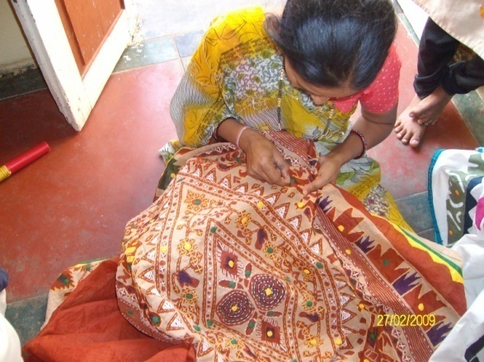



(9) Beti-Bachao Abhiyan and Kanya-Kelvani:

To create awareness among the people by arranging the meetings, camps and conferences at the village,taluka and district level and bringing this cause to the limelight. When this natural balance has been disrupted and disturbed,Parakh has made the sincere and sustained endeavor in focusing among the people on the possible disastrous fallout of the imbalanced sex –ratio and contributed substantially.
.

Under Kanya Kelvani, Parakh actively participated in the Shala Praveshotsav and Kanya kelvani rath yatra. During 2003 at the shala Praveshotsav of Arjanpura in Himatnagar taluka Pinkal was given rs.1000 of vidya laxmi bond on the spot by the secretary of Parakh for which 5 students of the primary school had been nominated. Besides this, in presence of state project director Mr. Sharma Parakh adopted a cuddly little flower like daughter Pinkal.Presently Parakh provides the study materials and uniform to Pinkal.Parakh has accepted the responsibility of higher education of Pinkal.

(10) Baxipanch Kumar Chhatralay:

The Parakh institution has got grant in aid Baxi Panch Kumar Chhatralay from 1998
through the social welfare,V.Jati,Department .Under which,in the year 2012-13,totally
32 students were given the facilities of lodging and boarding free of charge.

The student living in the hostel are studying in the schools suitable to them. The
children are being given educational articles as per their requirements. Over and
above, planning for tours and picnics are also being arranged.

(11) Dr.Babasaheb A.Open Uni.Programme Centre.

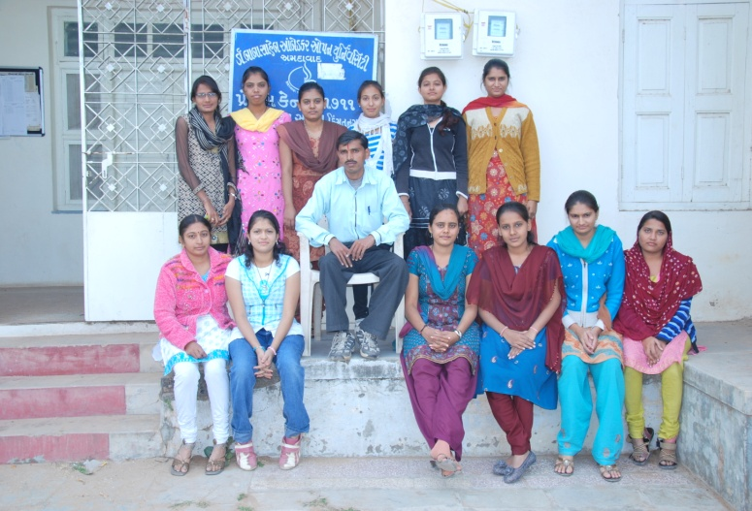
Parakh has received this programmer centre since Feb,2005.The students willing receive the education facilities according to their convince in case of lack of time and materials through distance education. The 20 various courses fo university certificate, degree diploma and Post –graduation courses. The Total 4158 students admitted have studied in this institute in the year 2012-13 students August -36 & February – 21, in which the most of the students after admission received training and passed as the demand of the time.
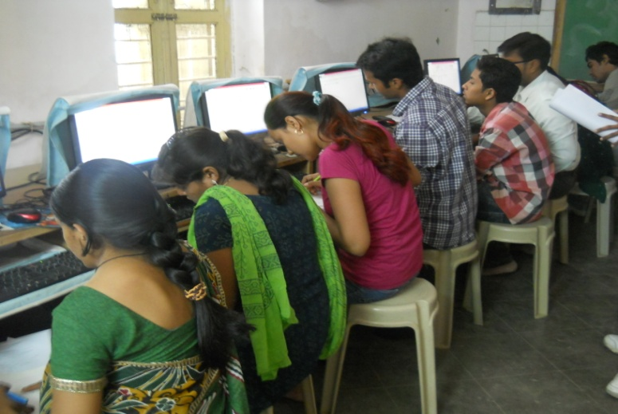

- Integrated Education Scheme, GCERT (IEDC cell ), Gandhinagar

Integrated education means the children bearing various types of disabilities can educate themselves staying with their families and studying in the general school of the village of their on area

S.N. | Years | MR  kit | Hearing aids | Crutches | Calipers | Tricycle | Edu.kit | Escort  Allowance
1. | 2004-05 | 08 | 10 | 45 | -- | 15 | 366 | --
2. | 2005-06 | 28 | 18 | 60 | 05 | 30 | 425 | 23
3. | 2006-07 | 62 | 26 | 30 | 05 | 29 | 577 | 26
4. | 2007-08 | 75 | 61 | 27 | 12 | 17 | 641 | 25
5 | 2008-09 | 78 | 65 | 31 | 16 | 26 | 701 | 47
6 | 2009-10 | 07 | 05 | 01 | -- | 02 | 030 | --
7 | 2010-11 | -- | 05 | -- | -- | -- | 035 | --
8 | 2011-12 | 02 | 03 | 01 | -- | 01 | 053 | --
9 | 2012-13 | -- | -- | -- | -- | -- | 046 | 16

The benefits out of the allotted assistance to the handicapped children

- The physically handicapped child can acquire education with the help of tricycle, calipers, crutches properly and effectively .Apart from it children can deal with other children of their own area amicably.

- The help of M.R. Educational kit enhances the interest of learning among the children. The pragmatic training received by the children and the knowledge obtained thereby facilitate the children to achieve mental and physical development through effective expression. The help of hearing aid and educational kit develop in the hearing- impaired child the hearing capacity. The hearing impaired child bails out of the inferiority complex of deafness by getting acquainted with the sounds of the surroundings and developing concepts with the average children with the help of hearing-aid

- ActivitiesPertainingtoIrrigation (Check Dams)

The work of three check dams’ different places of the skim of village Tajpuri-2, Ashokpura, Mhobatpural of Himatnagar Taluka Job.No.432 and Village Labandiya, Agiya of Khedbrma Taluka Job.No.307-308 with sharing of public contribution in the year 2012-13 was done by the executive Engineer’s office, irrigation Division, Himatnagar. And by this total 675 acres of land of 2500 beneficiaries occupying land surrounding it got the benefit of irrigation. And due to this check dams, the level of water has also come put and the fertility of the land has increased.
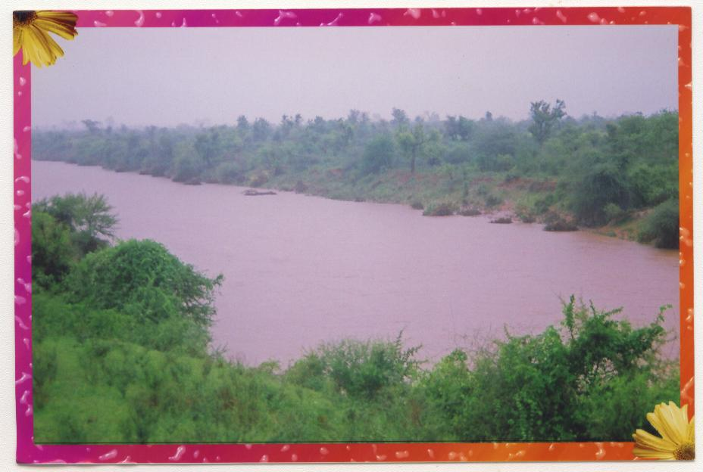
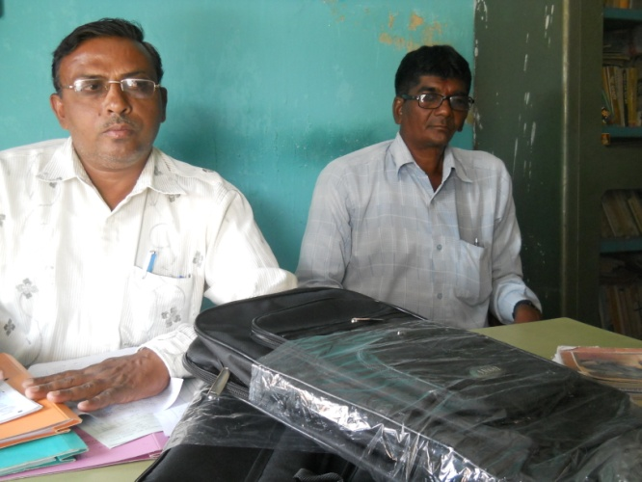

- The Parakh Institutionhas got approval as of consumer

Protection Mandan from the year 2005.Under this institution is giving programmers of awareness programmers are beings arranged for bringing transparency. In the matters that the customer may not be cheated for the quality of goods mark for values of, goods for weight and measurements etc. Taking complaints from the customers proper actions are being taken for its disposal. In the year 2012-13, the activities as shown below where taken on hand.
During the year total 48 programmers were arranged alike shippers, seminars, workshop, visual, meetings, Exhibition. And celebration of 24, December. The number of programmers -9;celebrations 15th March number of programmer -10.Over and above this complaints received from the customer -265.Pamphlates-7200 were distributed regarding awareness

- Education Health and Population awareness programme

with the co-operation the prohibition and excise Department, the institution is in active working movement of the various programmes of freedom of addiction on the day of Gandhi Jayanti. The Parakh institution is doing many activities for social Health and for formation of awaiking society during the year in which includes freedom bringing out of addictrion campaigin save female child campaign programme for awareness regarding Aids,Girls Education Career,Employment Guidance Protection pollution.
:- Consrntration can be brought in children.
:- The children can get nourishing food.
Remaining constantly active for eradication of polio campaign,shibir of legal knowledge,consumer protection campaign through shibirs,meetings,ralley,pamphlets distribution etc.Duriong the year 2012-13 , the activities as under were done.

No. | Details of programme | No. of Programme | Beneficiaries
1 | Leaving up of addiction | 10 | 720
2 | Environment Programme | 19 | 1080
3 | AIDS awareness Programme | 05 | 185
4 | Female Education | 03 | 155
5 | Guide lines for career &employment | 18 | 635
6 | Pollution protection | 13 | 603
7 | Pre-knowledge of legal | 65 | 1630
8 | Consumer protection campaign | 20 | 2250
9 | Polio eradication campaign | -- | --
10 | Pamphlets distribution. | -- | 18000
The parakh institution is going arranging special programmer again social basd customs and for addiction of tobacco,wine,gambling.For this,institution is working by getting co-operation of youths,social workers,volunteer and other social institutions.

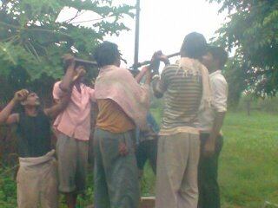
- Hand Pump Unit , Bhiloda

Gujarat Water supply And Sewerage Board, Gandhinagar
It is Useful for Tribal Areas People It is Organised Reapering by
Parakh Trust Teachnical Team Hand Pump Bhiloda Village 165 &
2681 Hand pump , Vijaynagar 85 & 1602 Hand Pump Ripe
ring activity tribal area ST Beneficiaries 79400 serves, Activity
under project unshine 1998

(17) TB ACSM ACTIVITIES

1. Community Meeting
2. School Activity
3. Sensitization Meeting
4.patient providers meeting
►Heath Facility meting
►TB Support Group Meeting
►Mobilization of Local Political commitment and resources for TB
►improved cases detection and treatment adherence
►Empower people and Communities Affected by TB
► Reduced Stigma and discrimination against persons Families Affected by TB

The NGO well be expected to coordinate with district RNTCP units to implement a minimum set of advocacy , communication and social mobilization interventions in district.

Community Meeting | School Activity | Sensitization Meeting | Total village | Total person  Participate
52 | 34 | 16 | 132 | 50,129

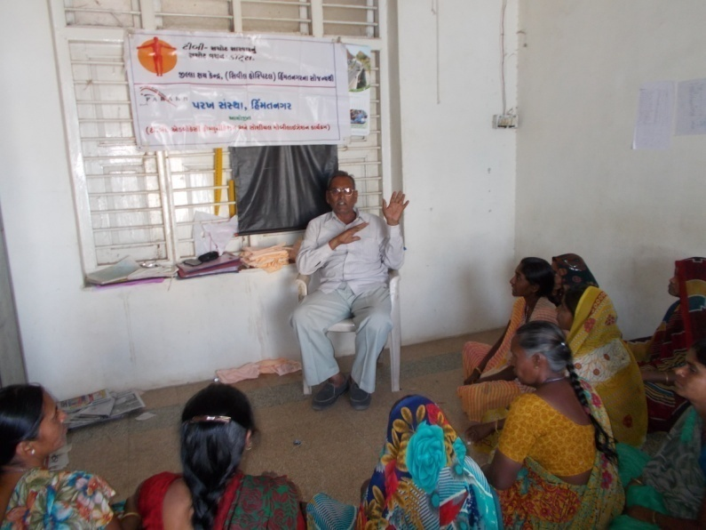
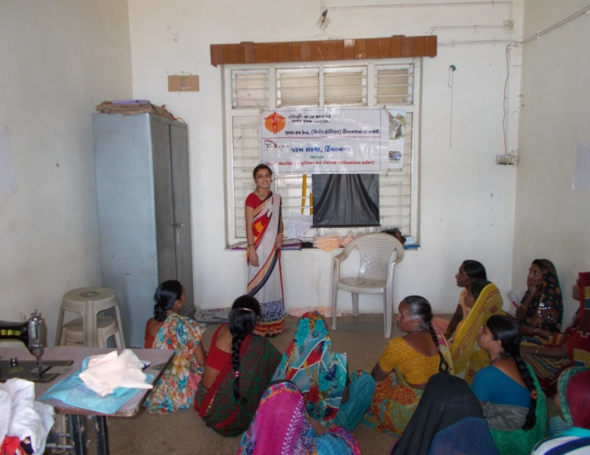

- Sarva Siksha Abhiyan (Bridge Course.)

Trust has begin the resident bridge course for the six months in the block of Megaraj in Sabarkantha district The resident bridge course for the age group 6 to 10 for the disabled children.The main purposr is to that the out school disabled Children get the primary education in his environment. This children has got the education from different subject expert and take exposure visit of different developed education institute and provide education.

(19) Ummid Programme
Ummid Programme is organised Parakh trust for theurban areas poor and necessity educated boys and girls get employment.Boys and girls got employment andlives life and got respect in society and include main stream in society.so this programme is for the employment of urban areas educated boys and girls amd make capable them.
To give relexation of 5 years Urban areas boys and girls of age group of 18 to 35 and standard -5 Pass/Fail urban areas poor student,and get first priority to BPL beneficiaries,widow,disabled,orphan. Especially for the needs for the techical skilled syllabus for the criteria of less than standard 5 study and inclusion of 40% women beneficiaries.

S.No | Distic | Nagarpalika Name | Name of Trade | No of Beneficiaries
1 | Sabarkantha | Himmatnagar | M.S. Office | 25
 |  |  | Beauty parlor | 30
 |  |  | Tailoring class | 25
 |  |  | Embroidery | 25
 |  | Pratij | Rakhadi | 25
 |  |  | Tailoring class | 94
 |  |  | M.S. Office | 30
 |  |  | Beauty parlor | 60
 |  |  | Planbaring | 26
 |  |  | Electronic | 26
 |  | Talod | M.S. Office | 30
 |  |  | Electric fiting | 25
 |  |  | Beauty parlor | 33
 |  |  | Catering | 40
 |  | Modasa | Headwear | 24
 |  |  | M.S. Office | 23
 |  |  | Beauty parlor | 29
 |  |  | Tailoring class | 30
 |  | Bayad | Beauty parlor | 28
 |  |  | Masnory work | 50
 |  | Vadali | Beauty parlor | 55
 |  |  | Tailoring class | 30
 |  |  | Masnory work | 25
 |  |  | Talley | 25
 |  |  | Mobilereparing | 25
2 | Gandhinagar | Kalol | Tailoring class | 90
 |  |  | Beauty parlor | 112
 |  |  | D.T.P | 80
 |  |  | C.C.C. | 59
 |  |  | Nursing | 36
 |  |  | Khatli Bharat | 51
 |  | Dahegam | Tailoring class | 43
 |  |  | Beauty parlor | 40
 |  | Mansa | Beauty parlor | 30
 |  |  | Peparcating | 25
3 | Kheda | Kathalal | M.S. Office | 40
 |  |  | Talley | 08
 |  | Mahudha | M.S. Office | 49
 |  |  | Talley | 21
 |  |  | D.T.P | 01
 |  | Balasinor | M.S. Office | 42
 |  |  | Talley | 20
 |  |  | Nursing | 27
 |  |  | Beauty parlor | 35
4 | Junagadh | Talala | Beauty parlor | 51
5 | Bhavnagar | Shihor | M.S. Office | 25
 |  |  | Talley | 20

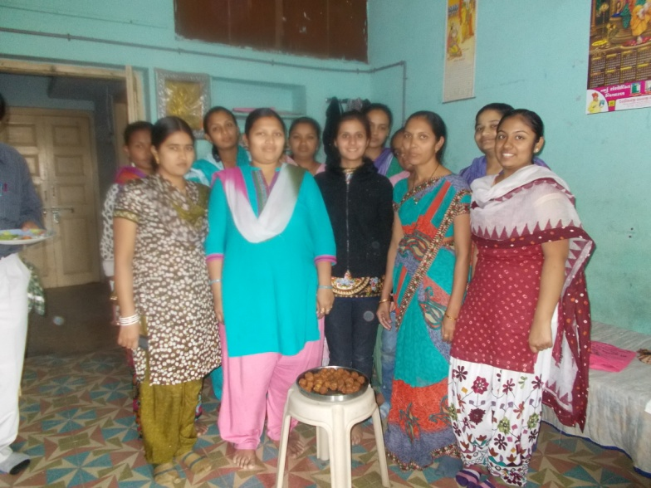
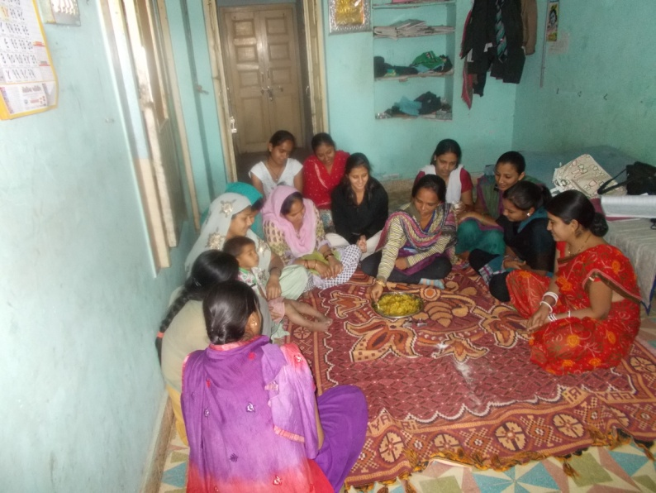

20. Out of School Children Report of House Hold Surveyunder Gujarat Council of Primary Education Gandhinagar &
S S a Himatnagar, Kheda & Anand organized by Parakh Trust.

- To identify 6-16 Years out of school children
- To identify children who have not completed elementary education (1-8 standard)
- To Provide unique ID number to each child
- To Collect Age wise, reason wise and category wise data.
- To prepare special data of Deprived group in urban areas (Rag pickers,orphan,working children)
- To make Online entry of oll identify out of school children
- To collect separate data for seasonally migrant children (Analyzed the data)
The survey would be done by census method, wherein every identified block, cluster is to be covered. In each block all the activities covered should be written in detail.
Detail of Blocks, clusters, village, Schools

S.No | District Name | Total blocks | Total  School | Total  clusters | Total  Village | Out of School Children
1 | Sabarkantha | 13 | 2455 | 214 | 1372 | 1759

s21f Gujarat water Resources Development Corporation, Gandhinaga
Division:G.W.R.Dn.Ahmedabad & Sub Dn : G.W.R.Himatnagar
Name of work: Construction of civi work of L.I.Scheme at Villge: Relyo,Tal.Megharaj
Dist.Sabarakantha M.O.U.No.55/2012-13 Parakh Trust.

- To make survey river and pond available water source
- To make R CC well on the bank of Vatrak River and lift water to provide beneficiaries.
- Todistribute water to beneficiaries for agriculture use by pipe-line.
- To make farmer mandali and elect president and secretary.
- This scheme is very useful for farmer and they developed wasteland and got lot of crop and make prosperous.
This scheme is implemented at Relyo village Block Meghraj.This irrigation Scheme developed 70 hecter land and make economic prosperous.

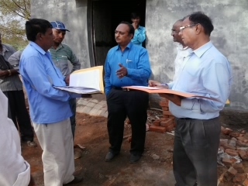
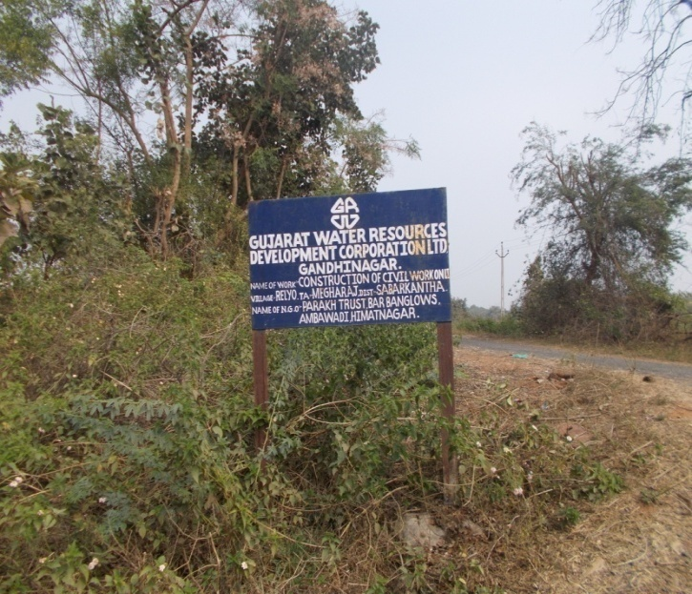

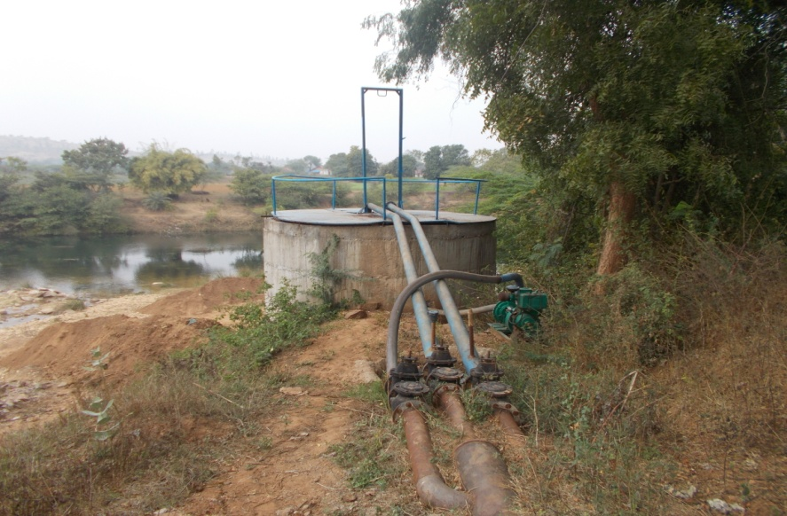
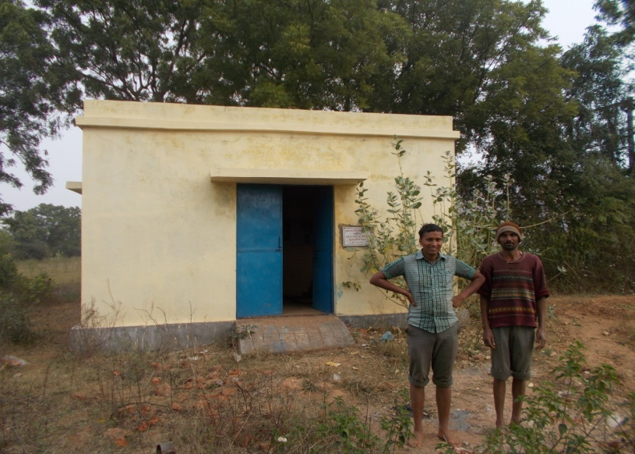

(22) Gujarat Council of Primary Education Gandhinagar & S S A Himatnagar (H.H.P)

Sabarkantha Dist 13 Block
63 Hend Holding Person
This Project objective SSA Govt of Gujarat,taken by Sabarkantha district. Total School-2463 SMC (school management Committee) monitering and causal tensing by members. TO school Development and buliding,wall,education.

